REPORT ON
COMMUNITY HEALTH DIAGNOSIS
BARPAK SULIKOT RURAL MUNICIPALITY-04
GORKHA, NEPAL



SUBMITTED BY
GROUP- C
14TH BATCH STUDENT OF BPH, 6TH SEMESTER

SUBMITTED TO
DEPARTMENT OF PUBLIC HEALTH
SCHOOL OF HEALTH AND ALLIED SCIENCES
FACULTY OF HEALTH SCIENCES
POKHARA UNIVERSITY
NOVEMBER 2025

LIST OF GROUP MEMBERS
 | Ritika Baskota  Group Coordinator  22730059 |  |  | Rasik Jamarkatel  Vice-Group Coordinator  22730057
Dibya Mainali  22730045 |  |  | Janak Gautam  22730046 |  |  | Resham Karki  22730058
Sachin Koirala |  |  | Savyata Neupane  22730063 |  |  | Shailu Adhikari  22730064
 |  | Suchita Subedi  22730068 |  |  | Sujita Subedi  22730069

APPROVAL SHEET

This is to certify that the 14th batch “Group-C” students from sixth semester, Bachelor of Public Health (BPH), School of Health and Allied Sciences, Pokhara has Successfully completed the CHD entitled “Community Health Diagnosis of Barpak Sulikot-04, Gorkha”. This CHD report is prepared for the partial fulfilment of the requirement for the Bachelor of Public Health (BPH) degree. This report has been accepted and approved.
Examiners: | Signature | Date
Associate Prof. Dr. Damaru Prasad Paneru | ……………… | …………………….
Associate Prof. Dr. Hari Prasad Kafle | …………………. | …………………….
Asst. prof. Dr. Arjun Thapa | …………………… | …………………….
Asst.prof. Mrs. Prativa Tiwari | …………………… | ……………………
Asst.prof. Mrs. Sapna Bhandari | ………………….. | ……………………
External Examiner:  ………………………. | …………………… | ……………………..
CHD Coordinator:  Mr. Rajesh Kumar Yadav | …………………… | ……………………..
BPH Coordinator:  ……………………….  Director  ………………………… | …………………..  ……………………. | ……………………..  ……………………..
School Seal

ACKNOWLEDGEMENT
The successful completion of this Community Health Diagnosis (CHD) report would not have been possible without the invaluable support, guidance, and cooperation of numerous individuals and organizations. We, the members of Group B, 14th Batch of Bachelor of Public Health (BPH), 6th Semester, express our deepest gratitude to all who contributed to this endeavor.
We are profoundly thankful to Pokhara University, School of Health and Allied Sciences, for providing us with this opportunity to integrate theoretical knowledge with practical community-based learning. Our sincere appreciation goes to Asst. Prof. Rajesh Kumar Yadav, our CHD Supervisor, for his unwavering mentorship, critical insights, and continuous encouragement throughout this journey. We are also grateful to Asso.Prof. Tulsi Ram Bhandari, Director of SHAS and Asst.Prof. Sapna Bhandari, BPH Coordinator, for their administrative support and academic guidance. We are also grateful to Asso.Prof. Bimala Bhatta, Former Director of SHAS and Asst.Prof. Bishwas Aacharya, Former BPH Coordinator, for their administrative support and academic guidance.
We are very grateful to the faculty members Asso.Prof. Dr. Hari Prasad Kafle, Asso.Prof. Dr.Damaru Prasad Paneru, Asso.Prof Dr.Arjun Thapa, Asst.Prof Prativa Sapkota Tiwari and Asst.Prof. Nand Ram Gahatraj for their helpful suggestions and ideas about the tasks during the Community health diagnosis.
We extend our heartfelt thanks to the local authorities of Barpark Sulikot -04, Saurpani, Gorkha, particularly the Ward Chairperson Mr. Bhimbahadur Gurung and office bearers, for granting us permission to conduct this study and for their generous cooperation. Our deep appreciation goes to the Health Post In-charge Mr.Pashupati Sharma and staff for sharing their valuable time, expertise, and facilitating our data collection process.
Special gratitude is owed to the Female Community Health Volunteers (FCHV) .We also acknowledge the contributions of school teachers,
We are profoundly indebted to the community members of Sulikot-04 for their warm hospitality, active participation, and willingness to share their valuable time and personal experiences. Without their trust and cooperation, this comprehensive assessment would not have been possible.

EXECUTIVE SUMMARY
Community health diagnosis refers to the identification and quantification of health problems in a community in terms of mortality and morbidity rates and ratios and the identification of their correlates for the purpose of defining those individuals or groups at risk or those in need of health care. The major focus of community health diagnosis is on the identification of health problems and different determinants that affect the health of community people. The objective of CHD is to assess the current health status of the people of Barpark Sulikot Rural Municipality-04, Gorkha and identify their health needs with an appropriate intervention with the cost-effective and locally available resources.
A community-based cross-sectional descriptive study was conducted by using a convenient sampling method among 500 households of Barpark Sulikot Rural Municipality-04, Gorkha. Face-to-face interview with each respondent was conducted to collect primary data using a semi structured questionnaire, anthropometric measurement tools. FGD and KII guideline were used to collect qualitative data. Data were entered in Epi-Data 4.7 and analyzed by using SPSS version 27.
The average household size was 4.06 with a nearly equal sex ratio (98.05 males per 100 females). Most families were nuclear (66%) and the literacy rate was 68%, with 17.9% educated up to the secondary level. Agriculture (64.4%) was the main source of income, followed by foreign employment (10.6%), and the majority (94.8%) earned Rs. 20,000–50,000 monthly. About 93% of families were non-migrant and 92.8% had ancestral residence. Only 1% of individuals had a disability. Tobacco and alcohol use were reported by 16.5% and 13.9%, respectively. 36% lacked birth registration and 40% were underweight. Deaths were reported in 3% of households, with 71% registered.

Regarding health knowledge, Tuberculosis (TB): 69% had heard of TB only 34% knew its key symptom (blood in sputum) and 59% were unaware of its transmission. 58% believed TB is curable and 44% identified hospitals as treatment sites. Awareness of DOTS was very low (5%). Diarrhoea: 35% reported diarrhoea in the past 6 month 58% used ORS for management though 51% lacked proper preparation knowledge. Only 14% recognized dehydration symptoms, and 65% identified avoiding stale food as prevention.Dengue: 73% had heard of it: 92% linked it to mosquito bites and 50% cited mosquito nets as prevention.
Hypertension (HTN): 84% had heard of HTN, but 43% didn’t know its causes and 71% were unaware of its complications. Gastritis: 92% were aware main causes cited were fatty meals (55%) and untimely diets (43%). 81% recognized avoidance of oily/spicy food as prevention.Diabetes: 73% had heard of diabetes: 60% blamed high sugar intake but 73% were unaware of complications. 63% suggested sugar reduction as prevention. Asthma: 76% were aware: 42% attributed it to smoking and 60% identified breathing difficulty as a symptom. 44% were unaware of prevention.Uterine Prolapse: 55% were aware: 62% linked it to heavy lifting, while 54% cited avoiding heavy loads as prevention. Mental Health: 51% were aware: major causes identified were stress (80%) and substance abuse (9%). Only 5% had affected family members, and 88% believed it is curable.
Among women surveyed, 65.8% married before 20 and most had first pregnancies between 20–30 years. ANC check-ups were widely practiced most had 4–8 or more visits, primarily at government health facilities, and all took iron tablets. 89% of deliveries occurred in institutions. PNC coverage was moderate 56% received PNC check-ups, and 85% received Vitamin A. All mothers fed colostrum milk to new-borns. Among respondents of reproductive age, 55% were using family planning, mainly sterilization (43%), Depo (30%), and condoms (16%). 30% experienced side effects, including headache, fatigue, and weight loss. The main reason for non-use was not necessary (74%).
Among the participants 57% understood the concept of balanced diet. 81% described it correctly as a mix of grains, fruits/vegetables, and animal sources, regarding sarbottam lito 59% knew its preparation: 77% did it correctly, about infant feeding 81% said colostrum is essential, 59% fed within one hour of birth. Regarding dietary diversity Within 24 hours, 99% ate rice, 72% green vegetables, and 60% cereals: fruit and egg intake were least common. Vegetable consumption: 58% ate daily: fruit consumption averaged 2–4 times weekly. Homemade meals were dominant (88%), with 40% reporting junk food intake. Nearly almost everyone used tap water (98%): 90% were satisfied with its purity, though only 60% purified it. Among those who purified, filtration (61%) and boiling (53%) were most common. Jerry cans (68%) were main storage containers. Most households used firewood (86%) for cooking, followed by gas stoves (49%). Waste segregation was done by 82%, though 96% practiced burning waste, indicating limited proper disposal systems.
All the children were immunized, where 81 % adolescent girls were vaccinated with HPV vaccine. Most houses were Ardha-Kachhi (77%), with 69% having adequate rooms and 85% separate kitchens. Proper ventilation was present in 65%, and toilet coverage was 98%. Cattle sheds were present in 85% of homes, often within 25 feet.
Clear Surrounding was reported by 70%.

Table of contents
LIST OF GROUP MEMBERS ii
APPROVAL SHEET iii
ACKNOWLEDGEMENT iv
EXECUTIVE SUMMARY v
LIST OF TABLES xi
LIST OF FIGURES xii
LIST OF ABBREVIATIONS xv
CHAPTER I: INTRODUCTION 1
1.1 Background of CHD 1
1.2 Background of study area 2
1.3 Rationale of study 2
1.4 Objective 3
1.5 Operational Definition 3
CHAPTER II: METHODOLOGY 5
2.1 Study Area 5
2.2 Study Design 5
2.3 Study Duration 5
2.4 Sampling Technique 5
2.5 Sample size 5
2.6 Unit of Study 5
2.7 Selection Criteria 5
2.8 Source of Data 6
2.9 Type of data 6
2.10 Data Collection Tools and Techniques 6
2.11 Data Analysis and Management 7
2.12 Validity and Reliability 7
2.13 Ethical Consideration 7
2.14 Logistics of CHD 7
CHAPTER III: RAPPORT BUILDING AND SOCIAL MAPPING 8
3.1 Rapport Building and Orientation 8
3.2 Process of Rapport Building 8
3.3 Social Mapping 9
3.4 Process of Social Mapping 9
CHAPTER IV: FINDINGS AND RESULT 10
4.1 Socio-demographic Information 10
4.2 Disease and Epidemiology 20
4.3 Food and Nutrition Consumption 42
4.4 Safe Water and Basic Sanitation 49
4.5 Maternal and Child Health 53
4.6 Family Planning 58
4.7 Immunization Against Major Infectious Diseases 61
4.8 Observation Checklist 62
CHAPTER V: FOCUS GROUP DISCUSSION AND KEY INFORMANT INTERVIEW 68
5.1 Focus Group Discussion (FGD) 68
5.2 Key Informant Interview 70
CHAPTER VI: SCHOOL HEALTH PROGRAM 75
6.1 Introduction 75
6.2 Objectives 75
6.3 Program detail: 76
CHAPTER VII: MICRO HEALTH PROJECT 79
CHAPTER VIII: COMMUNITY PRESENTATION 85
8.1 First Community Assembly 85
8.2 Second Community Assembly 85
8.3 Final Community Assembly 87
CHAPTER IX: Discussion 89
CHAPTER X: Learning experience 90
CHAPTER XI: CONCLUSION AND RECOMMENDATION 91
11.1 Conclusion 91
11.2 Recommendations 92
CHAPTER XII: REFERENCES 94
CHAPTER XIII: Annexure 95
Annex 1: Questionnaires 95
Annex 2: Workplan 108
Annex 3: Request letter from college to ward 110
Annex 4: CHD completion/Appreciation letter from ward 111
Annex 5: Minuting 112
Annex 6: PRA/PLA tools 119
Annex 7: Photographs 121

LIST OF TABLES
Table 1: Data collection tool and technique 6
Table 2: Logistic of CHD 7
Table 3: Socio demographic status 10
Table 4: Socio economic status 11
Table 5: Information related to birth 15
Table 6: Information related to death 16
Table 7: No of migrated family member 18
Table 8: Information related to diseased population 19
Table 9: Knowledge on symptoms of TB 20
Table 10: Mode of transmission of TB 21
Table 11: Place for treatment of TB 22
Table 12: Knowledge on preventive measure of TB 22
Table 13: Management of diarrhoea 24
Table 14: Causes of diarrhoea 25
Table 15: Sign and symptoms of dehydration 25
Table 16: Preventive measure of diarrhoea 26
Table 17: Awareness of dengue 26
Table 18: Knowledge about causative factor of dengue 27
Table 19: Symptoms of dengue 27
Table 20: Prevention of dengue 28
Table 21: Information related to mental issue 40
Table 22: Knowledge on exclusive breastfeeding 45
Table 23: Vegetable consumption within a week 46
Table 24: Fruits consumption within a week 46
Table 25: Nutrition status under 5 years 48
Table 26: Nutrition status of adult 48
Table 27 Information related to pregnancy 53
Table 28: Last pregnancy related information 54
Table 29: PNC related information 55
Table 30: Types of family planning currently used 59
Table 31: Immunization coverage o 10-15 years adolescent girls 62
Table 32: SHP method and media 76
Table 33: MHP Multi-Voting 81
Table 34: Role play method and media 83

LIST OF FIGURES
Figure 1:Population Pyramid 12
Figure 2 Disability among family members 12
Figure 3:Tobacco Consumption 13
Figure 4:Alcohol Consumption 13
Figure 5 Birth within one year 14
Figure 6 Birth Registration 14
Figure 7 Death within one year 15
Figure 8 Death Registration 16
Figure 9 Duration of residence 17
Figure 10 Migration of family members 17
Figure 11 Family members suffering from disease in past 1 year 18
Figure 12 Awareness of tuberculosis 20
Figure 13 Knowledge on cure of TB with course medication 21
Figure 14 Heard about DOTS 23
Figure 15 Prevalence of diarrhoea in family in past 6 months 23
Figure 16 Correct method of ORS preparation 24
Figure 17 Heard about HTN 28
Figure 18 Knowledge on causes of high blood pressure 28
Figure 19 Knowledge on prevention and control of HTN 29
Figure 20 Knowledge on complications of high pressure 29
Figure 21 Status of Hypertensive cases 30
Figure 22 Heard about gastritis 30
Figure 23 Perception on causes of gastritis 31
Figure 24 Knowledge on symptoms of gastritis 31
Figure 25 Knowledge on preventive measures of gastritis 32
Figure 26 Heard about diabetes 32
Figure 27 Perception on causes of diabetes 33
Figure 28 Perception on health complications of diabetes 33
Figure 29 Perception on preventive measures of diabetes 34
Figure 30 Heard about COPD 34
Figure 31 Perception on causes of asthma 35
Figure 32 Perception on symptoms of asthma 35
Figure 33 Perception on preventive measures of asthma 36
Figure 34 Heard about uterine prolapse 36
Figure 35 Perception on causes of uterine prolapse 37
Figure 36 Perception on preventive measures of uterine prolapse 37
Figure 37 Heard about mental health 38
Figure 38 Source for knowledge on mental disease 38
Figure 39 knowledge about causes of mental disease 39
Figure 40 Knowledge about symptoms of mental disease 39
Figure 41 Any family member suffering with mental disease 40
Figure 42 Knowledge about prevention of mental disease 41
Figure 43 Can mental disease be cured 41
Figure 44 Know about balanced diet 42
Figure 45 Knowledge about balanced diet 42
Figure 46 Knowledge about the preparation of Sarbottam litto 43
Figure 47 Method of preparing Sarbottam litto 43
Figure 48 Perception on feeding of colostrum milk 44
Figure 49 Time for feeding mother's milk 44
Figure 50 Food they had within 24 hours 45
Figure 51 Food items in lunch 46
Figure 52 Months enough from production for consumption 47
Figure 53 Income enough for consumption 47
Figure 54 Source of drinking water 49
Figure 55 Satisfaction with purity of water 49
Figure 56 Practice of water purification 50
Figure 57 Methods used for water purification 50
Figure 58 commonly used pot to store drinking water. 51
Figure 59 Commonly used fuel to cook 51
Figure 60 Practice of waste separation. 52
Figure 61 Commonly used practice for management of degradable waste 52
Figure 62 Management of non-degradable waste 53
Figure 63 Feeding to Children before breastfeeding 56
Figure 64 Colostrum milk fed to child 57
Figure 65 ARI in past One year 57
Figure 66 Heard about family planning 58
Figure 67 Currently family planning using 58
Figure 68 Suffered from side effect of family planning 59
Figure 69 Side effect of family planning 60
Figure 70 Reasons for not using family planning 60
Figure 71 Immunization Card 61
Figure 72 Types of houses 62
Figure 73 Sufficient lightening in the house 63
Figure 74 separate kitchen and sleeping room 63
Figure 75 Ventilation in room 64
Figure 76 availability of toilet in the house 64
Figure 77 Distance between source of water and toilet 65
Figure 78 Household having cattleshed 65
Figure 79 Distance between house and shed 66
Figure 80 Surrounding environmental status 66
Figure 81 Time to reach nearest health post 67

LIST OF ABBREVIATIONS
CHD | Community Health Diagnosis
BHS | Bachelor of Public Health
BP | Blood Pressure
BHS | Basic Health Service
FCHV | Female Community Health Volunteer
HIV | Human Immunodeficiency Virus
HTN | Hypertension
MS Office | Microsoft Office
MS Word | Microsoft Word
PMC | Pokhara Metropolitan City
ANM | Axillary Nursing Midwife
PU | Pokhara University
SHAS | School of Health and Allied Sciences
BHCC | Basic Health Care Centre
TB | Tuberculosis
CD | Communicable Disease
NCD | Non-Communicable disease
MOT | Mode of Transmission
GoN | Government of Nepal
PLA | Participatory Learning Appraisal
FGD | Focus Group Discussion
KII | Key Information Interview
PRA | Participatory Rural Appraisal
DOTS | Directly Observed Treatment Short Course
MHP | Micro Health Project
SPSS | Statistical Package for Social Sciences

INTRODUCTION

Background of CHD
CHD comes under Public Health Application strand, helps to acquire basic and practical skills of various theoretical disciplines of sixth semester as mentioned in course objectives.
CHD refers to the identification and quantification of the health problems in a community in terms of mortality and morbidity rates. Generally, it is a comprehensive assessment of the health status of the community in relation to its social, cultural, physical, psychological and environmental conditions. Its main purpose is to reveal the existing health problems in the community, setting priorities and applying appropriate intervention measures to solve that problem, which is based on the information from the study and observations of the community members.
With this program, it is possible to get an initial picture of a community and its health problems within short period of time. The process of CHD involves initial exploration and interaction with the community, planning the study, pre-testing the methods, executing the data collection and analysing the findings. The focus of CHD is on identification of the health problems of the community, identifications of the basic health needs, prioritization of the problems for community health action and applying the appropriate intervention measure to solve those problems. The final task is to feed these conclusions back to the community and health workers so as to initiate the process of interpretation for the planning. The aim of community health diagnosis is to: identify of basic health needs, identify health problems and different determinants that affect the health of community people and assist the community to promote their health by modifying the knowledge, attitude, and practice regarding their health with their own active participation.
Community diagnosis is a fundamental philosophy of Public Health, emphasizing problem-based and self-directed learning as well as community orientation. For BPH students, it is a crucial aspect of their education. Recognizing this, Group-C of the 14th batch of BPH students from Pokhara University were assigned to Barpark Sulikot-04, Gorkha.

Background of study area
Geographical location
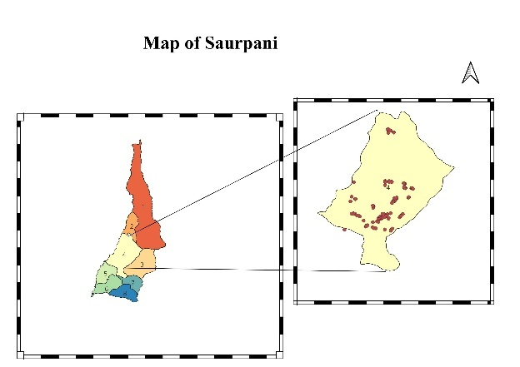
The study area of CHD was Barkpark Sulikot-04 , Gorkha. Ward no. 4 is joined with ward no. 1 and 2 in the north, ward no. 6 and 7 in the south, ward no. 3 in east and ward no. 5 in west. The area of ward no. 4 is 200.6 square km.
Resource information
Ward no. 4, Saurpani is rich in natural resources. The main natural resources are: forests and agricultural land. These resources are very useful for the overall socio-economic development of this ward.
Demographic Information
The population of ward no. 4 is 5133 (Barpak Sulikot-04, Gorkha) . Males and females are nearly equal and the majority of the proportion is the productive age group.
Socio-economic Information
Agriculture is the main occupation followed by people. The majority of people were Janajati followed by Brahmin/Chhetri and Dalit. Hinduism is major religion followed by people.
Institutional Information
This ward is well facilitated with basic infrastructure. It has different institutions such as School, Mother's Group, Schools, Health post, Police Station, Tol Development Committee and governmental organization.

Rationale of study
The study fulfils the requirement for the field practice to acquire basic and practical skills of various theoretical disciplines of sixth semester as mentioned in our course objectives. Our course helps to develop practical and applied skills to assess health problems and assessing these problems in scientific way for theory subject delivered during the semester.

Objective

General Objective
To assess the current health status of the people of Barpark, Sulikot Rural Municipality ward no. 4, Gorkha and identify the health problems of the community, prioritize that health problem and conduct MHP utilizing effective locally available resources.

Specific Objectives
- To identify the socio-demographic structure of the community.
- To explore the knowledge and practices of community people regarding NCDs and CDs.
- To assess the status of communicable disease and non-communicable disease among the community people.
- To assess the knowledge and practice regarding nutrition and food consumption among the community people.
- To access the nutritional status of children under 5 years old and adults.
- To identify the practice regarding safe water and basic sanitation.
- To assess the maternal and child health status in community.
- To assess the knowledge and practice of family planning method in reproductive aged married couple.
- To identify the status of immunization among children under 2 years old and adolescent girls.
- To prioritize the identified health problems and assess the health needs.
- To conduct the school health program.
- To conduct the micro health project utilizing cost effective locally available resources.
- To present overall finding of community health diagnosis to the community people.

Operational Definition
Average household size: It is the ratio of the total population to total households: (AHS=Total population/Total household)
Sex ratio: Sex ratio is defined as the ratio of males per 100 females: (SR= (No. of male/No. of female) * 100
Productive population: People aged between 15-64 years who were physically and economically active.
Literacy rate: Number of people who are able to write and study divided by the total population. People aged 5 or more years are included for calculating the literacy rate.
Informal Education: Those people who are able to read or write but has not any formal qualification.
Health services Accessibility: Households have health facilities within the walking distance of half an hour (30 minutes).
Teenage pregnancy: Women who were pregnant before the age of 20 years.
ANC protocol: Number of pregnant women who attended 8 ANC as protocol (12,16, 20, 28, 32, 34, 36 and 38 week of pregnancy) at a health facility.
Institutional Delivery: Number of deliveries conducted at health facilities (public or private) by trained health workers.
Exclusive breastfeeding: Lactating women should give only their milk to a newborn child for at least 6 months.
Immunization Target group: children below 1 year. For JE and MR^{nd} 12- 23 months’ children as per national protocol.
Reproductive Aged Group (RAG): People aged between 15-49 years who are active and capable of reproduction.
Distance between the source of water and toilet: It should be at least 15 meters (
Correct method of Sarbottam litto : 2 part cereals and 1 part pulses
Distance between house and shed: It should be at least 25 feet.

METHODOLOGY

Study Area
The study area of CHD was Barpak-Sulikot-04, Gorkha, Gandaki Province.

Study Design
The study design of CHD was cross-sectional descriptive type. The study design of Community Health Diagnosis was cross-sectional descriptive. CHD is snapshot study of overall health status of community. In which measurement of exposure and outcome are made at same time.

Study Duration
The study period was from 2082/02/28 to 2082/02/27 (30 days).

Sampling Technique
The sampling technique used for CHD was convenient sampling due to lack of proper sampling frame in which we select those sample who were convinced and willing to participate in our study.

Sample size
The sample size for CHD was 500.

Unit of Study
Unit of our study was household.

Selection Criteria

Inclusion criteria:
- Permanent resident of Barpak Sulikot-04, Gorkha aged above $≥$18 years, and willing to participate in the study.
- For family planning related information participants of 15-49 years of married couple were included,
- For maternal and child health related information pregnant women, mothers of under 5 year children and
- For anthropometric measurement children of 6–59 month age children were included.

Exclusion criteria:
- Those people who were not the permanent resident of Barpak Sulikot-04, Gorkha,
- Participants who were not able to respond and
- Age less than 18 years old.

Source of Data
The source of data was primary which were collected first hand by using semi-structured questionnaire, observation check list, FGD guideline and KII forms.

Type of data
The type of data for CHD was quantitative and qualitative. Quantitative data were collected by using semi-structured questionnaire while qualitative data were collected through a Focus Group Discussion (FGD) and Key Informants Interview (KII).

Data Collection Tools and Techniques
Table 1: Data collection tool and technique
Data type | Tool | Participants/Application | Technique
Quantitative | Semi-structured questionnaire | People aged between 18-70 years | Face-to-face interview
Quantitative | Shakir's tape | U5 children | MUAC measurement
Quantitative | Weighing machine and Stadiometer | Adults | Height, weight measurement
Quantitative | Observation checklist | Observing the household and surrounding | Observation
Qualitative | Social map, seasonal calendar, organizational chart, daily time schedule. | Community members | PRA/PLA Technique
Qualitative | FGD guideline | Concerned stakeholders | Group discussion
Qualitative | KII guideline | Concerned stakeholders | Interview

Data Analysis and Management
Data were entered in Epi-Data 4.7 software and Statistical Package for Social Science (SPSS) version 28 was used for data management and data analysis. Descriptive statistics (frequency, mean and multiple responses) were computed. The findings were presented in diagrammatic (pie-chart, bar-diagram) and tabular form.

Validity and Reliability
To ensure validity, we consulted with the CHD coordinator and subject experts and extensive literature review. To ensure reliability, we pretested the questionnaire in Khudi and made necessary modifications based on the supervisor's feedback.

Ethical Consideration
The study was approved by the School of Health and Allied Sciences, Pokhara University, and approval was also taken from the ward office of Barpak Sulikot-04, Gorkha. Written informed consent was taken from each participant. Participants were informed of their right to withdraw from the study at any time without reason. Data obtained from the study participants will not be used for any other purpose than for partial fulfillment of the BPH program. Privacy and Confidentiality was maintained.

Logistics of CHD
Table 2: Logistic of CHD
S.N. | Logistics | Uses
1 | Weighing machine | For measuring body weight
2 | Shakhir's tape | For measuring MUAC of U5 children
3 | Stadiometer | For measuring the height of people
4 | BP set | For measuring blood pressure
5 | Chart papers, newsprint paper Markers, sign pen, scale, and other stationery items | For preparing chart papers, presentations
6 | First aid kit | For using during the emergency and general health problems

RAPPORT BUILDING AND SOCIAL MAPPING

Rapport Building and Orientation
Rapport Building is the process of establishing a friendly, trusting relationship essential for enhancing communication and cooperation between stakeholders.
In this field practice, significant effort was dedicated to cultivating strong, positive connections with all concerned parties. Developing these meaningful bonds, characterized by mutual understanding, trust, and communication ease, is fundamental to community health diagnosis. This process served as the essential foundation for every task undertaken. By intentionally establishing and nurturing these relationships, we were able to build trust with community members, which was critical for facilitating the ethical collection of necessary data and ensuring the effective implementation of community-based programs.

Process of Rapport Building

Activities of Rapport Building
- Provided appropriate self-introductions during key interactions, including transect walks, community assemblies, and home visits.
- Clearly articulated the project's purposes and objectives using understandable language.
- Shared relevant personal information to foster deeper, more meaningful connections extending beyond the field work requirements.
- Described planned activities and distinctly highlighted the anticipated benefits these activities would bring to the community.
- Demonstrated active interest in community discussions and provided assurance of support as needed.
- Sustained engagement through formal and informal meetings, phone calls, and discussions.

Social Mapping
Social map is a visual representation of a social network which involves drawing the map of the concerned community with essential resources, along with the full participation of community members. It is very crucial part of our residential field practice since, initially, we are totally unaware about the study area. It is a platform during which we get to know the study area in deeper ways.

Process of Social Mapping
- Invitation to Key Informants/Local People
During our social mapping, we invited the key informants of our study area such as the ward president, ward members, BHCC staff, school principals, FCHVs, mother group, and more others.
ii. Local Resources Collection:
We collected different local resources to prepare the map of Barpak Sulikot-04, Gorkha. We gathered stones, pebbles, coal, leaves, stems, grass, sticks etc. We also used the soil from the fields to create various important structures such as health clinics, schools, temples, entrance, chautaras and painted with the help of abir and kesari to color them.
iii. Mapping:
Firstly, we shared the purpose and importance of social mapping to the community people. Then to facilitate the community members, we gathered and dispatched the materials to be used for mapping. The community people initiated the drawing by tracing the boundary and indicating the north pole. They discussed and located all the resources and structures in their community such as road, direction, ward office, health clinics, radio station, forest, temples, church, schools, chautara, FCHVs house and so on. After the mapping was completed, we copied the map into a chart paper using pencils, markers, sign pens etc and thanked each participant for their participation in this process.
Date: 2082/ 02/30
Venue: Outside of School (Shree Himalaya Secondary School)

FINDINGS AND RESULT

Socio-demographic Information

Demographic information
Out of 500 households our study revealed that the average household size was about 4.062, with a total population of 2031. Males and females were nearly equal, which makes the sex ratio (M/Fe*100) 98.05. Among total households, more than half (66%) were nuclear families. Around one fifth (17.9%) of the people had secondary level education. The overall literacy rate was 68%.
Table 3: Socio demographic status
Socio-demographic Information | Frequency | Percentage (%)
Gender (n=2031)
Male | 1005 | 49.5
Female | 1026 | 50.5
Education level (n=2031)
Illiterate | 600 | 29.5
Informal | 178 | 8.8
Basic education | 716 | 35.3
Secondary | 363 | 17.9
Bachelor | 67 | 3.3
Master or higher | 19 | 0.9
Marital Status (n=2031)
Married | 1150 | 56.6
Unmarried | 573 | 28.2
Widow | 90 | 4.4
Widower | 32 | 1.6
Divorced | 12 | 0.6
Religion (n=500)
Hinduism | 333 | 66.6
Buddhism | 135 | 27
Christianity | 29 | 5.8
Muslim | 3 | 0.6
Ethnicity (n=500)
Dalit | 103 | 20.6
Janajati | 276 | 55.2
Muslim | 2 | 0.4
Brahmin/Chhetri | 118 | 23.6
Madhesi | 1 | 0.2
Family Type (n=500)
Nuclear | 330 | 66.0
Joint | 169 | 33.8
Extended | 1 | 0.2

Socio-economic Information
Among the total 500 households, 64.4% household major source of income was Agriculture followed by 10.6% foreign employment. Majority of household 94.8%, had monthly income twenty to fifty thousand.
Table 4: Socio economic status
Socio-economic Information | Frequency | Percentage (%)
Major Source of Income (n=500)
Agriculture | 322 | 64.4
Foreign employment | 53 | 10.6
Business | 39 | 7.8
Daily wages | 21 | 4.2
Services | 34 | 6.8
Pension | 16 | 3.2
Private sector/ INGO’s | 9 | 1.8
Others | 6 | 1.2
Monthly Family Income (n=500)
<20000 | 8 | 1.6
20000-50000 | 474 | 94.8
>50000 | 18 | 3.6

Population Pyramid
The population pyramid as shown in figure above indicates the total population is 2031, with 1005 males and 1026 females. The largest age group is 20-24 years and the smallest is 0-4 years.

Figure 1:Population Pyramid

Disability among the family members
Among 2031 members, very few (1%) had disability where as others (99%) were with no disability as shown in figure.

Figure 2 Disability among family members

Tobacco Consumption
Among 2031 population, 16.5 % were currently consuming tobacco whereas 81.4% never consumed tobacco as shown in figure.

Figure 3:Tobacco Consumption

Alcohol Consumption
Among 2031 population,13.9 % were currently drinking alcohol,2.9% drank in past whereas 83.3 % never drank alcohol as shown in figure.

Figure 4:Alcohol Consumption

Birth Related information

Birth within 1 year in the family
Out of 500 households 3 % had new-born in their family as shown in figure.

Figure 5 Birth within one year

Birth Registration
Out of 14 new-born children, 5 children had no birth registration.

Figure 6 Birth Registration

Information related to Birth
Among 10 children under one year of age, 4 children were underweight (< 2.5 kg).
Table 5: Information related to birth
Birth related information (n=10) | Frequency(n) | Percentage (%)
Gender
Male | 4 | 40
Female | 6 | 60
Birth status
live | 10 | 100
dead | - | -
Age of mother while giving birth
20 years or less | 2 | 20
21-29 years | 7 | 70
30 years or more | 1 | 10
Weight of infants
Less than 2.5 kg | 4 | 40
2.5 kg or more | 6 | 60

Death Related Information

Death within one year
Out of 500 households, only 3% reported the death of a family member within the past year as illustrated in figure.

Figure 7 Death within one year

Death Registration
Among 14 households informed about death of family member within one year, 10 respondent said they had done the death registration of death family member and 4 said they had not done as it is illustrated in above figure

Figure 8 Death Registration

Information related to death
Table 6: Information related to death
Death related Information | Frequency(n) | Percentage (%)
Sex (n = 7)
Male | 3 | 43
Female | 4 | 57
Age at death (n=7)
<18 years | 0 | 0
18-59 years | 1 | 14
60 years or more | 6 | 86
Reasons of Death. (n=7)
NCD | 4 | 57.14
Accidents | 3 | 42.85
Visit of Hospital for treatment (n=7)
Yes | 3 | 43
No | 4 | 57

Information Related to Migration

Duration of Residence
Among 500 households, 92.8% were habituated from ancestral and only 0.8% people were living from less than 5 years. Duration of residence information is illustrated in a the figure.

Figure 9 Duration of residence

Migration of family members
Among the 500 households ,7% of the family had their family members migrated and 93% of the family hadn’t their family members migrated as shown in the illustrated figure.

Figure 10 Migration of family members

No. of family members migrated
Among the total 33 migrated members, 9.1 % migrated from the one family whereas 12.1 % migrated from the 10 families as shown in the table above.
Table 7: No of migrated family member
No of family members migrated(n=33) | Frequency | Percentage(%)
1 | 3 | 9.1
2 | 5 | 15.2
3 | 4 | 12.1
4 | 9 | 27.3
5 | 5 | 15.2
6 | 1 | 3.0
7 | 1 | 3.0
8 | 1 | 3.0
10 | 4 | 12.1

Family members suffering from disease in past one year
Among the 500 households, 33% of family had suffered from disease whereas 67% of family hadn’t suffered from disease as shown in the above figure.

Figure 11 Family members suffering from disease in past 1 year

Information related to diseased population
In one year 153 people suffered from diseases as shown in table .
Table 8: Information related to diseased population
Diseased related information | Frequency(n) | Percentage (%)
Sex (n=153)
Male | 52 | 34
Female | 101 | 66
Age (n=124)
20 years or less | 11 | 7
21-59 years | 80 | 52
60 years or more | 62 | 41
Type of disease
NCDs/Accidents | 127 | 83
CDs | 26 | 17
Place of treatment
Home | 18 | 12
Government Hospital | 76 | 50
Private hospital | 44 | 29
Health Post | 15 | 9
Current Disease Status
Fit | 88 | 58
Unfit | 65 | 42

Disease and Epidemiology

Awareness of Tuberculosis
Among total 500 respondents, 69% had heard about TB and rest 31% had not heard about it as shown in figure.

Figure 12 Awareness of tuberculosis

Knowledge on Symptoms of TB
Among total 345 respondents who had heard about TB,34% responded blood in sputum ,27% told persistent cough for more than weeks, fever (22%),chest pain (18%),weight loss (9%), loss of appetite (4%) and night sweats by 1% as a symptom of TB. Moreover, a significant portion of the respondents,44% indicated they were unknown about any symptoms,suggesting a major knowlede gap.
Table 9: Knowledge on symptoms of TB
Responses (n=345) Frequency (n) Percentage(%)
Blood in sputum | 118 | 34
Persistent cough for more than 2 weeks | 92 | 27
Fever | 76 | 22
Chest pain | 63 | 18
Weight loss | 31 | 9
Loss of appetite | 15 | 4
Night sweats | 5 | 1
Don’t know | 151 | 44

Mode of transmission of Tuberculosis
Among total 345 respondents who had heard about TB, most commonly known method of transmission was through the air while talking with patient(20%) followed by 18% responding when the patient sneezes,16% told wearing clothes used by the patient, 10% responded eating food contaminated by patient.Notably ,59% of respondents stated they were unknown about how TB transmits.
Table 10: Mode of transmission of TB
Responses (n=345) | Frequency (n) | Percentage(%)
Through the air while talking with patient | 63 | 20
When the patient sneezes | 57 | 18
Wearing clothes used by the patient | 51 | 16
Eating food contaminated by patient | 33 | 10
Don’t know | 190 | 59

Knowledge on cure of TB with course medication
Among total 345 respondents who had heard about TB, 58% responded TB is curable with full course medication, 11% responded TB cannot be cured while 21% were unknown as shown in figure.

Figure 13 Knowledge on cure of TB with course medication

Place for treatment of TB
Among total 345 respondents who had heard about TB, majority (44%) identified hospitals as the place for treatment of TB,followed by Health posts(24%),PHC,traditional healers, pharmacy were each mentioned by only 1% of respondents while 46% indicated they were unknown where to seek TB treatment
Table 11: Place for treatment of TB
Responses(n=345) | Frequency(n) | Percentage(%)
Hospitals | 150 | 44
Health posts | 81 | 24
Primary Healthcare Center | 5 | 1
Traditional Healers | 2 | 1
Pharmacy | 4 | 1
Don’t know | 158 | 46

Knowledge on preventive measures of TB
Among total 345 respondents who had heard about TB, 20% recognized patient covering nose and mouth while coughing and sneezing ,followed by taking precautions while coming closer to the patient(13%),staying in well-ventilated rooms by 10%, consuming Balanced Diets by 9%, taking complete medicines (8%), B.C.G Vaccination (3%) as preventive measures of TB whereas a substantial majority of respondents,59%, were unknown.
Table 12: Knowledge on preventive measure of TB
Responses(n=345) | Frequency(n) | Percentage(%)
Patient covering nose and mouth while coughing and sneezing | 69 | 20
Taking precautions while coming closer to the patient | 44 | 13
Staying in well-ventilated rooms | 33 | 10
Consuming Balanced Diets | 30 | 9
Taking complete medicines | 29 | 8
B.C.G Vaccination | 12 | 3
Don’t Know | 203 | 59

Heard about DOTS
Among 345 respondents, only 5% had heard about DOTS which indicates significant lack of awareness as shown in figure .

Figure 14 Heard about DOTS

Prevalence of Diarrhoea in Family in past 6 months
Among total 500 respondents, 35% indicated that a family member had experienced diarrhoea in the past 6 months, while 65% reported no such cases as shown in figure .

Figure 15 Prevalence of diarrhoea in family in past 6 months

Management of Diarrhoea
Among 177 respondents with prevalence of Diarrhoea in family in past 6 months, the most common management method was taking ORS used by 58% of individuals, followed by medication (37%), eating liquid or soupy foods (18%), 10% responded visiting hospitals and 8% told other methods such as staying hydrated, avoiding oily and spicy foods and personal hygiene.
Table 13: Management of diarrhoea
Respondent (n=177) | Frequency(n) | Percentage(%)
Taking ORS | 102 | 58
Medication | 65 | 37
Eating liquid or soupy foods | 32 | 18
Visiting Hospitals | 17 | 10
Others | 14 | 8

Correct method of ORS preparation
Among 177 respondents,49% knew the correct method of preparing ORS but a slightly higher proportion (51%) lack proper knowledge as shown in figure .

Figure 16 Correct method of ORS preparation

Causes of Diarrhea
Among 500 respondents, the most commonly perceived cause of Diarrhoea was eating leftover foods, followed by dirty surroundings (31%) and drinking polluted water (27%), a smaller proportion attributed it to maintaining personal hygiene (5%) and 1% told other reasons such as over eating, eating too much oily and spicy foods while 28% were unknown about causes of Diarrhoea.
Table 14: Causes of diarrhoea
Respondent (n=500) | Frequency(n) | Percentage(%)
Eating Leftover foods | 269 | 54
Dirty surroundings | 153 | 31
Drinking polluted water | 132 | 27
Not maintaining personal hygiene | 24 | 5
Don’t Know | 139 | 28
Others | 6 | 1

Signs and Symptoms of Dehydration
Among total 361 respondents, only a small minority identified the signs, with 14% reporting weakness,13% reporting a dry mouth and tongue,8% reporting cold hands and feet and 2% responded torn skin while stretching while a concerning large.
Table 15: Sign and symptoms of dehydration
Respondent (n=361) | Frequency(n) | Percentage(%)
Weakness | 53 | 14
Dry mouth and tongue | 51 | 13
Cold hands and feet | 31 | 8
Skin torn while stretching | 7 | 2
Don’t know | 289 | 76

Prevention of Diarrhoea
Among total 361 respondents, a significant majority of respondents 65% identified avoiding stale, rotten or spoiled foods as a way to prevent Diarrhoea, followed by safe drinking water by 37%, proper sanitation around home by 17%, maintaining personal hygiene by 13% and 15% of respondents mentioned other methods like handwashing and food hygiene
Table 16: Preventive measure of diarrhoea
Respondent (n=361) | Frequency (n) | Percentage (%)
Avoiding stale, rotten or spoiled foods | 320 | 65
Safe drinking water | 183 | 37
Proper sanitation around home | 82 | 17
Maintaining personal hygiene | 62 | 13
Others | 72 | 15

Awareness of Dengue
Among total 500 respondents, 73% had heard about Dengue as shown in figure .

Table 17: Awareness of dengue

Knowledge about Causative Factor of Dengue
Among total 364 respondents who had heard about Dengue, an overwhelming majority of 92% identified mosquito bite as the cause,other less common answers included not using mosquito nets, consumption of contaminated water, blood transfusion through infected person and unsafe sexual contact while 8% were unknown about the cause of Dengue.

Table 18: Knowledge about causative factor of dengue
Respondent (n=364) | Frequency(n) | Percentage(%)
Mosquito bite | 335 | 92
Not using mosquito nets | 9 | 3
Consumption of contaminated water | 7 | 2
Blood transfusion through infected person | 2 | 1
Unsafe sexual contact | 2 | 1
Don’t know | 29 | 8

Symptoms of Dengue
Among total 364 respondents who had heard about Dengue, most widely known symptom of Dengue was fever identified by 61% of respondents, followed by nausea and vomiting 19%, bone and joint pain 17%. Less common symptoms like bleeding from the gums and pain in the back part of the eye were recognized by 2% each while a significant portion 32% were unknown about Dengue symptoms.
Table 19: Symptoms of dengue
Respondent (n=364) | Frequency(n) | Percentage(%)
Fever | 223 | 61
Nausea and vomiting | 70 | 19
Bone and joint pain | 62 | 17
Bleeding from the gums | 7 | 2
Pain in back part of the eye | 6 | 2
Don’t know | 116 | 32
Others | 4 | 1

Prevention of Dengue
Among total 364 respondents who had heard about Dengue, the most recognized preventive measure was using mosquito nets identified by 50% of respondents, followed by 40% responding wearing long sleeve clothes and 23% responding avoiding water stagnation while 24% were unknown about Dengue preventive measures.

Table 20: Prevention of dengue
Responses(n=364) | Frequency(n) | Percentage(%)
Using mosquito nets | 184 | 50
Wearing long sleeve clothes | 147 | 40
Avoiding water stagnation | 83 | 23
Cleaning water storage vessel once in a week | 16 | 4
Don’t Know | 88 | 24

Heard about HTN
Among total 500 participants, 84% had heard about HTN and rest 16% didn’t heard about it as shown in figure.

Figure 17 Heard about HTN

Knowledge on causes of high blood pressure (multiple response question)
Among total 420 households, 36% respondents had answered high intake of salt, and the causes of the high blood pressure as shown in figure.

Figure 18 Knowledge on causes of high blood pressure

Knowledge on prevention and control of HTN (multiple response question)
Among total 420 households, 40% respondents had answered low intake of salt , 24% reduce stress , 6% physical activity and 47% responded they don’t know the preventive measures of high blood pressure as shown in figure.

Figure 19 Knowledge on prevention and control of HTN

Knowledge on complications of high pressure (multiple response question)
Among total 420 households, 71% respondent don’t know the complication of HTN followed by 17% heart attack, 6 % kidney problem and 6% death as shown in figure.

Figure 20 Knowledge on complications of high pressure

Status of Hypertensive cases
Among total 500 respondents, 50% respondent suffered from pre-hypertension followed by 30% cases of Normal Blood Pressure, 17% had Stage-I Hypertension and 3% had Stage-II Hypertension as shown in figure.

Figure 21 Status of Hypertensive cases

Heard about Gastritis
Among total 500 respondents, 92% had heard about the gastritis and 8% had not heard about it as shown in figure.

Figure 22 Heard about gastritis

Perception on causes of gastritis (*multi response question)
Among the total responses, 55% responded fatty meal, 43% responded with untimely diet, 19% told fasting was the cause of gastritis and 17% responded they didn’t know the cause as shown in figure.

Figure 23 Perception on causes of gastritis

Knowledge on symptoms of Gastritis (*Multi-response Question)
Among the total responses, 37% responded Stomach-ache was the symptom of Gastritis, 29% responded with heart-ache, 26% told burping, 25% responded with loss of appetite and 7% said they didn’t know any symptoms as shown in figure.

Figure 24 Knowledge on symptoms of gastritis

Knowledge on preventive measures of gastritis (*multi response question)
Among the total respondents, 81% said that gastritis can be prevented through avoiding oily and spicy meal, 16% said by maintaining a balanced diet, 14% said by avoiding deep-fried food and 8% said that they don’t know about preventive measures as shown in figure.

Figure 25 Knowledge on preventive measures of gastritis

Heard about diabetes
Among 500 participants, 73% had heard about diabetes and 27% hadn’t heard about it as shown in figure.

Figure 26 Heard about diabetes

Perception on causes of diabetes (*multi response question)
Among total 366 households, 60% respondents answered high intake of sugar followed by 17% who answered growing age and 30% said they didn’t know any causes as shown in figure .

Figure 27 Perception on causes of diabetes

Perception on health complications of diabetes (*multi response question)
Among 366 respondents, 12% answered diabetes caused eye problem or even vision loss, 7% answered kidney problem, 7% answered premature death and 73% said they didn’t know any health complications due to diabetes as shown in figure.

Figure 28 Perception on health complications of diabetes

Perception on preventive measures of diabetes (*multi response question)
Among total 366 households, 63% said that diabetes can be prevented through less intake of sugar while people who were mentioning regular physical exercises, consumption of fruits and avoiding alcohol/tobacco consumption were 12%, 36% said they don’t know the preventive measures of DM as shown in figure.

Figure 29 Perception on preventive measures of diabetes

Heard about COPD
Among 500 respondent, 76% had heard about COPD and 24% hadn’t heard about it as shown in figure.

Figure 30 Heard about COPD

Perception on causes of COPD
Among 380 respondents who had heard about the COPD 42% had answered that COPD is caused due to smoking, 9% answered cooking in firewood ,5%answered hereditary and 6% answered others such as unhealthy diet, cold, alcohol, oily and spicy food as causes of asthma as shown in figure.

Figure 31 Perception on causes of asthma

Perception on symptoms of COPD (*multi response question)
Among 380 respondents, 60% said that COPD can have symptom of difficulty in breathing,35% answered don’t know, 3% answered continuously coughing while 1% answered others such as lethargy and cancer as shown in figure.

Figure 32 Perception on symptoms of asthma

Perception on preventive measures of COPD (*multi response question)
Among 380 respondents, 44% said that they don’t know how asthma can be prevented 39% said asthma can be prevented by avoiding contact with smoke, 18% said by using smokeless stove, 15% said by avoiding smoking, 6% said having healthy diet and 6% said consume medicine prescribed by physicians as shown in figure.

Figure 33 Perception on preventive measures of asthma

Heard about uterine prolapse
Among 500 respondents,55% had heard about uterine prolapse and 45% hadn’t heard about it as shown in figure.

Figure 34 Heard about uterine prolapse

Perception on causes of uterine prolapse (*multi response question)
Among 274 respondents who knew about the uterine prolapse, 62% answered heavy weight lifting followed by 29% responded don’t know, 18% large number of childbirths,3% due to obesity,2% due to old age and 1% others such as small aged pregnancy and abortion as shown in figure.

Figure 35 Perception on causes of uterine prolapse

Perception on preventive measure of uterine prolapse (*multi response question
Among 274 respondents, 54% said avoiding carrying heavy load , 32% said don’t know ,23% said that uterine prolapse can be prevented by not having excessive child birth and 3% said that by maintain healthy weight and 1% were others such as awareness, and no child marriage as shown in figure.

Figure 36 Perception on preventive measures of uterine prolapse

Heard about mental disease
Among 500 respondents, 51% had heard about mental disease and 45% hadn’t heard about it as shown in figure.

Figure 37 Heard about mental health

Source for knowledge on mental disease
Among 257 respondents 63% said from neighbour/friend,20% said from social media, 17% said from radio/tv, 14% said from health worker, 5% said from FCHV, 2% said from newspaper as shown in figure.

Figure 38 Source for knowledge on mental disease

Knowledge about causes of mental disease (*multi response question)
Among 257 respondents 80% said the cause of mental disease is due to stress, 18% said don’t know, 9% said by substance abuse while 3% said it is heredity as shown in figure.

Figure 39 knowledge about causes of mental disease

Knowledge about symptoms of mental disease (*multi response question)
Among 257 respondents ,44% said that the symptoms of mental disease is mood swing, 32% said don’t know, 27% said mental instability,14% said extreme fear, 7% said change in food habits and sleeping patterns and 1% others such as depression, confusion as shown in figure.

Figure 40 Knowledge about symptoms of mental disease

Any family member suffering with mental disease
Among 257 respondents, 5% had family member suffering with mental disease while 95% had no member suffering with mental disease as shown in figure.

Figure 41 Any family member suffering with mental disease

Information related to mental issue
7 people suffered from mental issues as shown in table.
Table 21: Information related to mental issue
Diseased related information | Frequency(n) | Percentage (%)
Type of Disease
Dementia | 2 | 28
Schizophrenia | 2 | 28
Depression | 2 | 28
Anxiety Disorder | 1 | 16
Age
0-59 | 4 | 57
≥60 | 3 | 43
Gender (n=7)
Male | 4 | 57
Female | 3 | 43
Substance Consumption
Smoking
Yes | 3 | 43
No | 4 | 57
Alochol Consumption
Yes | 1 | 14
No | 6 | 86

Knowledge about prevention of mental disease (*multi response question)
Among 257 respondents ,63% said that the prevention of mental disease is hospital visit, 25% said don’t know,10% said witch doctor,9% said stress free while 4% said taking good care of the person as shown in figure.

Figure 42 Knowledge about prevention of mental disease

Can mental disease be cured
Among 257 respondents 88% said mental disease can be cured while 12% said it can’t be cured as shown in figure.
n=257
Figure 43 Can mental disease be cured

Food and Nutrition Consumption

Know about balanced diet
Among 500 respondents, 57% knew about balanced diet while 43% were unknown about balanced diet as shown in figure.

Figure 44 Know about balanced diet

Knowledge about Balanced diet
Among 302 respondents, 81% responded mix type of food items (Grains, cereals, fruits/vegetables and animal source) ,16% responded rice, lentils and vegetables, and 3% responded with unknown as shown in figure.

Figure 45 Knowledge about balanced diet

Knowledge about the preparation of Sarbottam litto
Among 500 respondents, 59% respondents knew how to prepare Sarbottam litto and 41% were unknown as shown in figure.

Figure 46 Knowledge about the preparation of Sarbottam litto

Method of preparing Sarbottam litto
Among 205 respondents who had knowledge about the preparation Sarbottam litto, 77% knew the right method of preparing Sarbottam litto while 23% did not as shown in figure.

Figure 47 Method of preparing Sarbottam litto

Perception on Feeding of colostrum milk
Among 500 respondents, 81% responded colostrum milk is essential to fed after child birth,14% responded is not essential while 5% respondent weren’t aware of it as shown in figure.

Figure 48 Perception on feeding of colostrum milk

Knowledge on Breast feeding immediately after child birth
Among 500 respondents, 59% responded within 1 hour of child birth while 8% didn’t know and 33% responded after 1 hour.

Figure 49 Time for feeding mother's milk

Knowledge on exclusive breastfeeding
Table 22: Knowledge on exclusive breastfeeding
Exclusive breastfeeding | Frequency | Percentage
Less than 6 months | 25 | 5
6 months | 419 | 84
More than 6 months | 56 | 11

Food they had within 24 hours (*multiple choice question)
Among 500 respondents, 99% had rice, 72% had green leafy vegetables, 60% had cereals, followed by 42% ,21%,15%,13%,10% who had dairy product, fish/meat, junk foods, fruits, and eggs respectively within 24 hours as shown in figure.

Figure 50 Food they had within 24 hours

Vegetables consumption within a week
Among 500 participants, 8% had consumed vegetable every 1-3 days, followed by 34% and 58% who had consumed vegetables 4-6 days and every day in a week respectively.

Table 23: Vegetable consumption within a week
No of days (n=500) | Frequency | Percentage
1-3 days | 40 | 8
4-6 days | 169 | 34
7 days | 291 | 58

Fruit consumption within week
Among 376 participants, 23% had consumed fruits thrice a week followed by 19% and 17% who had consumed fruits four and two times a week respectively.
Table 24: Fruits consumption within a week
No of days (n=376) | Frequency | Percentage
0 days | 75 | 15
1-3 days | 351 | 70
4-6 days | 60 | 12
7 days | 14 | 3

Food items in lunch (*multiple choice question)
Among 638 respondents, 88% responded they had homemade lunch, 40% had junk food as shown in figure.

Figure 51 Food items in lunch

Months enough from production for consumption
Among 500 respondents 51% had 3-6 months enough from production for consumption, 27% had 6 months while 22% less than 3 months as shown in figure.

Figure 52 Months enough from production for consumption

Income enough for consumption
Among 500 respondents, 38% had income enough for consumption for more than 6 months, 32% had income enough for 3-6 months while 30% had income enough for less than 3 months as shown in figure.

Figure 53 Income enough for consumption

Nutritional Status of under 5 years old children
Among the 36 children, 1 of them was stunted and 4 were wasted, 61 % were male female and 39 % were male. After measuring the upper arm circumference by MUAC tape (Shakir tape) 100 % were normal as shown in table.

Table 25: Nutrition status under 5 years
Children (6-59 months) n=36 | Frequency | Percentage
Gender
Male | 22
Female | 14
MUAC
Severely malnutrition< 11.5 cm | - | -
Moderately malnutrition (11.5-12.5cm) | - | -
Normal more than 12.5cm | 36 | 100

Nutritional status of adults
Among total 500 adults, 44% were male and 56 % were female. After assessing their weight and height, 2.2 % were underweight, 73.4% had healthy weight, 23.4% were overweight and remaining 1% were obese. It is illustrated in table.
Table 26: Nutrition status of adult
Adult (n=500) | Frequency (n) | Percentage (%)
Gender
Male | 222 | 44
Female | 278 | 56
BMI
Under weight (<18.5) | 11 | 2.2
Normal weight (18.5-24.9) | 367 | 73.4
Overweight (25-29.9) | 117 | 23.4
Obesity (≥30) | 5 | 1

Safe Water and Basic Sanitation

Source of drinking water
Among 500 participants, 98% responded tap water, 1% responded Stone spout as the source of drinking water as shown in figure.

Figure 54 Source of drinking water

Satisfaction with purity of water
Among 500 participants, 90% were satisfied with purity of water while 10% were not satisfied as shown in figure.

Figure 55 Satisfaction with purity of water

Practice of water purification
Among 500 participants, 60% responded they purify water while 46% responded they didn’t as shown in figure.

Figure 56 Practice of water purification

Methods used for water purification (multiple choice question)
Among 234 participants who purified water, 61% responded they used filtration method, 53% responded as boiling method, 3% responded as purification through sun exposure and 1% responded as using purification tablets as shown in figure.

Figure 57 Methods used for water purification

Commonly used pot to store drinking water (multiple choice question)
Among 500 participants, 68% stored drinking water in jerry cans, 42% in plastic containers followed by 8% in copper containers and 2% in clay pots as shown in figure.

Figure 58 commonly used pot to store drinking water.

Commonly used fuel to cook
Among 500 participants, 86% responded as firewood as fuel used to cook, 49% responded gas stove, 5% responded electric stove, 2% responded improved stove and 1% used Bio gas as fuel to cook food as shown in figure.

Figure 59 Commonly used fuel to cook

Practice of waste separation
Among 500 participants, 82% separated their waste while 18% didn’t as shown in figure.

Figure 60 Practice of waste separation.

Commonly used practice for management of degradable waste
Among 412 participants, 51% responded they practice draining their waste into ditch, 36% responded by using waste as natural fertilizer and 13% responded as serving to cattle as shown in figure.

Figure 61 Commonly used practice for management of degradable waste

Management of non-degradable waste
Among 412 participants, 96% responded they practice burning method, 2% responded as using municipal van, 1% responded as by burying and 1% responded by throwing in river and water sources as shown in figure .

Figure 62 Management of non-degradable waste

Maternal and Child Health

Pregnancy related information
Among the total participants (n=38) most of the participants i.e. 65.8% got married in <20 years age. Similarly 40% women had said we have to visit 8 or more times for ANC cheackup follwed by 40% < 4 times. Likewise, among 45 children 35 were alive,2 died, 4 were the case of abortion and 4 were the first pregnancy.
Moreover, among 38 respondents, most of the people had done ANC check-up 8 or more times. Similarly, 65.8% respondents responded that they had done ANC check-up to know the condition of the foetus.
Table 27 Information related to pregnancy
Information related to pregnancy | Frequency(n) | Percentage (%)
Age at marriage (n=38)
<20 | 25 | 65.8
20-30 | 13 | 34.2
Age at first pregnancy(n=38)
<20 | 11 | 28.9
20-30 | 27 | 71.1
Number of children
Live birth | 35 | 77.8
Still birth | 2 | 4.5
Abortion | 4 | 8.9
1st pregnancy | 4 | 8.9
Frequency of health checkup during pregnancy
<4 times | 15 | 40
4-7times | 8 | 20
>8 times | 15 | 40
Reason for health check-up during pregnancy (n=38)
For T.D immunization | 8 | 21.1
To consume iron pills | 13 | 34.2
To consume folic acid tablets | 11 | 28.9
To know condition of foetus | 25 | 65.8
To know condition during pregnancy | 6 | 15.8
Others | 1 | 2.6

Last Pregnancy related information
Among the total participants (n=34) ,32 participants had gone for ANC visits, and 2 had not. 30 participants had visited a government health facility while 2 had gone to private health clinics for checkup during last pregnancy. 2 participants had <4 checkup, 7 had 4 checkup, 16 had 4-8 checkup and 7 had >8 check-up during their last pregnancy. All respondent had consumed iron tablets during their last pregnancy.4 deliveries were conducted at home, 26 at government health institution and 4 at private health institution. Regarding the financial initiatives 4 participants received <Rs3000, 4 received exactly Rs3000 and 26 received >Rs3000.
Table 28: Last pregnancy related information
Information related to ANC | Frequency (n) | Percentage (%)
Check-up during last pregnancy (n=34)
Yes | 32 | 94
No | 2 | 6
Place of check-up during pregnancy (n=32)
Government health facility | 30 | 94
Private clinics / pharmacy | 2 | 6
Frequency of check-up during last pregnancy(n=32)
<4times | 2 | 6.3
4 times | 7 | 21.9
4-8 times | 16 | 50
>8 times | 7 | 21.9
Consumption of iron tablet during last pregnancy (n=32)
Yes | 32 | 100
No | - | -
Place of delivery during last pregnancy
Home | 4 | 12
Government health institution | 26 | 76
Private health institution | 4 | 12
Amount of incentives
<3000 | 4 | 12
3000 | 4 | 12
>3000 | 26 | 76

PNC related information
Among the participant,19 had gone for PNC check-ups and 13 had not. 15 participants had attended <3 visits PNC visits and 4 had attended 3 visits for PNC. 7 participants received PNC service from health worker, 1 from home clinic, 9 from health post and 2 from hospital. The majority of PNC visits promotions were conducted through FCHVs. Additionally, 29 participants had consumed vitamin A capsule while 5 had not.
Table 29: PNC related information
Information related to PNC | Frequency (n) | Percentage (%)
Post –natal visit
Yes | 19 | 59
No | 13 | 41
Frequency of PNC visit (n=19)
<3 times | 15 | 78.9
3 times | 4 | 21.1
Place of PNC visit (n=19)
Through health worker at home | 7 | 36.8
Nearby home clinic | 1 | 5.3
Health post | 9 | 47.4
Hospital | 2 | 10.5
Promotion of PNC visit (n=19)
Through health worker | 5 | 26.3
Mother-in-law | 1 | 5.3
Friends | 1 | 5.3
FCHV | 9 | 47.4
Self | 3 | 15.8
Consumption of vit. A capsule (n=19)
Yes | 14 | 73.68
No | 5 | 26.31

Feeding to children before breastfeeding
Among the 34 participants, 15% had other things before breast-feeding to their children and among them all had fed Lactogen.

Figure 63 Feeding to Children before breastfeeding

Colostrum milk fed to Child
Similarly, 85% of participants among that of 34, had fed colostrum milk, and among 15% of those who had not fed colostrum milk, all of them responded that milk did not come as the reason for not feeding colostrum milk.

Figure 64 Colostrum milk fed to child

ARI in past one year
Among 46 respondents, 9% had told that their children have been suffered from ARI and 91% told that their children have not suffered from ARI as shown in figure .

Figure 65 ARI in past One year

Family Planning

Heard About family planning
Among the 246 respondents of reproductive age (15-49), 51% answered yes, while 29% answered no and 20% they do not want to answer about family planning as shown in figure .

Figure 66 Heard about family planning

Currently Family Planning Using
Among the total respondents,55 % were currently using family planning ,34% were not and 10% didn’t want to give answer as illustrated in figure .

Figure 67 Currently family planning using

Types of family planning currently used
Table show that among the 69 participants currently using family planning, 30 had undergone sterilization, 11 were using condoms, 4 were using pills, 21 were using Depo, 2 were using implants, and 1 were using an IUD
Table 30: Types of family planning currently used
Methods of family planning(n=69) | Frequency (n) | Percentage (%)
Female sterilization | 9 | 30
Male sterilization | 21 | 70
Condom | 11 | 28.2
Pills | 4 | 10.3
Depo | 21 | 53.8
Norplant | 2 | 5.1
IUCD | 1 | 2.6

Suffered from side effect of Family Planning
Out of total respondent 30% get side effect from any type of family planning contraceptives using while 70% were not as shown in figure.

Figure 68 Suffered from side effect of family planning

Side effect of Family planning
In a study sample of 69 individuals, 21 reported experiencing side effects from contraceptive use, 33% were suffered from headache, 33% were suffered from weight loss, 33% were suffered from loss of energy as shown in figure .

Figure 69 Side effect of family planning

Reasons for not using family planning
Out of total respondent, the most common reason was “not necessary” (74%), followed by partner reason (9%) Indicating that the partner's perspective influenced the decision, “birth planning” (7%), ‘didn’t know’ (5%) and “others” (5%) as shown in figure.

Figure 70 Reasons for not using family planning

Immunization Against Major Infectious Diseases

Immunization status
All of the respondents (25) have had done immunization of their child.

Immunization card
Among 25 respondent mothers of under two-year child, 96% have had immunization card and remaining 4% of them had not made the card as shown in figure.
n=25
Figure 71 Immunization Card

Vaccination coverage of under 2 years’ children
Among 25 respondent mothers of under two-year child who had immunization card (child health card), All under two years’ child were vaccinated according to their age as shown in table
Table 31 Vaccination coverage of under 2 years children
Vaccines | Immunized frequency | Percentage | Not Applicable  frequency | Percentage
BCG | 25 | 100 | 0 | 0
Pentavalent 1st dose | 24 | 96 | 1 | 4
Pentavalent 2nd dose | 24 | 96 | 1 | 4
Pentavalent 3rd dose | 23 | 92 | 2 | 8
OPV 1st dose | 24 | 96 | 1 | 4
OPV 2nd dose | 24 | 96 | 1 | 4
OPV 3rd dose | 23 | 92 | 2 | 8
PCV 1st dose | 24 | 96 | 1 | 4
PCV 2nd dose | 24 | 96 | 1 | 4
PCV 3rd dose | 21 | 84 | 4 | 16
IPV 1st dose | 23 | 92 | 2 | 8
IPV 2nd dose | 21 | 84 | 4 | 16
MR 1st dose | 21 | 84 | 4 | 16
MR 2nd dose | 21 | 84 | 4 | 16
JE | 21 | 84 | 4 | 16
Rota virus 1st dose | 24 | 96 | 1 | 4
Rota virus 2nd dose | 24 | 96 | 1 | 4
Typhoid | 21 | 84 | 4 | 16

Immunization of 10–15-year adolescent girls
Table 31: Immunization coverage o 10-15 years adolescent girls
Immunization of 10–15-year adolescent girl by HPV vaccination | Frequency | Percentage
Yes | 85 | 81
No | 20 | 19
Reason of not taking vaccination n= (20)
Studied under 5 class while vaccination from class six | 13 | 65
Don’t know | 7 | 35

Observation Checklist

Type of house
Among the total households, 77% had Ardha kachhi house, 9% had RCC/Pakki house and 15% had mud/kacchi house as shown in figure.
n=500
Figure 72 Types of houses

Sufficient lightening in the house
Among the total households, 69% had proper room in the house where as 31% had not as shown in figure.

Figure 73 Sufficient lightening in the house

Separation of kitchen and sleeping room
Among total 500 households, 85% household had separate kitchen and sleeping room while 15% household had attached kitchen and sleeping room as shown in figure.

Figure 74 separate kitchen and sleeping room

Ventilation in room
Among total 500 households, 65% household had proper ventilation in each room of the house while 35% household had not proper ventilation as shown in figure.

Figure 75 Ventilation in room

Availability of toilet in the house
Among total 500 households, 98% household had toilet in house while 2% household had not as shown in figure.

Figure 76 availability of toilet in the house

Distance between source of water and toilet
Among total 500 households, 14% household had distance of source of drinking water and toilet is less than or equal to15 meter and 86% household had the distance of source of drinking water and toilet is more than 15 meters as shown in figure.

Figure 77 Distance between source of water and toilet

Household having cattle shed
Among total 500 households, 85% household had cattle shed in the house and 15% household had not in their house as shown in figure.

Figure 78 Household having cattleshed

Distance between house and shed
Among the total 500 household who had shed, 42% household had shed in the distance of less than or equal to 25 feet, 28% household had shed in the distance of more than 25 feet and 15% household’s shed are attached with house as shown in figure.

Figure 79 Distance between house and shed

Surrounding environmental status
Among total 500 households 70% household had clean surrounding and 30% had dirty as shown in figure.

Figure 80 Surrounding environmental status

Time to reach nearest health post
Among total 500 households 70% household can reach nearest health post in less than 30 minute and 30% takes more than 30 min as shown in figure.

Figure 81 Time to reach nearest health post

FOCUS GROUP DISCUSSION AND KEY INFORMANT INTERVIEW

Focus Group Discussion (FGD)
Relationship Between Junk Food Consumption and Mental Health Among School Students

Introduction
The growing popularity of junk food among school students in Nepal has become a significant concern for both educators and health professionals. Easy availability of packaged snacks such as noodles, chips, and biscuits has influenced students’ eating habits, often replacing traditional homemade Discussion (FGD) was conducted among school teachers in Gorkha District. This report summarizes the key findings, challenges, and recommendations derived from that discussion.

Methodology
A qualitative Focus Group Discussion was conducted in one community school of Gorkha District. Discussion mainly focuses on identifying Relationship Between Junk Food Consumption and Mental Health Among School Students. The participant was arranged in face-to-face C-shaped sitting aggrievement. They were informed about the venue, time, Date and FGD objective as per the workplan.
- Participants: 12 teachers (both male and female).
- Facilitators: Students from Pokhara University.
- Study Area: One Community School, Gorkha District,
- Method: Semi-structured discussion guided by nine main questions.
- Duration: 30 min.
- Data Handling: The conversation was recorded, transcribed, translated into English, and thematically analyzed.

Findings (Thematic Analysis)
Theme 1: Students’ Mental Health Status
Most teachers agreed that students are not severely mentally disturbed. however, many seem less attentive and their reasoning ability appears weaker. Some teachers observed that students are less active in class and show reduced motivation for learning.
Theme 2: Impact of Junk Food on Mental Health
Participants reported that regular consumption of junk foods especially long-stored packaged noodles and snacks affects both the digestive system and mental alertness. Teachers observed that such students become dull, less energetic, and comparatively weaker in studies.
Theme 3: Effect on Learning and Classroom Activities
Several teachers stated that junk food consumption has led to reduced concentration and thinking capacity among students. The discussion revealed a common perception that junk food contributes to academic underperformance.
Theme 4: Efforts to Control Junk Food Consumption
Schools have taken several initiatives to discourage junk food, such as:
- Encouraging students to bring homemade snacks like roasted corn and soybeans.
- Discouraging or punishing students who bring junk food.
- Collaborating with local government bodies promoting nutrition-friendly programs.
Day meal program for upto class 6 students.
Theme 5: School Programs for Mental Health Promotion
Schools conduct regular counseling sessions, particularly for adolescent girls. Different teachers are assigned to provide counseling on specific topics. In addition, municipalities and health posts organize annual awareness and counseling programs related to mental health.
Theme 6: Awareness Among Parents and Students
Teachers noted that many parents, especially from lower and middle-income families, lack knowledge about the negative impacts of junk food. Children think avoiding junk food is only necessary at school, not at home. Many parents do not attend awareness programs and often serve junk food as a regular meal.

“When I asked the students during the program or while teaching whether they know why they should not eat junk food, they said, ‘Yes, we know,’ and when I asked why they should not eat it, they replied, ‘Because the head sir will beat us.’This is the kind of mentality they have.” (Speaker No: 4)
Theme 7: Challenges Faced by Teachers
Teachers highlighted several challenges:
- Proximity of markets selling junk food near schools.
- Limited control beyond school hours.
- Lack of parental cooperation and awareness.
- Economic factors many families consider junk food as cheap and convenient.
Controlling such habits thus remains difficult without community-level intervention.
Theme 9: Suggestions from Participants
- Focus awareness programs on low-income groups.
- Include grades 7–12 students in the mid-day meal program.
- Strengthen collaboration among schools, local government, and parents.
- Encourage monitoring and regulation of food vendors near schools.

Conclusion
The study concludes that junk food consumption negatively influences students’ mental alertness, reasoning ability, and learning outcomes. Teachers play a crucial role in promoting healthy habits, but effective control requires community and government collaboration.

Recommendations:
- Launch regular awareness and counselling programs for students, parents, and teachers.
- Implement school meal programs up to grade 12 to reduce reliance on junk food.
- Enforce junk food restrictions within and around school areas.
- Encourage shops near schools to sell healthy, locally prepared food.
- Strengthen the partnership among schools, municipalities, and health sectors for sustained awareness campaigns.

Key Informant Interview

Introduction
This qualitative study explores the roles, experiences, challenges, and community perceptions of Female Community Health Volunteers (FCHVs) in Barpak Sulikot Rural Municipality, Ward No. 4 of Gorkha District.The Key Informant Interviews (KIIs) were conducted with selected FCHVs of varying experience levels (ranging from 1 year to over 10 years of service).The purpose was to gain in-depth insights into their contributions to community health, particularly in maternal and child health, health promotion, disease prevention, and coordination with local health systems.

Methodology
- Study design: Qualitative descriptive study
- Data collection method: Key Informant Interviews (KIIs)
- Participants: Four FCHVs (Pampha Sodari, Sita Gurung, Sabitri Neupane, and Menu Gurung)
- Setting: Barpak Sulikot Rural Municipality, Ward No. 4, Gorkha District
- Data analysis: Thematic analysis based on inductive coding from translated transcripts. Major themes and subthemes were derived through close reading and pattern identification.

Key Findings and Thematic Analysis
Theme 1: Roles and Responsibilities of FCHVs
Across all interviews, FCHVs described playing multifaceted roles in promoting community health:
- Maternal and Child Health: FCHVs conducted home visits to monitor pregnant women, encouraged antenatal checkups, distributed iron and calcium tablets, facilitated safe deliveries, and promoted postnatal care.
- Health Education: They organized mothers’ group meetings to spread awareness about nutrition, sanitation, seasonal diseases, and vaccination.
- Basic Treatment and Referral: FCHVs provided basic first aid, distributed ORS, paracetamol, and referred serious cases to health facilities.
- Disease Prevention: They participated actively in health campaigns and public health awareness, especially during outbreaks.
- Behavior Change Communication: Volunteers emphasized hygiene practices such as handwashing and toilet use, contributing to visible community improvements.
“We go door-to-door to spread awareness… conduct mothers’ meetings and teach about nutrition and hygiene.” (FCHV ward-04)
Theme 2: Community Perception and Trust
Community acceptance and trust toward FCHVs were consistently positive.
- FCHVs reported being respected and appreciated for their services.
- Community members often sought advice from them, especially regarding child illness and maternal care.
- Their interventions led to improved health-seeking behavior and reduced reliance on traditional healers.
“People value us and come for advice. If it’s serious, I refer them to the health post.” (FCHV ward-04)
Theme 3: Challenges Faced by FCHVs
While the FCHVs expressed dedication, they highlighted several challenges:
- Geographical barriers: Difficult terrain and long distances to health posts made work physically demanding.
- Limited incentives: Lack of regular allowances and delayed provision of refreshments during meetings reduced motivation.
- Community misconceptions: Some people accused FCHVs of “working for money” despite their voluntary nature.
- Logistical constraints: Insufficient medicines and resources at local health posts limited service delivery.
“People say we get paid for doing this work, but we do it voluntarily.” (FCHV ward-04)
Theme 4: Family and Social Support
All participants mentioned strong family support, especially from husbands and in-laws. Such encouragement allowed them to participate actively in meetings and community mobilization activities. However, a few noted social gossip or misunderstanding from neighbours, which they learned to ignore.
“My husband and in-laws support me. They understand my work.” (FCHV ward-04)
Theme 5: Impact on Maternal and Child Health
All FCHVs agreed that their work had significantly improved maternal and child health outcomes:
- Decrease in home deliveries and neonatal deaths.
- Increased antenatal and postnatal care utilization.
- Improved hygiene and nutrition practices.
- Decline in preventable diseases such as pneumonia and diarrhea.
“Earlier many infants died at home, now most deliveries happen at health posts.” (FCHV ward-04)
Theme 6: Coordination and Support from Health System
The findings show varying levels of coordination between FCHVs and health institutions:
- Positive relationships with health post staff and ward officials were reported.
- However, several participants called for better coordination and training opportunities from higher authorities.
- FCHVs expressed a desire for more frequent interaction, monitoring, and collaboration with municipal and provincial health teams.
“If staff came and talked to villagers, it would be more effective.” (FCHV ward-04)
Theme 7: Expectations and Suggestions for Improvement
FCHVs provided practical suggestions for enhancing their work effectiveness:
- Regular training and capacity-building programs.
- Provision of adequate supplies and incentives.
- Establishment of nearby health facilities for easier access.
- Government investment in equipment such as X-rays and adequate medicines at local health posts.
- Conducting more community awareness programs and health campaigns.
“the government should provide X-ray and operation facilities in local health posts.” (FCHV ward-04).

Conclusion
FCHVs in Gorkha’s Barpak Sulikot ward have made remarkable contributions to improving maternal and child health, community hygiene, and disease prevention.
They are trusted health promoters and first points of contact for rural families.
However, to maintain and expand these impacts, systematic support, training, and recognition from all government levels are essential.

Recommendations
- Strengthen training and refresher programs for FCHVs focusing on maternal, child, and communicable diseases.
- Ensure regular supply of essential medicines and materials at the local level.
- Introduce performance-based incentives or recognition schemes.
- Enhance coordination among FCHVs, health facilities, and local government.
- Expand community health awareness campaigns through mothers’ groups and schools.
- Upgrade local health infrastructure (e.g., X-ray, laboratory, maternity services).

SCHOOL HEALTH PROGRAM

Introduction
The School Health Program is an important part of community health activities. According to modern concepts, school health programs are an economical and powerful means of raising community health and are most important in the future generations. It can be a strong base in promoting physical and mental health in students, promoting healthy habits, detecting diseases early and treatment and in overall community wellbeing.
School Health Program was conducted based on the felt need of the community people which was identified from the data collection and analysis. Hence, based on these data, we decided to conduct SHP on the topic: Dignified Menstruation and Anti-Tobacco. We had communicated with the head principal of the Shree Himalaya Secondary School and got approval to conduct our School Health Program at the Audio-Visual room of Shree Himalaya Secondary School.

Objectives

General objective
To promote healthy, hygienic and stigma-free menstrual practices among students as well as to develop awareness about the harms of tobacco and encourage a tobacco-free lifestyle.

Specific objectives
- To change the knowledge and behaviour of adolescents related to menstruation.
- To change the knowledge and behaviour of adolescents related to tobacco consumption.
- To reduce substance abuse among adolescents.
- To encourage safe practices during menstruation.
- To provide information about the consequences of tobacco consumption.
- To provide information regarding symptoms during pre-menstruation and during menstruation.
- To inform about the prevention and control of tobacco consumption and other health problems resulting from tobacco abuse.
- To inform about the proper way of using Sanitary pads.

Program detail:
Date:2082-3-10
Time:2PM - 4PM
Venue: Shree Himalaya Secondary School, Barpak R.M – 4, Saurpani
Target students: Class – 7,8 (Dignified Menstruation to both boys and girls)
Class – 9,10 (Anti-tobacco lesson to both boys and girls)
S.N. | Activity | Description
1. | Determination of date and venue | We talked with the principal of the school and fixed the date and venue.
2. | Preparation of chart papers and slideshows | We searched the content and prepared the chart papers and PowerPoint slides.

Method and media:
Table 32: SHP method and media
Topic | Method | Media | Facilitator
Introduction to Dignified Menstruation | Mini-lecture | Slides | Rasik Jamarkattel
Menstrual Cycle | Mini-lecture, Group discussion | Slides | Suchita Subedi
Symptoms before menstruation and during menstruation  Health complications of menstruation | Mini-lecture | Slides | Janak Gautam
Control of health issues during menstruation  Hygiene tips for Menstruation and things to remember during menstruation | Mini-lecture | Slides | Sayelu Adhikari
Proper way of using Sanitary Pads | Demonstration | Sanitary Pad | Dibya Mainali
Topic | Method | Media | Facilitator
Introduction to tobacco and related substances | Mini-lecture | Slides | Sujita Subedi
Economic, Social and health related complications due to tobacco consumption | Mini-lecture | Slides | Ritika Baskota
Vape, its types and effects  Hookah, its types and effects | Mini-lecture | Slides | Resham Karki
Effect of Nicotine on Respiratory Tract  Trend of Initiation of Tobacco Consumption  Types of smokers on the basis of Proximity | Mini-lecture | Slides | Sachin Koirala
Myths and facts regarding Menstruation  How to be prevented from tobacco consumption  Control of Tobacco abuse and helpline information  Environmental Impacts of Tobacco consumption | Mini-lecture | Slides | Savyata Neupane

Evaluation of SHP
Before conducting the session of SHP, we asked question to the students regarding: Dignified Menstruation and Tobacco Consumption to know their knowledge upon them. We taught the students how to properly use Sanitary Pads.
After completion of the SHP session, we asked question to the students and they were able to:
- Know about the menstrual cycle and symptoms before and during menstruation.
- Ways to control health issues and maintain hygiene during menstruation.
- Understand about the consequences of tobacco consumption
- Prevention and Control of Tobacco Consumption.
- Proper way of wearing Sanitary Pads.
In this way, the SHP was conducted in the topic: Dignified Menstruation, Menstrual Cycle, symptoms before and during menstruation, Prevention and control of issues faced during menstruation, Anti-tobacco: Introduction and types, Consequences of Tobacco Consumption, effect of nicotine respiratory tract, age of Tobacco initiators, types of smokers, prevention and control of tobacco consumption and appropriate way of wearing sanitary pads. The students attended the session with curiosity and great attention. The school principal appreciated our session. Photos and videos were taken during and after the session with the students.

MICRO HEALTH PROJECT

Introduction:
Micro Health Project is a small form of a short-term project designed to develop health skills and autonomy on the priority basis of real needs among the community people through maximum utilization of the local resources and techniques. It was just one of the way to demonstrate the method of solving community health problems. To carry out MHP, a health needs assessment should be done at first which was done by discussing the felt and observed needs and deciding the real needs on the priority order.
The process of health need assessment and its prioritization was performed in our first community presentation. As per the obtained result on prioritized real health needs, MHP was implemented on the 23rd of Ashad 2082 at saurpani ward no 4, sulikot, Gorkha with the active participation of community people.
Micro Health Project is conducted after the completion of the following steps:
I. Need Identification
II. Need Prioritization
I. Need Identification
Based on our findings, local people’s interests and expectations, the need for Gorkha, Barpark Sulikot rural municipality ward number 04 Saurpani was identified. It was a very crucial part as the whole intervention part is based on it
A. Observed Needs
Observed needs were identified by analyzing the collected data through an interview and observation checklist. The observed needs were:
- Hypertension
- Diabetes mellitus
- Gastritis
- Tuberculosis
- Diarrhoea
- Uterine prolapse
- Institutional Delivery
- Health education Awareness
- Non degradable waste management
- Safe drinking water
- Food and Nutrition
- Facilitated hospital
- Access to health care
B. Felt Needs
Felt needs were identified from key informants’ interviews with Health Post in charge, FCHV, ward president, School teacher informal interaction with the social worker, health workers, FGD, and community people during the first community presentation. The felt needs were:
- Hypertension
- Diabetes mellitus
- Gastritis
- COPD
- Safe drinking Water
- Institutional Delivery
- Health education and Awareness
- Facilitated hospital
- Access to health care
C. Real Needs
Real needs were identified from the joint understanding of prioritized felt needs and observed needs through community participation: while MHP was conducted based on real needs. The real needs identified were:
- Hypertension
- Diabetes mellitus
- Gastritis
- Safe drinking water
- Health education and Awareness
- Facilitated hospital
- Access to health care
II. Community Interest Identification
Prioritization of actionable programs for intervention was done by prioritization tool need prioritization by Multi-Voting technique to select major health problems in the coordination of FCHVs, health workers, teachers, Local leaders, and community members. In response to them, it was constructed and identified the health problems to run the micro health project and provide appropriate health intervention. The Multi-Voting technique was done as the following:
Table 33: MHP Multi-Voting
Health Indicators | Round 1 vote | Round 2 vote | Round 3 vote
Hypertension | llll l | llll lll | llll llll llll
Diabetes mellitus | lll | - | -
Gastritis | llll lll | llll llll ll | llll llll llll l
Safe drinking water | llll | llll | -
Facilitated Hospital | ll | - | -
Access to health care | lll | - | -
Health education and Awareness | llll | llll l | -

A multi-voting process was conducted to prioritize the identified health issues, which included Hypertension, Diabetes mellitus, Gastritis, Safe drinking water, Health education and Awareness, Facilitated hospital and Access to health care.
In the first round of voting Diabetes mellitus, facilitated hospital, access to health care were excluded due to lower preference. In the second-round Safe drinking water, Health education and awareness followed by the exclusion of hypertension in third round.
Finally, the Gastritis received the highest number of vote and was selected as the Micro Health Project (MHP) for intervention based on the multi-voting results.

Objective of MHP
- To aware community about Non -communicable Disease .
- To aware community people about risk factor, symptoms, preventive measures and complication of Gastritis through role playing.

Planning of MHP:
To implement the MHP effectively, careful planning was essential. After identifying and prioritizing health issues, we planned the MHP. We first set objectives that could be achieved with community participation and available local resources. We then selected an appropriate health education method (role play) to conduct the MHP.
We gathered information on Gastritis causes and risk factors, which were to be shared during the program. We consulted with the ward president, health in-charge, and local leaders to ensure the project’s feasibility and effectiveness, incorporating their feedback and support. Additionally, we coordinated with community members, the school principal, and other stakeholders to determine a suitable time and venue for the MHP. This is how we organized the plan.

Role play Planning
We selected role play as an appropriate method to make community people realize their health needs. The topic for role play was Gastritis. The time, situation and characters to be played for each member involved in role play was determined. Then, necessary resources materials were arranged and venue was set up. The team members who were involved in role play acted based on real life situation and narrated the story and message in simple manner. Additionally, colourful posters and charts were used to support the messages so it could be clearly understood by community people. At the end of role play, the effectiveness of program was evaluated by interacting with audience and seeking their feedback.

Implementation of MHP:
With the support and participation of community people along with relevant stakeholders, we conducted MHP at the ward no 04 Saurpani. We did presentation to make the community members aware about the causes, risk factors, complication and preventive action of Gastritis.
We performed role play as our planned script that is basis on real life scenario of Gastric patient who fought with the Gastric with tailored message of risk factors, symptoms, complication of Gastric preventive measures and how we can health behavior, health diet, and regular exercise can reduce risk of Gastritis.
Table 34: Role play method and media
Topic: causes, risk factors and preventive measures of Gastritis
Date: 2082/03/23
Venue: Sulikot, Ward no 04 Saurpani
Topic | Method | Media | Facilitator
Introduction and present condition of Gastritis | Mini-lecture | Poster and charts | Resham karki
Risk factors associated with Gastritis | Mini-lecture | Poster and charts | Suchita subedi
Complication of Gastritis | Mini-lecture | Poster and charts | Divya mainali
Preventive measures of Gastritis | Mini-lecture | Poster and charts | Janak Gautam

Topic: Role play on risk factor, symptoms,preventive measures and complication of diabetes
Date: 2082/03/23
Venue: Sulikot, Ward no 04 Saurpani
Role | Significance of role | Role played by
Story Narrator | To provide background of story | Shailu Adhikari
Diabetes patient | To shows complication of Gastritis  Preventive measures, risk factors of Gastric. | Rasik Jamarkattel
Patients’ wife | To encourage patient in healthy behavior | Savyata Neupane
Patients' children | To show health impacts due to junk food in children | Ritika Baskota  Janak Gautam
Doctor | To diagnose Gastric, to promote healthy behavior, | Sachin koirala
FCHV | To share knowledge about Gastritis | Sujita Subedi
Neighbor | To help patient | Dibya Mainali,

Evaluation and Sustainability of MHP:
During the MHP, the community members showed great attention and gained lots of information and knowledge on causes, symptoms, complication and preventive measures of Gastritis. At the end of the role-playing session we evaluated the effectiveness of the MHP discussion and interaction with participants and took feedback from participants.
We had formulated a committee in the chairmanship of FCHV for the sustainability of the MHP and we handed over the responsibility to them to regularly conduct awareness program on Gastric as well as other different NCDs. Similarly, this kind of MHP can be replicated in similar setting. Training and educating community people and mobilizing community level health workers in order to educate and aware community people is key for sustainability of this kind of MHP.

COMMUNITY PRESENTATION
Community presentation is a systematic process of sharing and presenting the findings of the Community Health Diagnosis (CHD) along with the general introduction, objectives, and activities carried out in the community. It involves the use of available local resources and active participation of stakeholders and community members. The presentation is conducted in a simple , polite, and easily understandable language to ensure effective communication and community involvement.

First Community Assembly
The first community assembly was organized to introduce our team and explain the purpose of the Community Health Diagnosis (CHD). We shared our objectives, reasons for being there, and the activities we planned to do. The meeting also helped us build good relationships with community members, local leaders, and stakeholders, and encouraged their participation and support in the CHD process.
Objectives
- To introduce ourselves to the community people and inform them about the purpose of community health diagnosis.
- To conduct social mapping to understand the physical layout and social structure of community and also to identify available community resources and facilities such as schools, health posts, and water sources etc.
- .To build rapport with community members, stakeholders, and local leaders.

Date of program: 2082/02/30
Venue: Shree Himalaya Secondary School, Barpak Sulikot-04, Gorkha

Second Community Assembly

Introduction
After the completion of data collection, entry and analysis we found out the key findings on various topics. The entire noticeable, distinct and problematic findings of our survey conducted on households were presented on the day. The major findings reflected the overall health status of the community.

Objectives:
- To disseminate all the findings of our survey to community people, stakeholders and local leaders.
- To identify and prioritize the health needs of the community based on discussion with the community members.
- To identify the possible local resources available in the community for the MHP.

Details of programs
We presented our key findings in forms of pie-chart and bar-diagram and tables in simpler form so that it was easily understandable by community people. The program was organized under the chairmanship of Ritika Baskota and the chief guest , FCHVs, school teachers and community peoples participated in the program.
Date of the program: 2082/03/18
Venue: Health Post, Barpak Sulikot-04, Gorkha
S.N. | Activity | Responsible person | Remarks
1. | Program host | Janak Gautam
2. | Welcome speech | Shailu Adhikari
3. | Introduction and objectives of  CHD | Savyata Neupane
4. | Socio-demography finding  presentation | Dibya Mainali
5. | Disease and Epidemiology finding  presentation | Resham Karki and Rasik Jammarkatel
6. | Food supply and nutrition finding  presentation | Rasik Jammarkatel
7. | Safe water and basic sanitation  finding presentation | Suchita Subedi
8. | Maternal and child health finding  presentation | Sujita Subedi
9. | Family Planning and  Immunization finding presentation | Sachin Koirala
10. | Health problem and needs of the community and observation  checklist finding presentation | Ritika Baskota
11. | Speech | Sarita Bisukya
12. | Conclusion and vote of thanks | Ritika Baskota

Final Community Assembly

Introduction
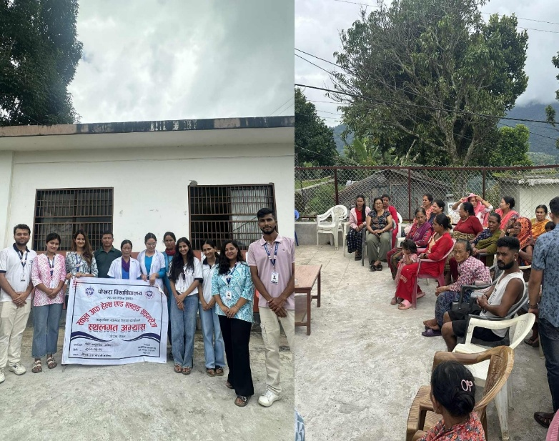
The final community presentation, held at the end of the CHD fieldwork, serves to summarize and share the activities, findings, and experiences of the one-month stay. It is an important program for disseminating results, reflecting on achievements, and engaging with community stakeholders.

Objectives
- To present the final findings of the CHD and outcomes of the MHP
- To summarize the entire CHD process reflecting the key achievements,
- To provide specific recommendations to the concerned stakeholders for addressing the health problems,
- To ensure active participation and feedback from community members and local stakeholders,
- To acknowledge and appreciate the continuous support and cooperation of community members, stakeholders, leaders and institutions during the CHD fieldwork.

Details of the program
Date of Program: 2082/03/26
Venue: Outside of Ward Office, Barpak Sulikot-04, Gorkha
After completion of all the activities of CHD as per the work plan, we planned for the third and final community assembly. We prepared the content for the presentation on the chart paper and newsprint. We present the mobility chart , seasonal chart, daily routine of the community members. We pre-informed all the stakeholders and community members for the assembly. The program was conducted under the chairmanship of Ms. Ritika Baskota (Group leader) and Mr. Sunem Gurung (ward member) was the chief guest for the program. Ward members, FCHVs, local leaders were present on the program.
S.N. | Description | Responsible member
1 | Program host | Resham Karki
2 | Welcome speech | Janak Gautam
3 | Introduction and objectives of CHD | Shailu Adhikari
4 | Major findings presentation | Savyata Neupane and Suchita Subedi
5 | FGD/KII related presentation | Janak Gautam
6 | SHP related presentation | Rasik Jamarkattel
7 | MHP related presentation | Sujita Subedi
8 | PRA tools | Dibya Mainali and Sachin Koirala
9 | Conclusion, recommendation and report submission | All member
10 | Speech | Sunem Gurung
11. | Conclusion and vote of thanks | Ritika Baskota

Discussion
Our study reveals several key findings when compare to national data. The average household size in our study is 4.06 which is slightly lower than the national average of 4.37 reported in the 2021 Census. Similarly, the sex ratio in our sample is 98.05 slightly surpassing the national figure of 95.59 this could be due to the smaller sample size. The literacy rate (68%) which is lower than the national rate of 76.2% according to Census 2021. Agriculture remained (64.4%) which is similar to population engaged in Farming compared to the national average of 66% as per World bank from 2022.
Health behaviors show stark differences as well, with only 16.5% of population using tobacco, sightly lower than 28.9% reported in the Nepal STEPS Survey 2019. Similarly, 13.9% of people consume alcohol, which is slightly lower compared to the national figure of 23.9%. In terms of maternal health, 93.8% had at least four antenatal care (ANC) visits, which is higher to 81% reported in NDHS 2022. Institutional delivery is notably high in our study, with 86% of women giving in health facilities, compared to the national average of 79%. 59% Under 5 children mother had received Postnatal Care (PNC) services.
Additionally, 85.3% of postpartum mothers took Vitamin A supplements, higher than the national figure of 76.3%. Immunization coverage is excellent, with 100% of children fully immunized according to the NIP schedule, exceeding the national average of 91.2%. Family planning usage among reproductive-age individuals is 55% which is higher compared to modern contraceptive prevalence rate (mCPR) of 27 % for Gandaki Province.
Regarding the infrastructure, 98% of household used tap water as their main source of drinking water, moderately higher than the 87.2% reported in Sulikot rural municipality 2021 Census, and 60% practiced water purification, primarily through boiling and filtration which is significantly higher than the national rate of 25%. Nearly all houses had toilets (98%), reflecting successful sanitation initiatives which is slightly above the 95.5% recorded in the 2021 Census. However, improper waste management burning (96%) or dumping—poses an environmental health concern.

Learning experience
The one-month residential Community Health Diagnosis (CHD) program serves as a vital bridge between theoretical public health education and practical application in real-world settings. Upon completion of the program, we gain valuable knowledge and skills in personal, professional, and academic domains.
Academic and Professional Development
The CHD program enhances our abilities to design and implement public health initiatives. Key skills acquired include setting objectives, developing tools, and finalizing methodologies. We learn to make informed decisions, negotiate with community members, and establish rapport with key stakeholders. The program provides foundational insights into successful community-level program execution, including social mapping and stakeholder engagement.
During the CHD, we develop practical skills in data collection, including gathering information from community members and preparing data entry sheets in EpiData. we also learn data management and analysis using SPSS. Through interaction with community members, we acquire techniques for creating institutional diagrams, seasonal calendars, daily routines, and community timelines. The program also equips us with qualitative research skills, such as conducting Focus Group Discussions (FGDs) and Key Informant Interviews (KIIs). These methods help identify the community’s real needs, enabling us to prioritize and address those issues. Moreover, we learn to conduct School Health Programs (SHPs) to educate and raise awareness among school-aged children and adolescents. The CHD emphasizes the implementation of community-based health interventions that are both time-efficient and cost-effective.
Personal Development
CHD fosters personal growth, particularly in teamwork and collaboration. We learn the importance of working effectively in groups to achieve common goals within set timelines. The experience of living in a rural community offers valuable insights into the local lifestyle, behaviours, and challenges faced by residents. Throughout the program, we refine their communication, coordination, and problem-solving skills. we learn to provide support to those in need, navigate difficult situations with empathy, and maintain politeness and professionalism in all interactions.

CONCLUSION AND RECOMMENDATION

Conclusion
The community health diagnosis conducted at Barpak Sulikot-04, Gorkha, revealed that the overall health status of the community is moderately satisfactory, yet with several areas needing improvement. The socio-demographic data showed that more than half of the families were nuclear in type, and almost two-thirds of the population depended primarily on agriculture as their main source of income.
In terms of disease awareness, more than half of the respondents had heard about common diseases such as tuberculosis, dengue, hypertension, gastritis, and diabetes, while less than half had knowledge about uterine prolapse and mental health, reflecting major gaps in awareness of certain conditions. Similarly, more than half of the respondents lacked proper knowledge about the prevention and management of communicable diseases such as diarrhoea and tuberculosis.
Regarding nutrition, more than half of the households were aware of balanced diets and the preparation of Sarbottam Lito, and almost all practiced breastfeeding and colostrum feeding. However, less than half of the families had sufficient food or income for more than six months of consumption, which highlights food security issues in the community.
In environmental health, almost all households used tap water as their drinking source, but less than two-thirds practiced water purification. More than four-fifths separated household waste, yet most relied on burning as the primary method of non-degradable waste disposal.
In maternal and child health, more than half of pregnant women had adequate ANC visits and institutional delivery, and almost all received iron supplementation. However, less than half had complete postnatal care as per the protocol. The immunization coverage of children and adolescent girls was almost universal, showing positive health service utilization.
In family planning, more than half of the respondents had heard about family planning and were using some form of contraceptive method, with Depo and sterilization being most common. However, less than half had comprehensive knowledge of possible side effects and proper use.
Overall, more than half of the households had satisfactory housing, lighting, and toilet facilities, but less than half had properly ventilated rooms or separate kitchens.
In conclusion, while the community demonstrates moderate awareness and practices regarding major health determinants, less than half of the population possesses adequate knowledge on several specific health topics. There is a clear need for continued community-based health education focusing on disease prevention, maternal and child health, nutrition, sanitation, and environmental hygiene. Strengthening health literacy and promoting behavioral changes through local health institutions and FCHVs would significantly enhance the overall health status of Barpak Sulikot-04.

Recommendations
Based on the findings and conclusions of the Community Health Diagnosis conducted at Barpak Sulikot-04, Gorkha, the following recommendations are proposed to improve the community’s overall health status:

To Ward Office
- Facilitate regular collaboration among health posts, schools, and community groups for awareness campaigns on sanitation, nutrition and disease prevention.
- Include health education and safe drinking water projects in local development plans.
- Strictly regulate and monitor open burning of household waste through local by-laws and awareness program to reduce air pollution and health problems.

To Health Post
- Conduct periodic outreach health education sessions on communicable and non-communicable disease (like tuberculosis, gastritis, hypertension and diabetes).
- Integrate mental health education in outreach programs.
- Address major NCDs like HTN and diabetes through periodic health screening programs.
- Provision of Laboratory Services in Health Post

To local people
- Maintain a balanced diet and engage in regular physical activities.
- Implement the practice of boiling water for drinking

REFERENCES
- National Population and Housing Census 2021, Central Bureau of Statistics. Government of Nepal, Available from: https://unstats.un.org/unsd/demographicsocial/census/documents/Nepal/Nepal-Census-2021-Vol1.pdf
- Population pyramid of Nepal at 2022, Available from: https://populationpyramid.net/en/pp/nepal
- Preliminary Report of National Population Census 2021, Available from:https://censusnepal.cbs.gov.np/Home/Details?tpid=1&dcid=0f011f13-7ef6-42dd-9f03-c7d309d4fca3
- Annual Report. Department of Health Services, MoHP, Government of Nepal, 2080/81, Available from: https://dohs.gov.np/wp-content/uploads/2021/07/DoHS-
Annual-Report-FY-2080-81-for-website.pdf
- Report, MoHP and New Era. Nepal Demographic Health Survey, 2022, Available from: https://www.dhsprogram.com/pubs/pdf/fr336/fr336.pdf
- Barpak Sulikot Rural Municipality, Gorkha. Available from: https://barpaksulikotmun.gov.np/
- Multiple Indicator Cluster Survey 2019, Central Bureau of Statistics. Government of Nepal, Available from: https://www.unicef.org/nepal/media/9076/file/NMICS_2019__Key_findings.pdf
- Non-communicable diseases risk factors STEPS survey Nepal 2019. Nepal Health Research Council, Government of Nepal, Available from:https://www.who.int/docs/default-source/nep documents/ncds/ncd-stepssurvey-2019compressed.pdf?sfvrsn=807bc4c6_2
- Epi-Data Mannual, Available from: http://www.epidata.dk/downloads/epidataguideziad.pdf
- SPSS Mannual, Available from: https://www.ibm.com/docs/en/SSLVMB_25.0.0/pdf/en/IBM_SPSS_Statistics_Br ief_Guide.pdf
- WHO Anthroplus, Available from: https://www.who.int/tools/growth-referencedata-for-5to19-years/application-tools
- QGIS for map location, Available from: https://qgis.org/

Annexure

Annex 1: Questionnaires
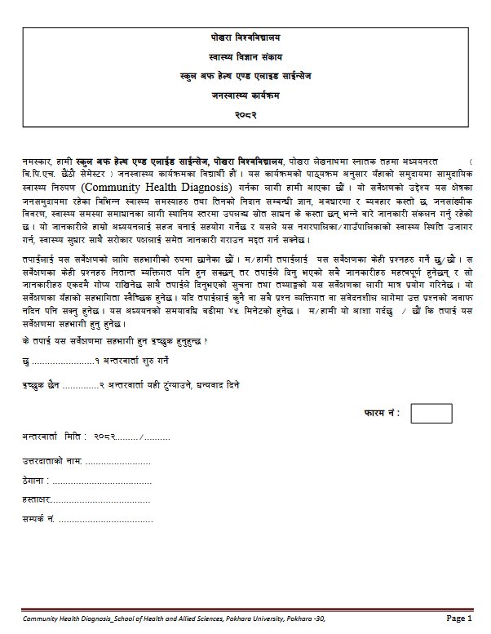

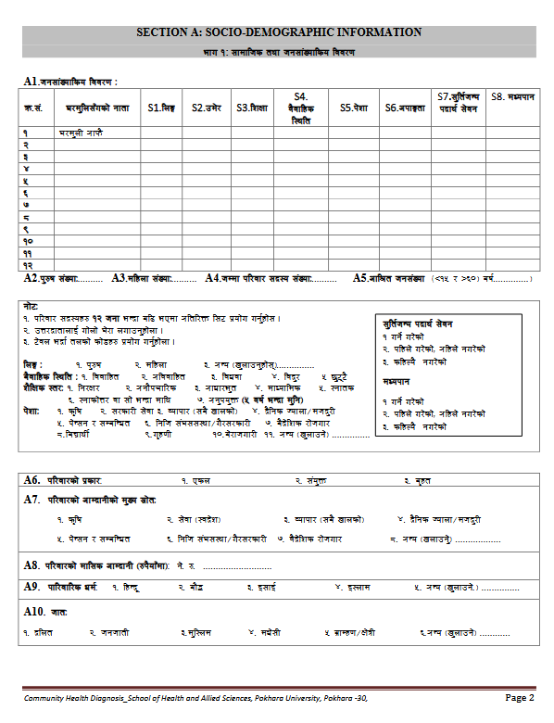

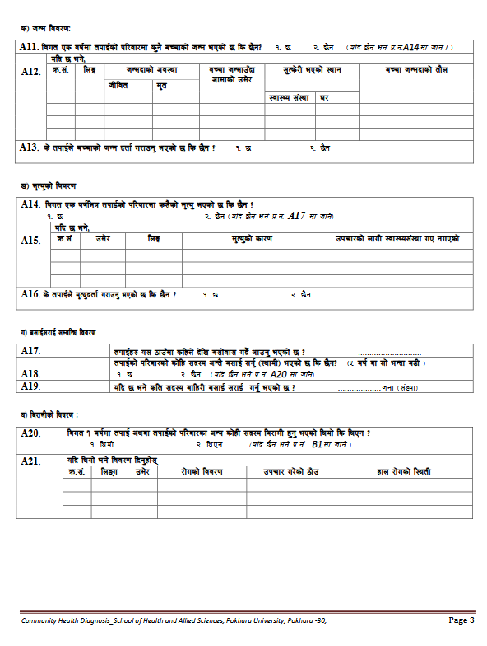
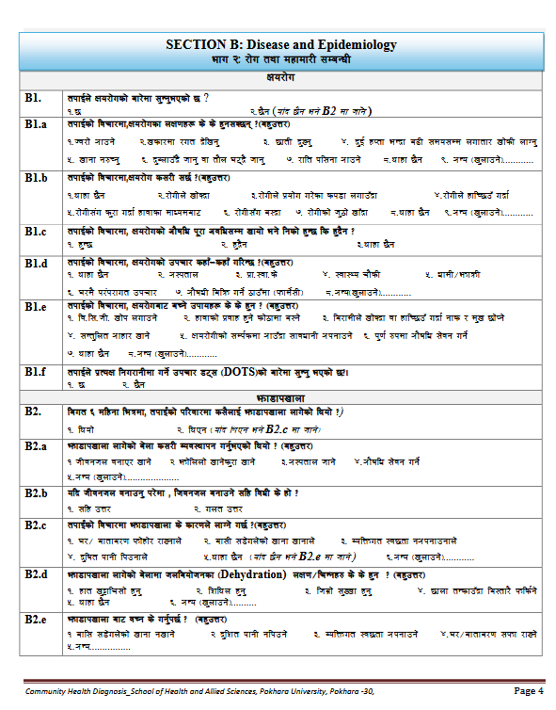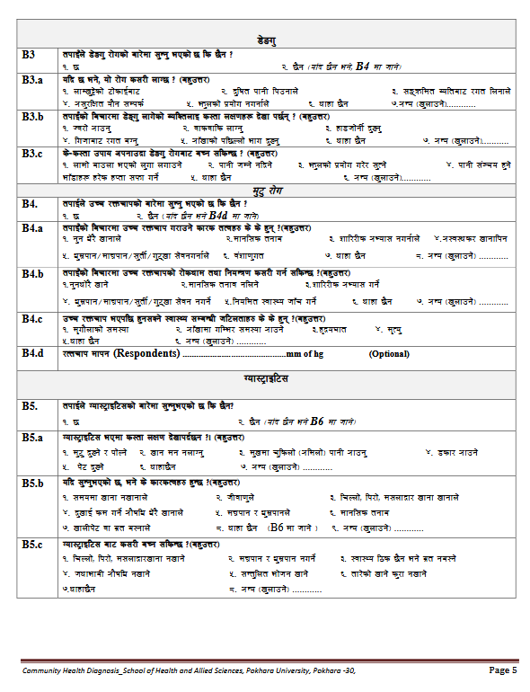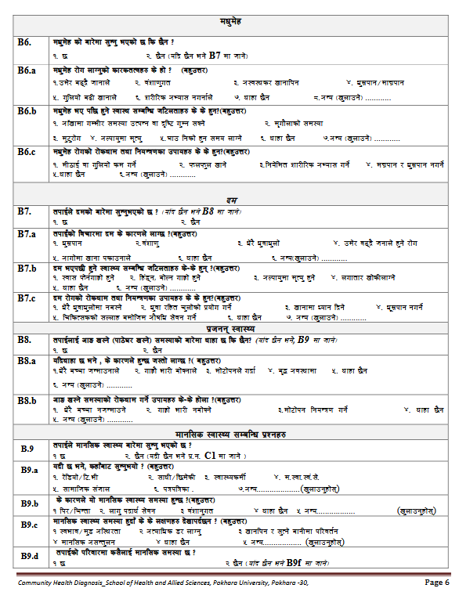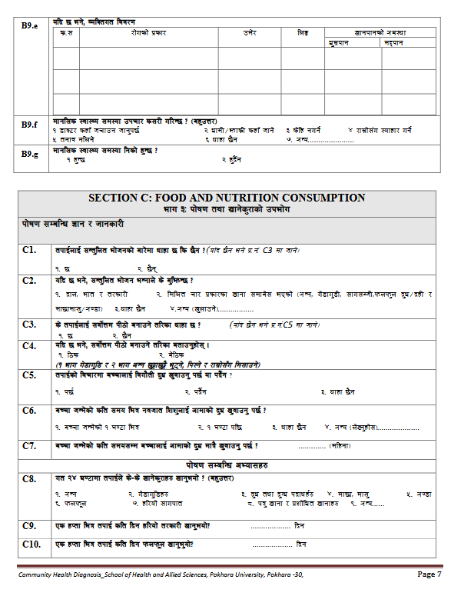

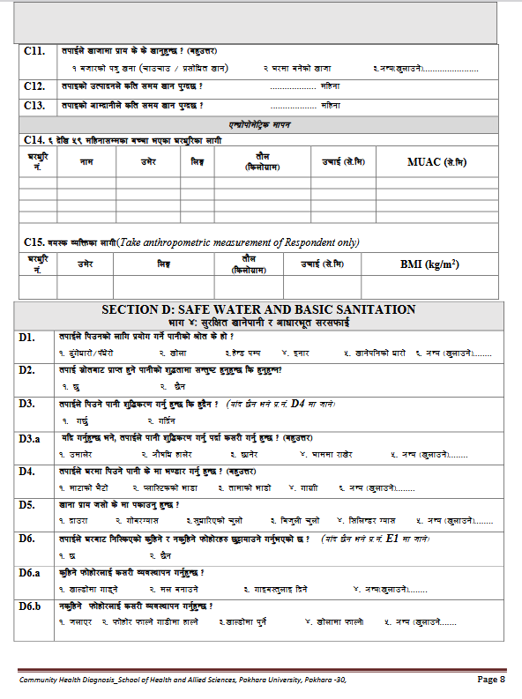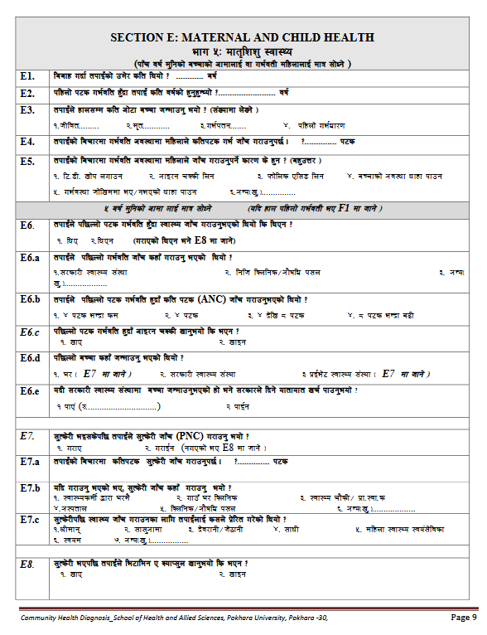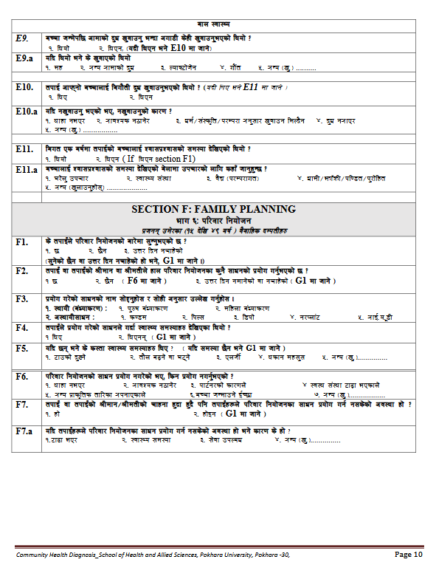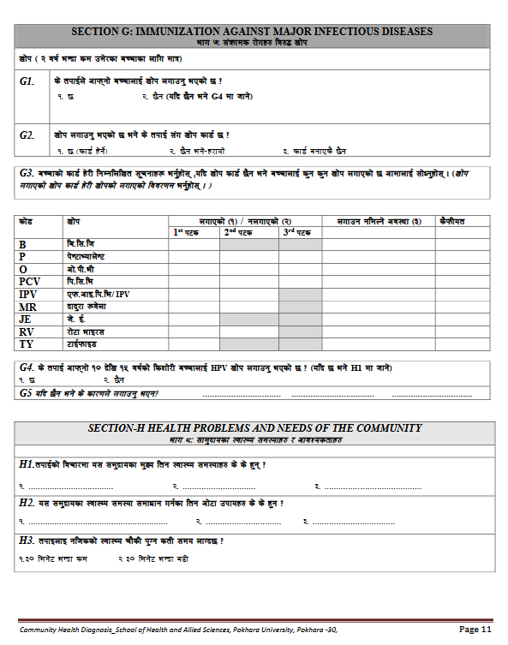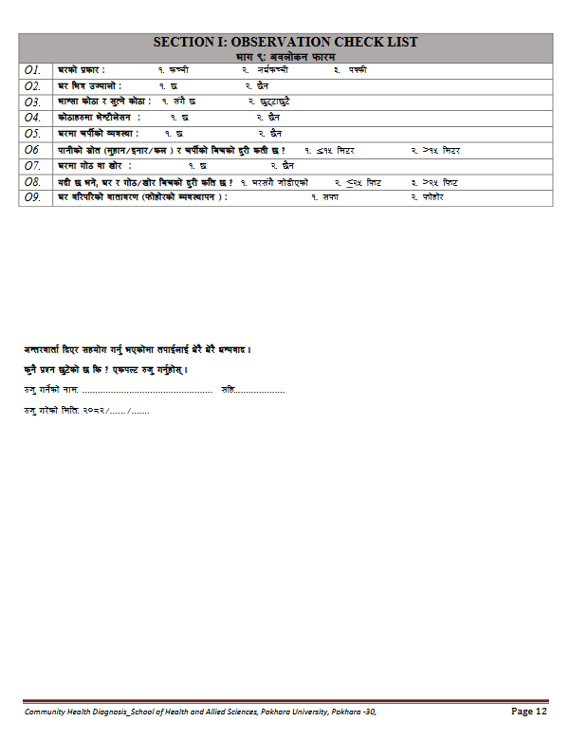

Annex 2: Workplan
S.N. | Activities |  |  |  |  |  |  |  |  |  |  |  |  |  | Jun 2025 |  |  |  |  |  |  |  |  |  |  |  |  |  |  |  |  |  |  | Jul-25
S.N. | Activities | 3 | 4 | 5 | 6 | 7 | 8 | 9 | 10 | 11 | 12 | 13 | 14 | 15 | 16 | 17 | 18 | 19 | 20 | 21 | 22 | 23 | 24 | 25 | 26 | 27 | 28 | 29 | 30 | 1 | 2 | 3 | 4 | 5 | 6 | 7 | 8 | 9
1 | CHD orientation Workshop (Tool development, Rapport building, Social mapping, Epidata, SPSS, and EXCEL Training, Pretesting)
2 | Preparation for CHD field Practices (Required logistics arrangement, tool finalization and printing
3 | Departure from college to community
4 | Site Visit ( Transect Walk), Rapport building
5 | Preparation of First Community Assembly
6 | First Community Assembly (Objective Sharing, Social mapping)
7 | Data Collection
8 | Data Entry and Analysis
9 | Preparation for Second Community Assembly
10 | Second Community Assembly
11 | Need Prioritization, Planning and development of implementation, monitoring and evaluation plan for MHP
12 | Conduction , Monitoring, and Evalution of MHP
13 | Preparation for Final Community Assembly
14 | Final Community Assembly
15 | Preparation for departure from Community to College
16 | Departure from Community to College

Annex 3: Request letter from college to ward
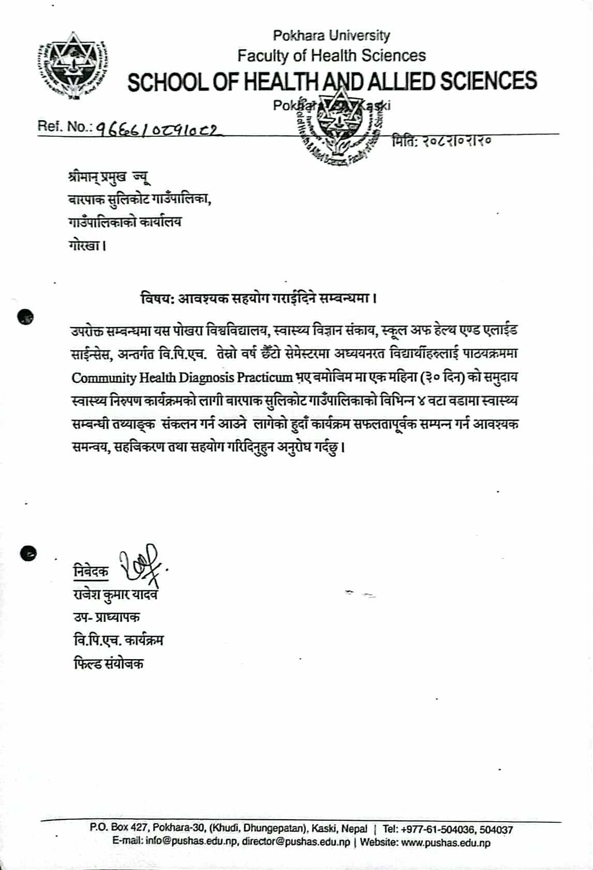

Annex 4: CHD completion/Appreciation letter from ward
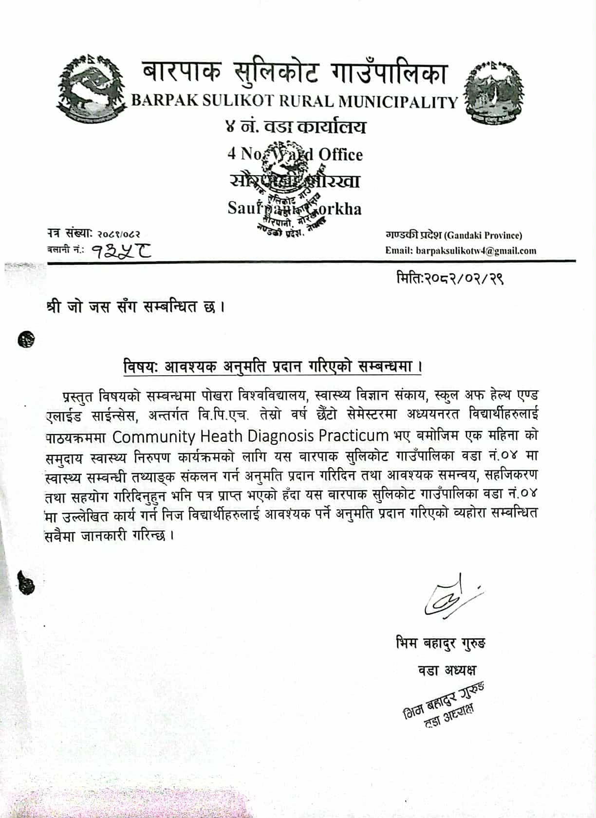

Annex 5: Minuting
1.Social Mapping and First Community Assembly
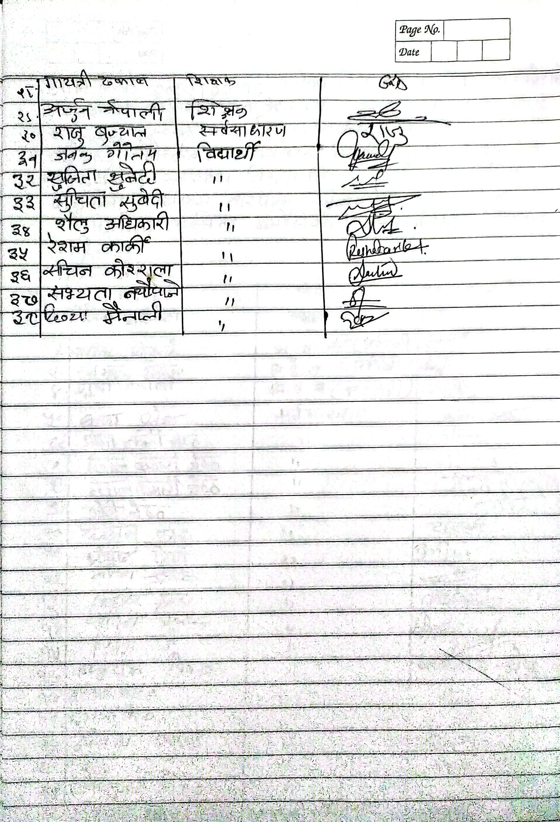
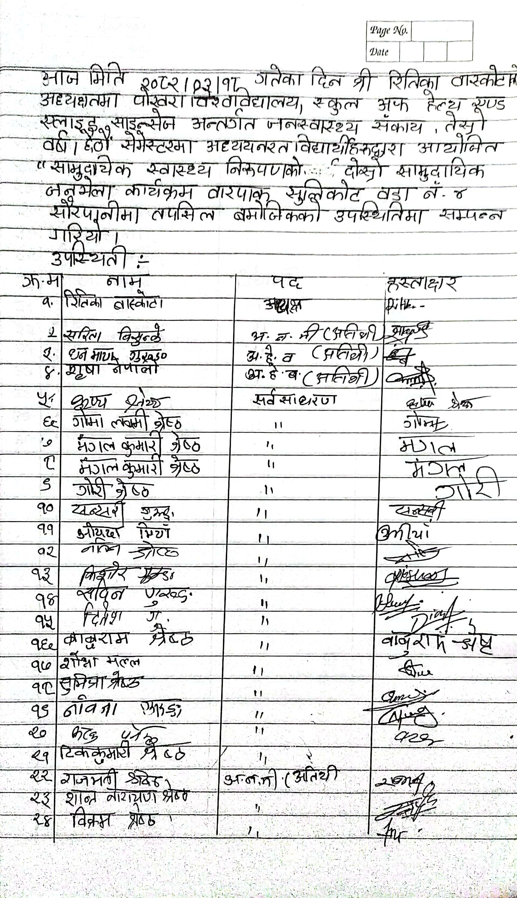
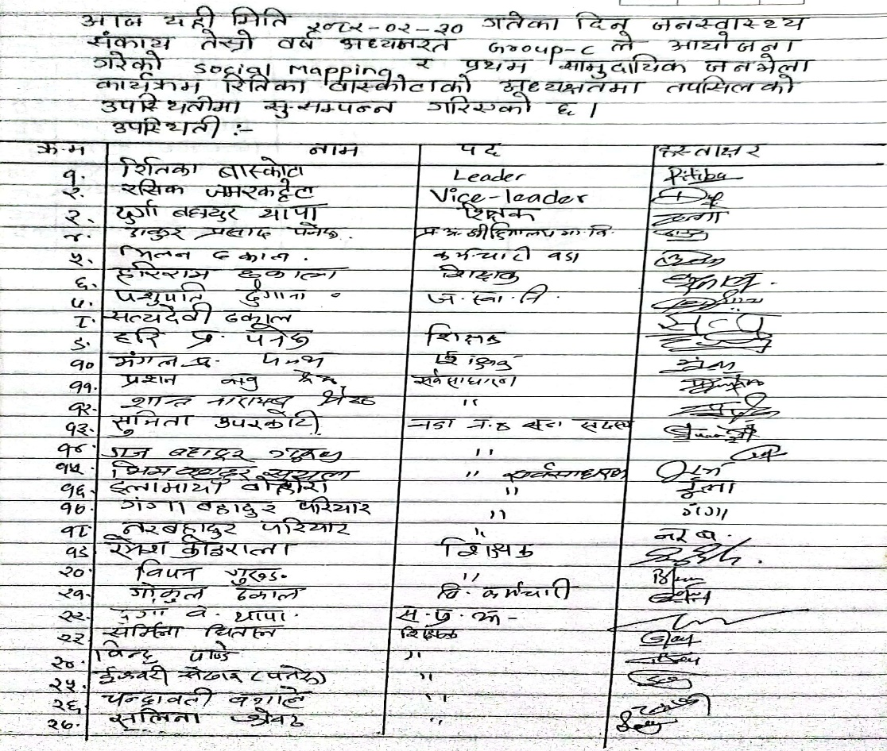
2.Second Community Assembly
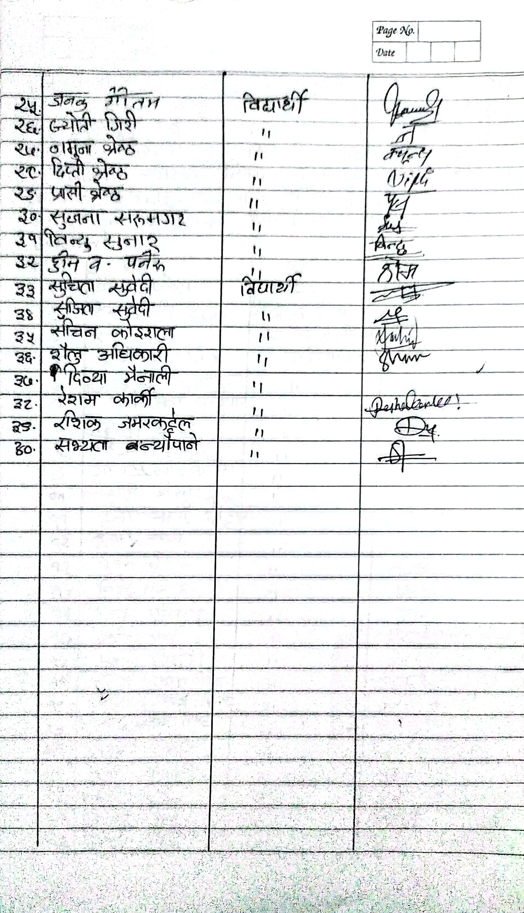
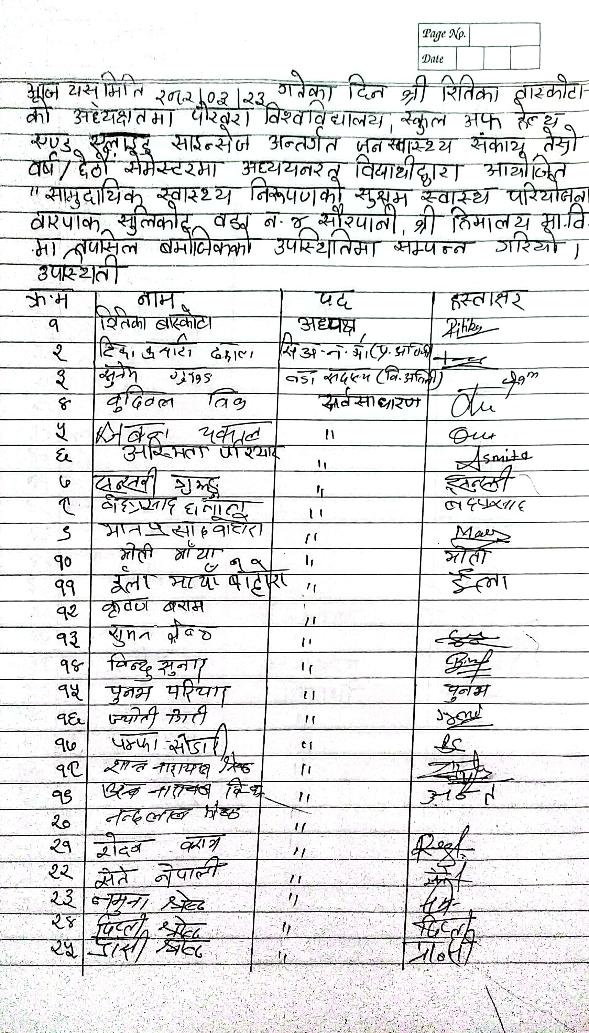
3.Micro Health Project
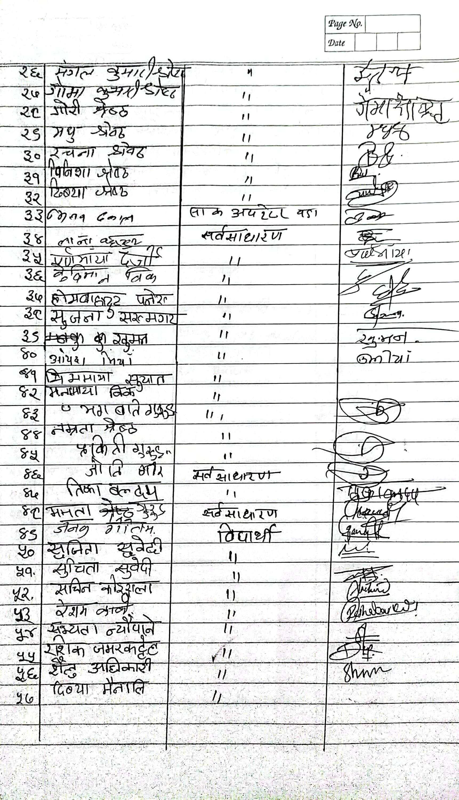
4. Third Community Assembly
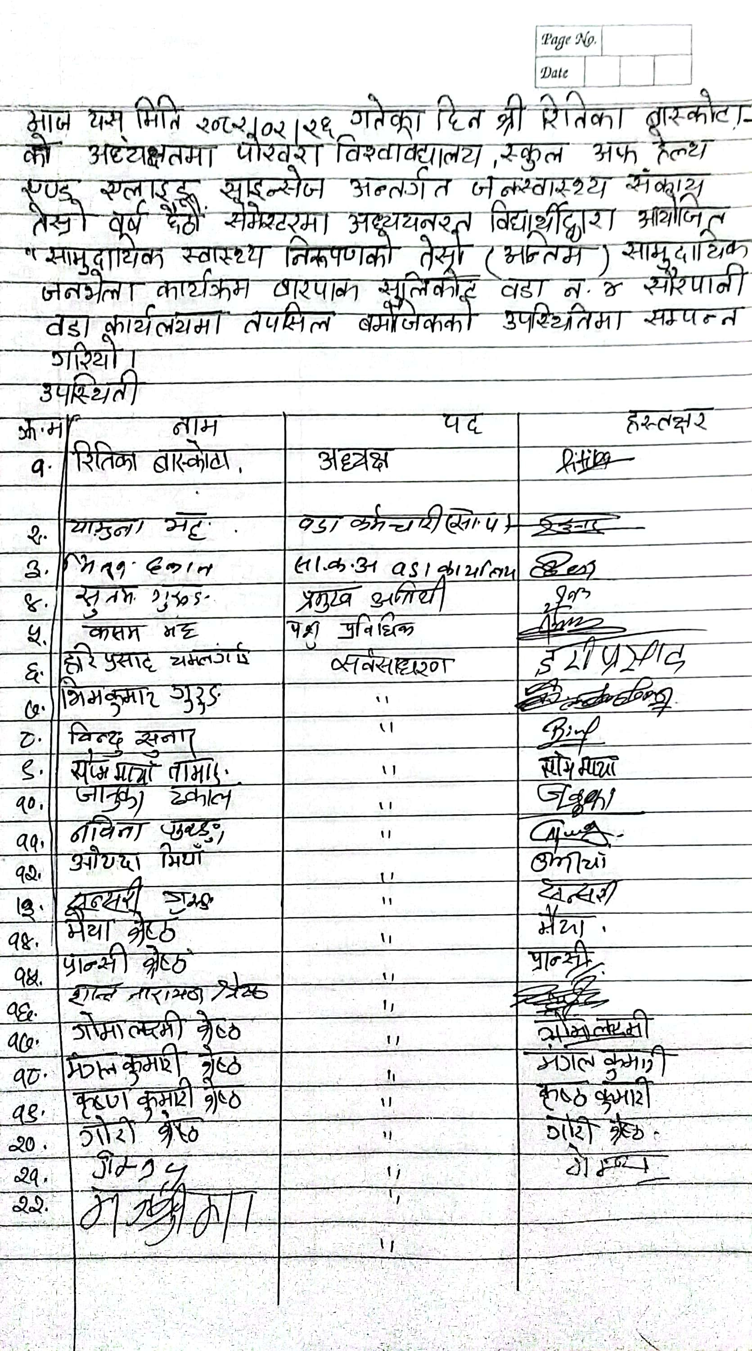
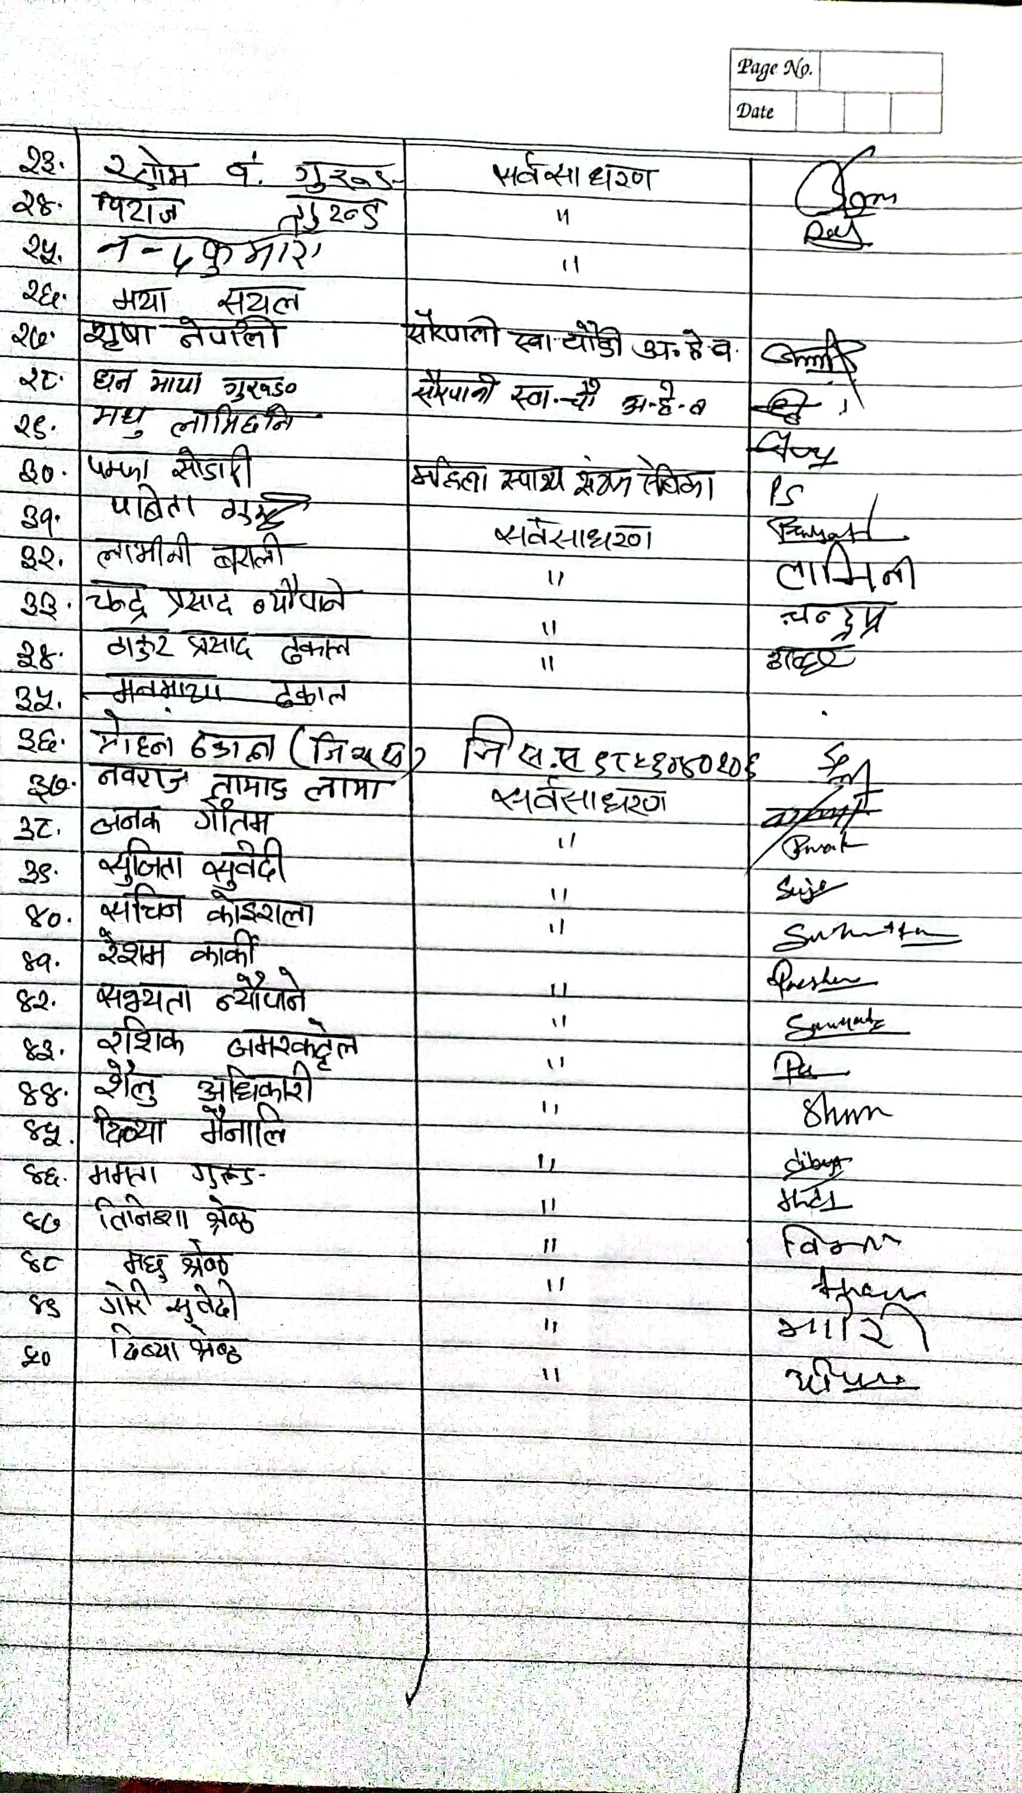

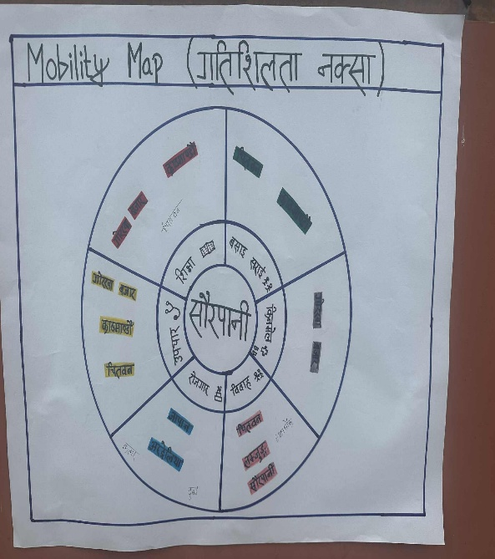
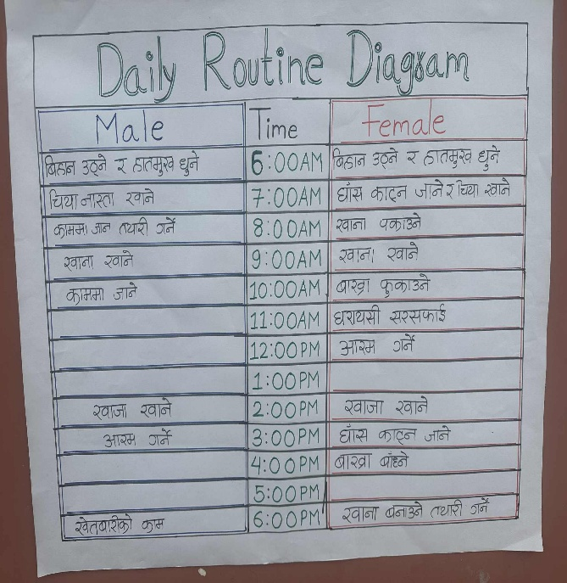
Annex 6: PRA/PLA tools

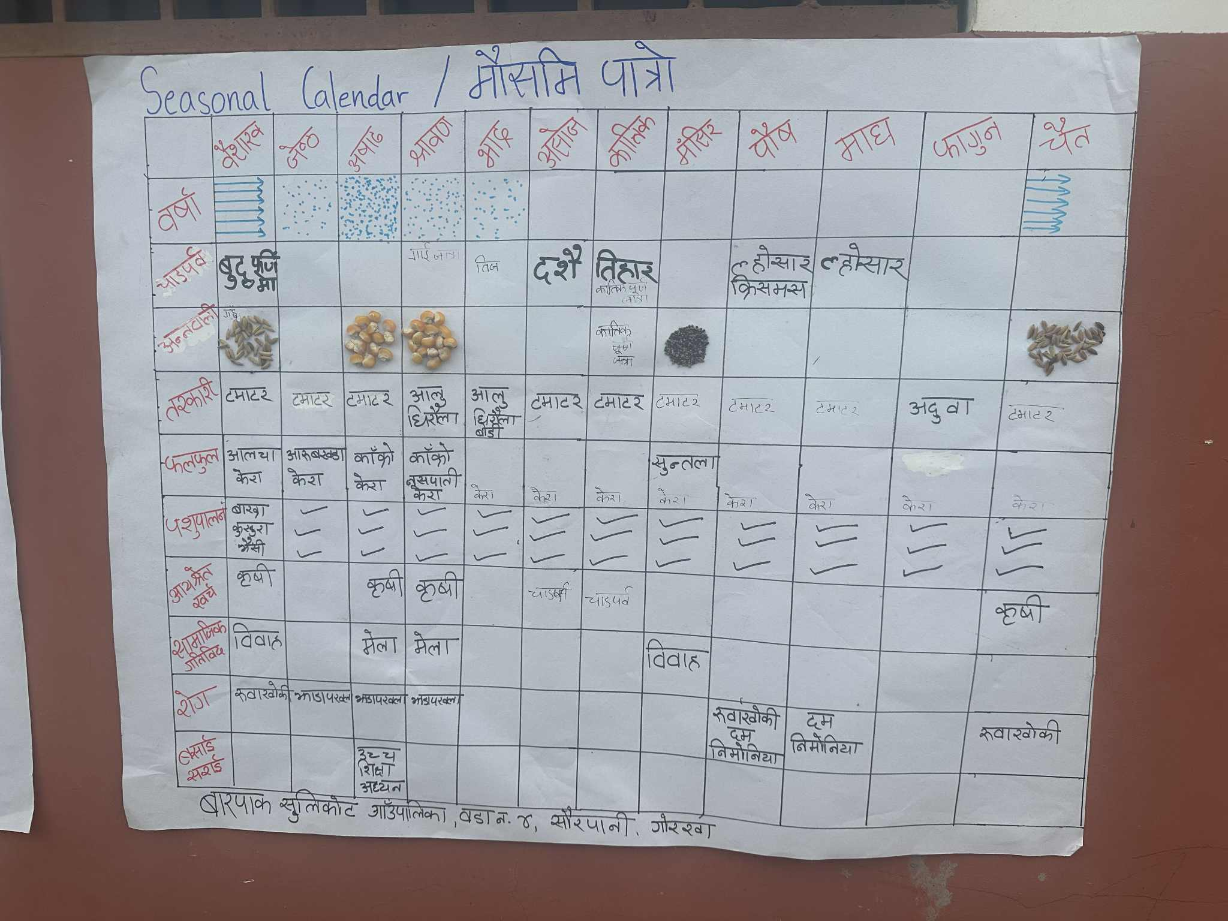
Mobilty map
Daily routine Calendar

Seasonal Callender

Map of Barpak Sulikot-04,Gorkha
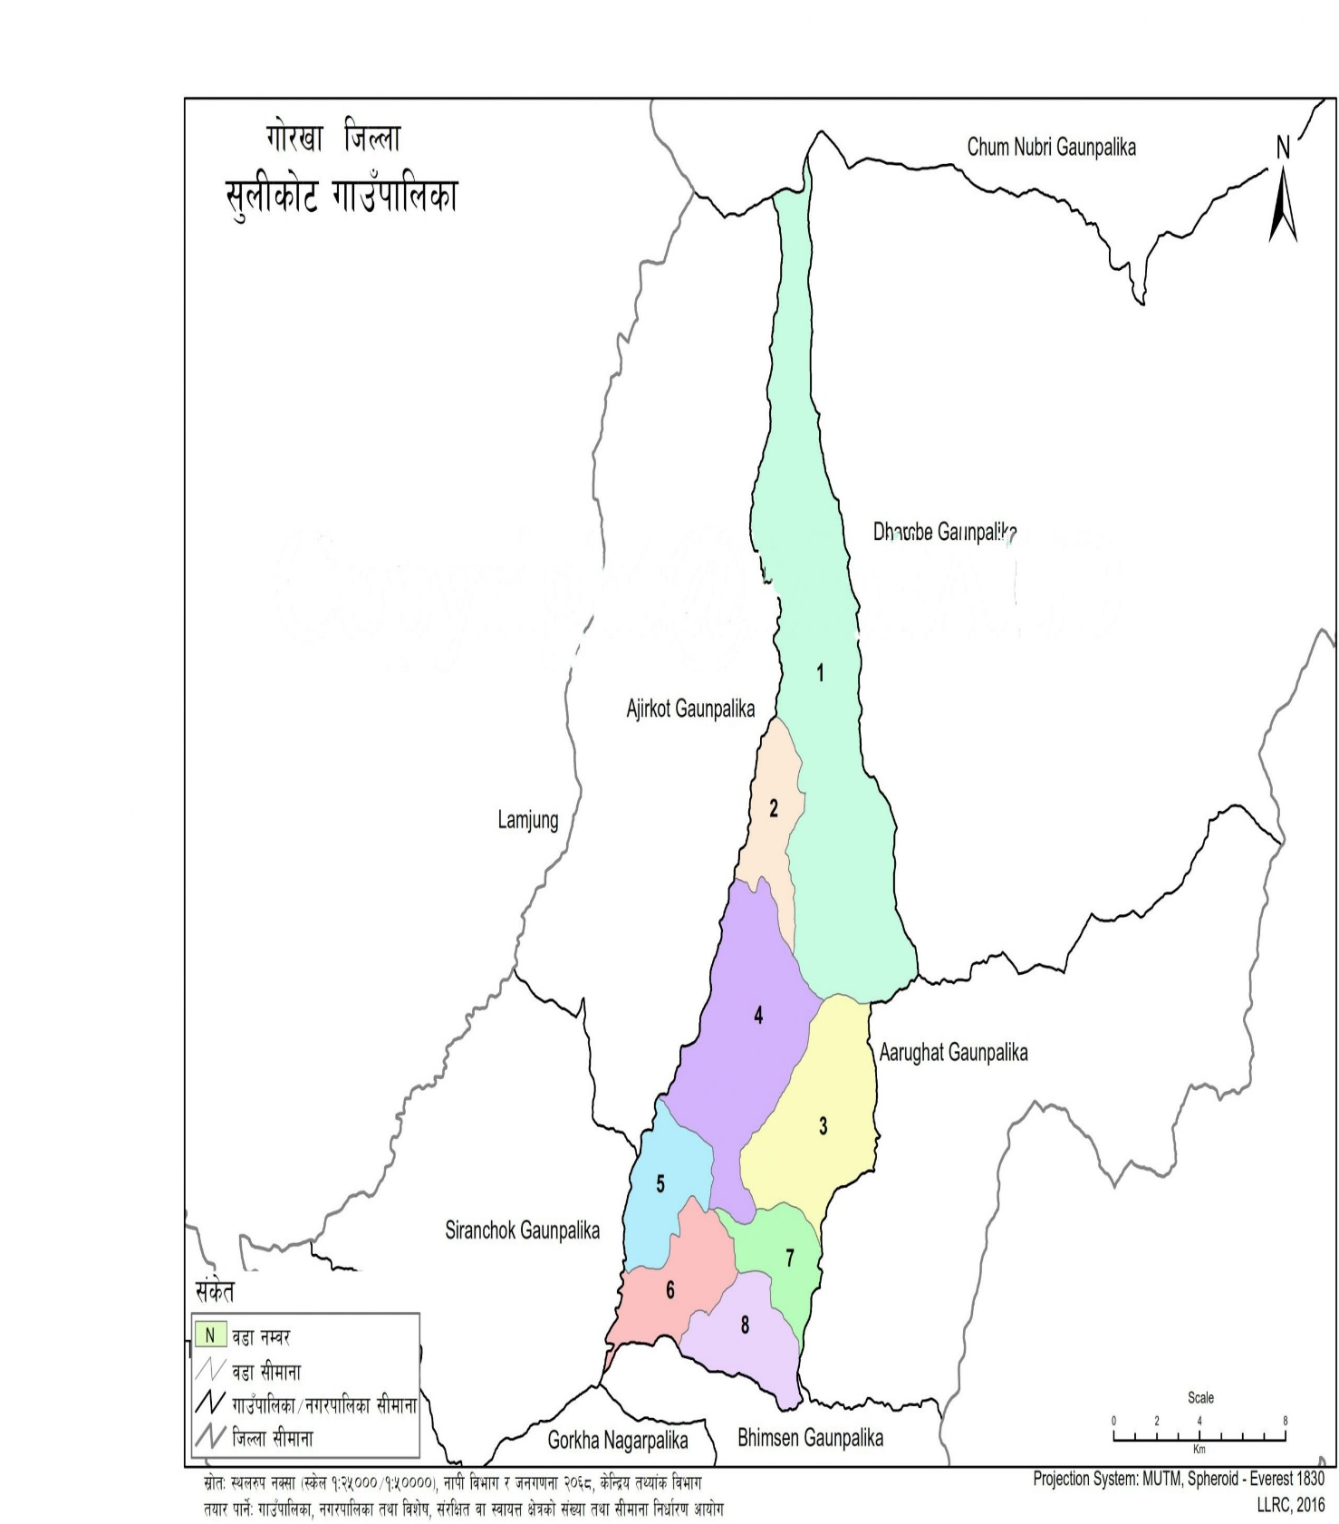
4

Barpak Sulikot-04, Gorkha

Annex 7: Photographs
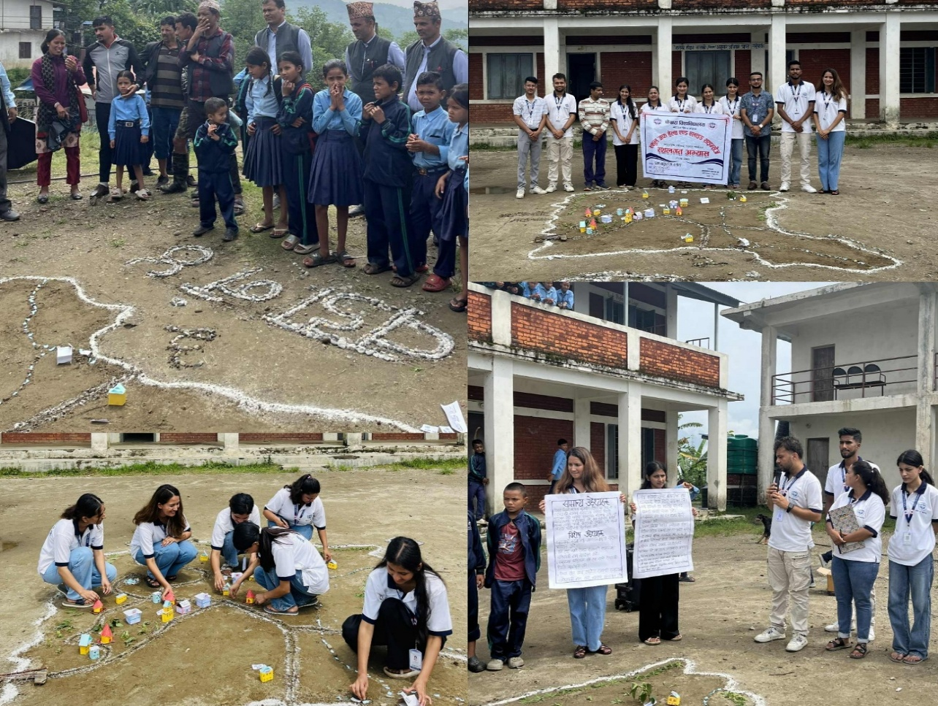
Image 1: Social Mapping and First Community assembly
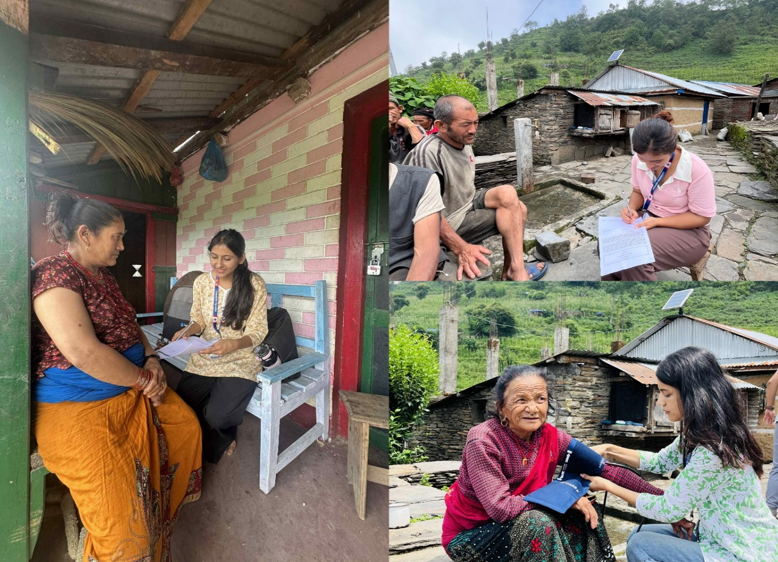
Image 2: Data Collection
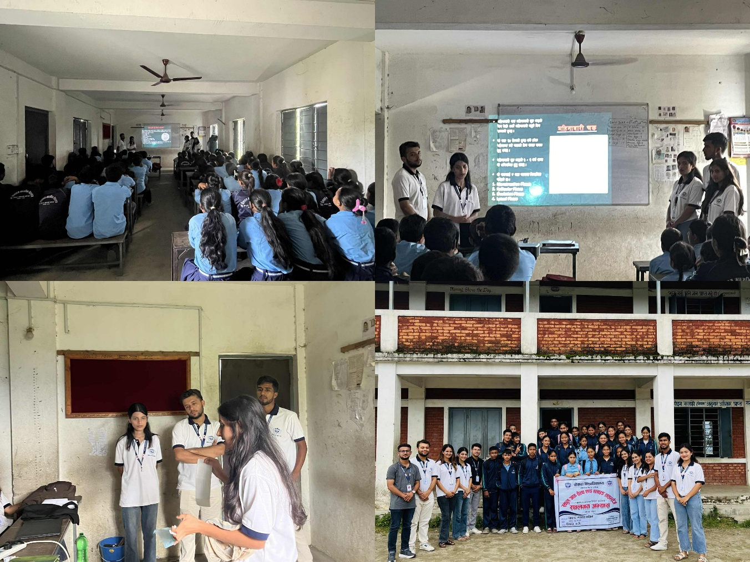
Image 3: School Health Program
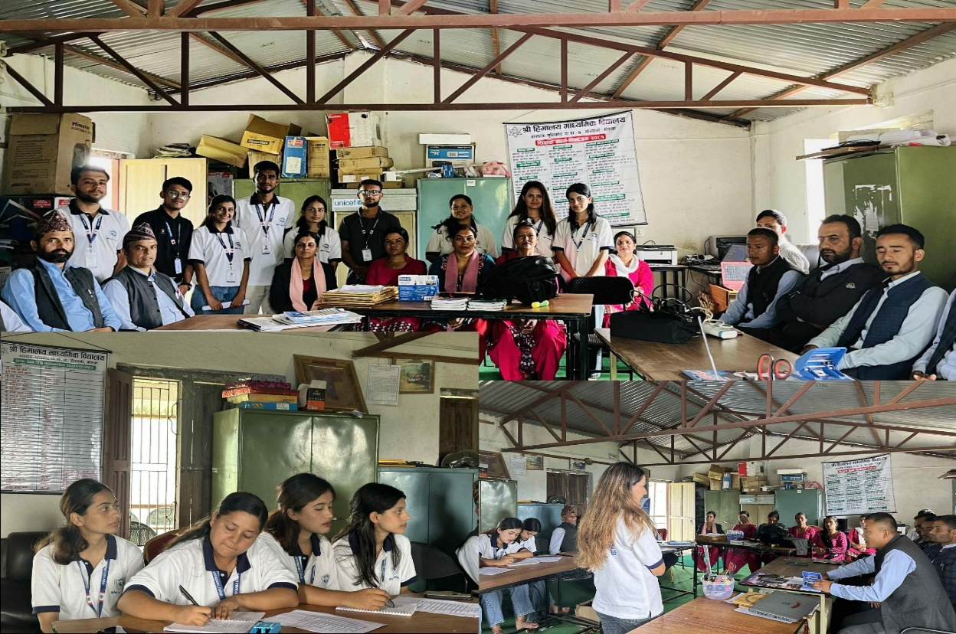
Image 4: Focal Group Discussion
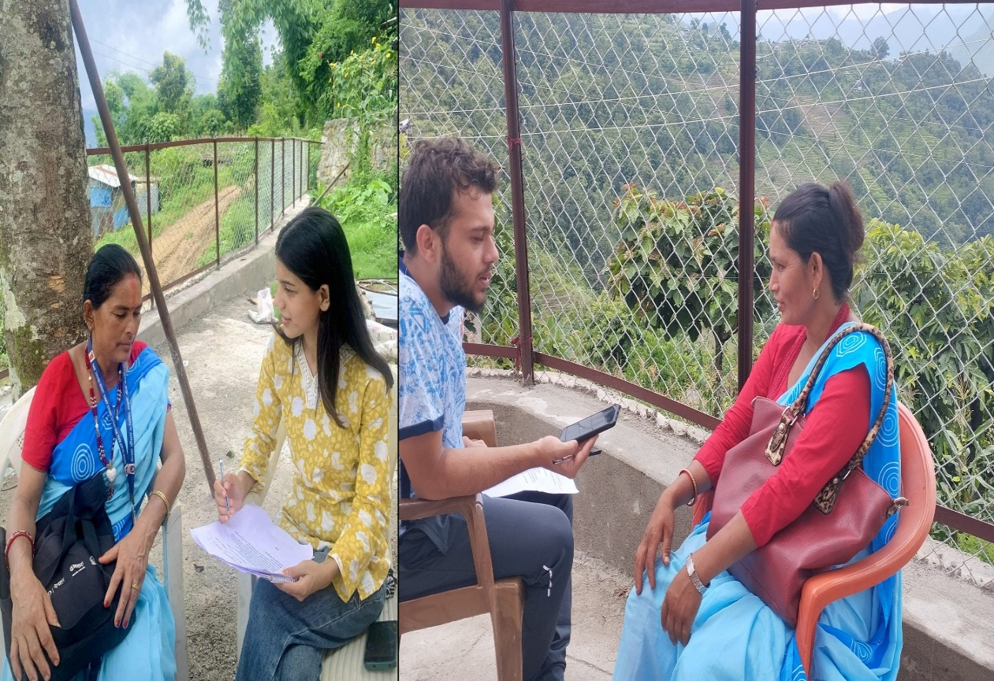
Image 5: KII
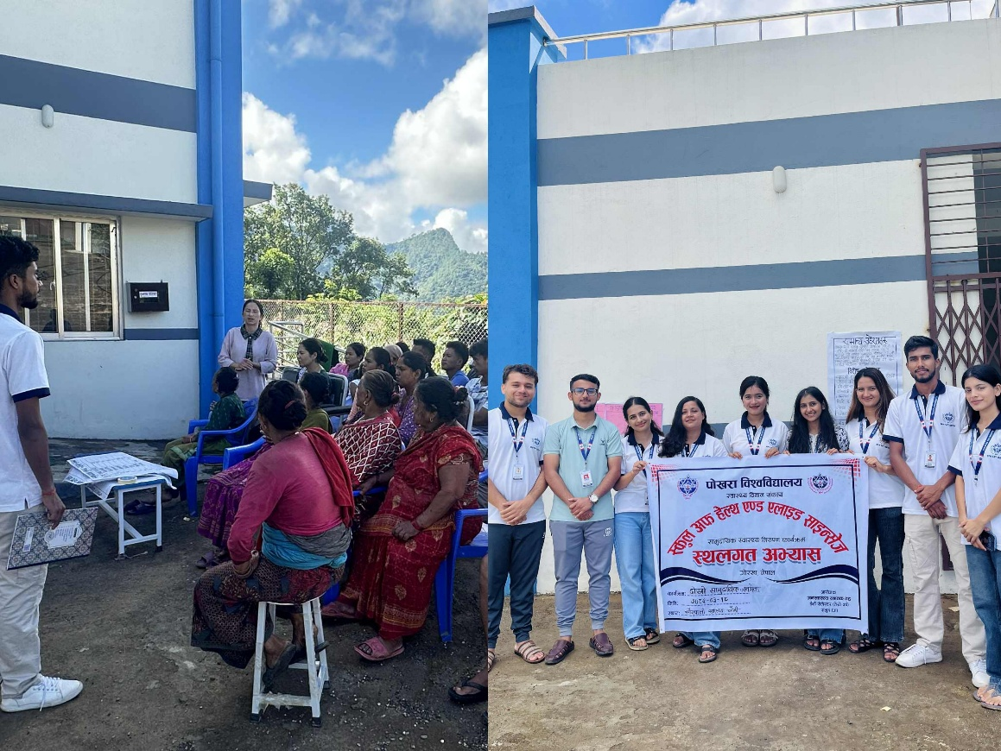
Image 6: Second Community Assembly and need priotization

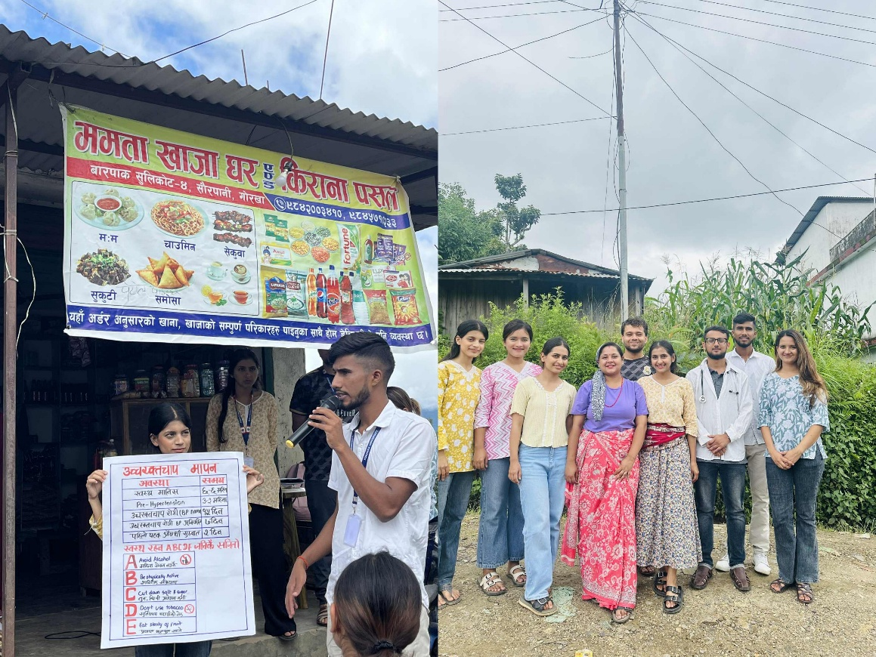
Image 7: MHP
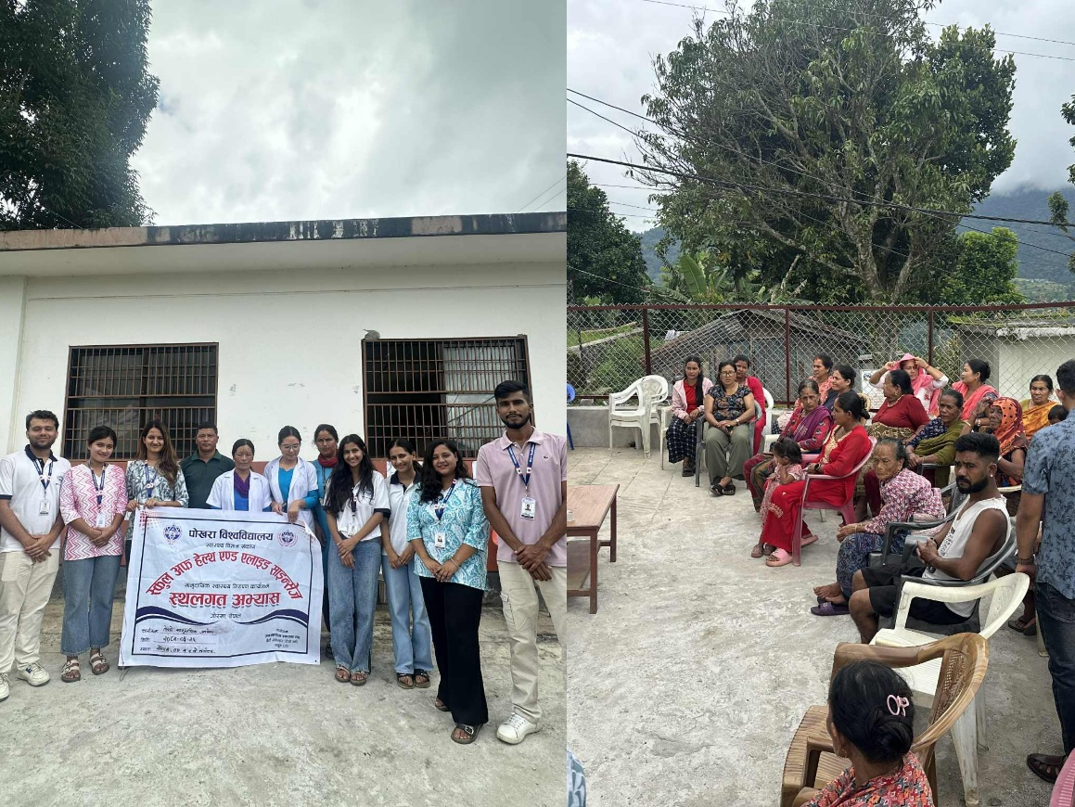
Image 8: Final Community Assembly

