SDG 3 TARGETS AND INDICATORS FOR NEPAL (2014–2030)

At the United Nations Sustainable Development Summit on 25 September 2015, world leaders adopted the 2030 Agenda for Sustainable Development, which includes a set of 17 Sustainable Development Goals (SDGs) to end poverty, fight inequality and injustice, and tackle climate change by 2030.
The Sustainable Development Goals, otherwise known as the Global Goals, build on the Millennium Development Goals, eight anti-poverty targets that the world is committed to achieving by 2015. The MDGs, adopted in 2000, aimed at an array of issues that included slashing poverty, hunger, disease, gender inequality, and access to water and sanitation. Enormous progress has been made on the MDGs, showing the value of a unifying agenda underpinned by goals and targets. Despite this success, the indignity of poverty has not been ended for all.

SDG 3: Ensure healthy lives and promote well-being for all at all ages
TARGETS
3.1 By 2030, reduce the global maternal mortality ratio to less than 70 per 100,000 live births
3.2 By 2030, end preventable deaths of newborns and children under 5 years of age, with all countries aiming to reduce neonatal mortality to at least as low as 12 per 1,000 live births and under-5 mortality to at least as low as 25 per 1,000 live births
3.3 By 2030, end the epidemics of AIDS, tuberculosis, malaria and neglected tropical diseases and combat hepatitis, water-borne diseases and other communicable diseases
3.4 By 2030, reduce by one third premature mortality from non-communicable diseases through prevention and treatment and promote mental health and well-being
3.5 Strengthen the prevention and treatment of substance abuse, including narcotic drug abuse and harmful use of alcohol
3.6 By 2020, halve the number of global deaths and injuries from road traffic accidents
3.7 By 2030, ensure universal access to sexual and reproductive health-care services, including for family planning, information and education, and the integration of reproductive health into national strategies and programmes
3.8 Achieve universal health coverage, including financial risk protection, access to quality essential health-care services and access to safe, effective, quality and affordable essential medicines and vaccines for all
3.9 By 2030, substantially reduce the number of deaths and illnesses from hazardous chemicals and air, water and soil pollution and contamination
3.a Strengthen the implementation of the World Health Organization Framework Convention on Tobacco Control in all countries, as appropriate
3.b Support the research and development of vaccines and medicines for the communicable and non-communicable diseases that primarily affect developing countries, provide access to affordable essential medicines and vaccines, in accordance with the Doha Declaration on the TRIPS Agreement and Public Health, which affirms the right of developing countries to use to the full the provisions in the Agreement on Trade-Related Aspects of Intellectual Property Rights regarding flexibilities to protect public health, and, in particular, provide access to medicines for all
3.c Substantially increase health financing and the recruitment, development, training and retention of the health workforce in developing countries, especially in least developed countries and small island developing States
3.d Strengthen the capacity of all countries, in particular developing countries, for early warning, risk reduction and management of national and global health risks

SDG Targets and Indicators for Nepal (2014–2030)
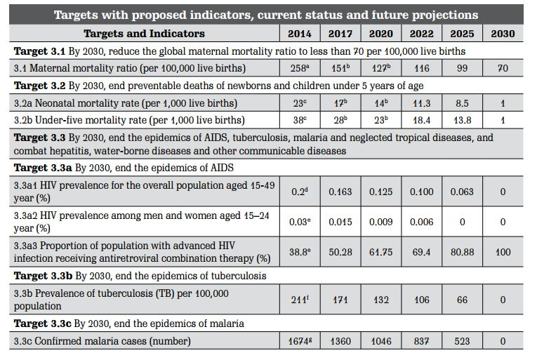
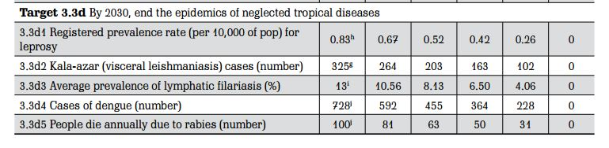
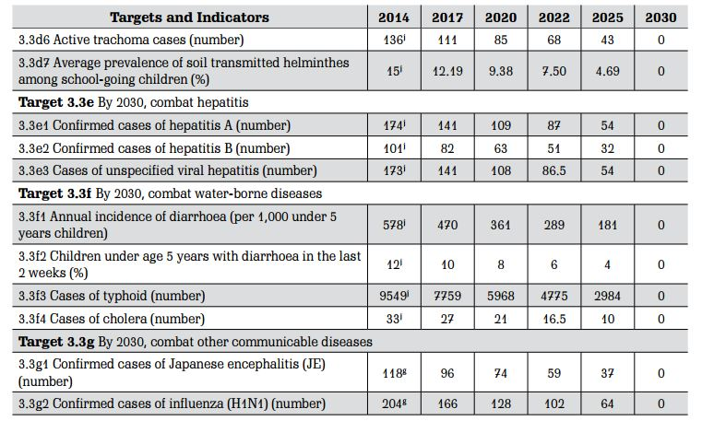
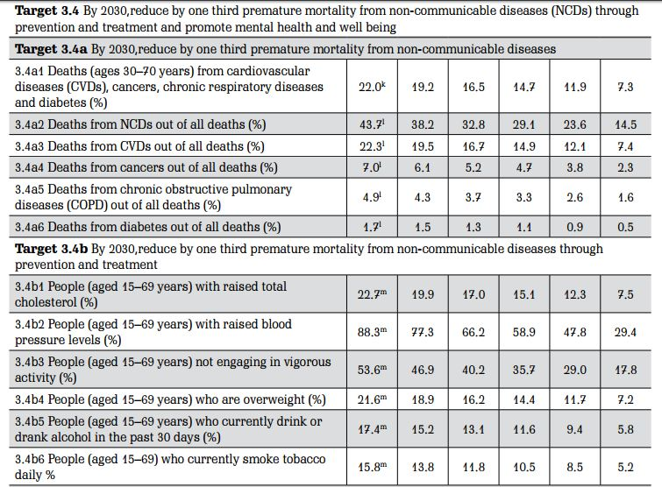
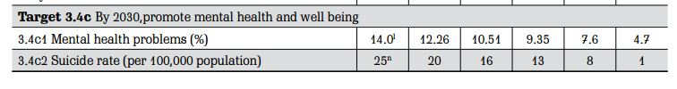
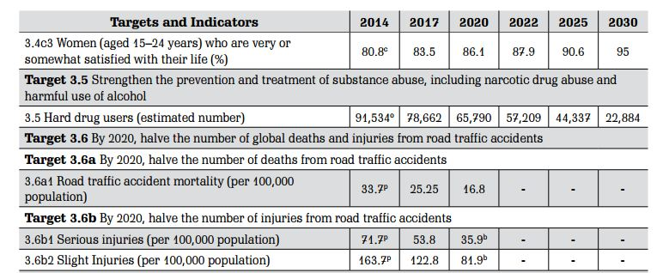
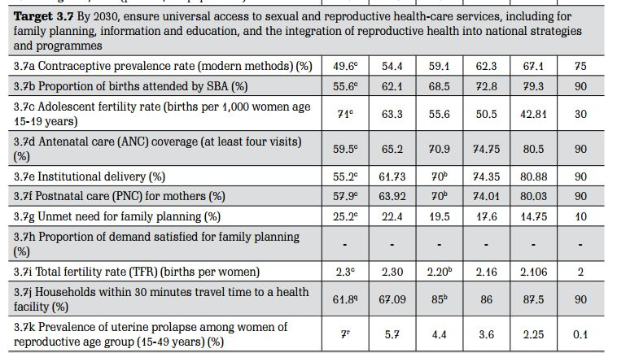
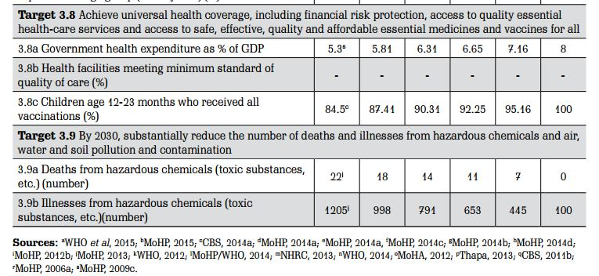
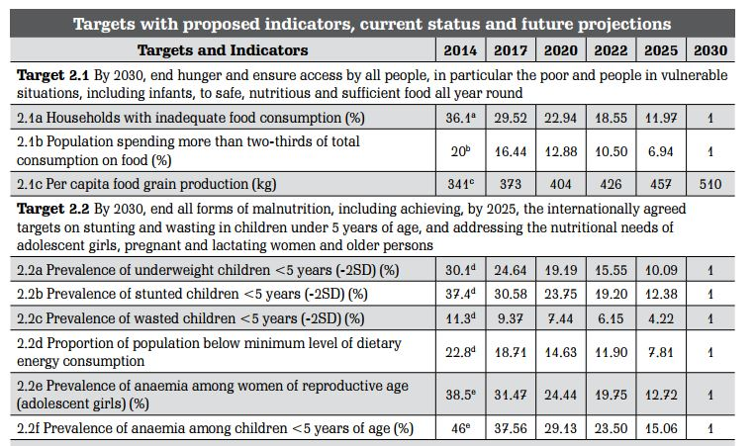
SOURCE: Sustainable Development Goals2016-2030 National (Preliminary) Report

