Unit IV: Climate Change
8 hrs

4.1 Concept of climate and weather
Weather of an area is the total physical conditions of the lower atmosphere over the area for hours or days as can be measured as temperature, precipitation, humidity, direction and speed of wind, cloud cover, sunshine and others.
Climate is a region’s general pattern of atmospheric or weather pattern over a long time (decades or centuries). Climate is what we expect for the atmospheric condition and weather is what we experience at the time. Temperature and precipitation are the two major factors determining climate, along with closely related factors of latitude, elevation, slope amount and slope aspect.
Solar Energy and Global Air Circulation
Many factors contribute to a local climate, including the amount of solar radiation reaching the area, the earth’s daily rotation and annuyal path around the sun, air circulation over the earth’s surface, the global distribution of land masses and water bodies, the circulation of ocean currents, and the elevation of land masses.
Four major factors determine global air circulation patterns. The first factor is the uneven heating of the earth’s surface by the sun. Air is heated much more at the earth’s flattest part, the equator, where the sun’s rays strike directly, than at poles, where sunlight strikes at a slanted angle and spreads out over a much larger area.
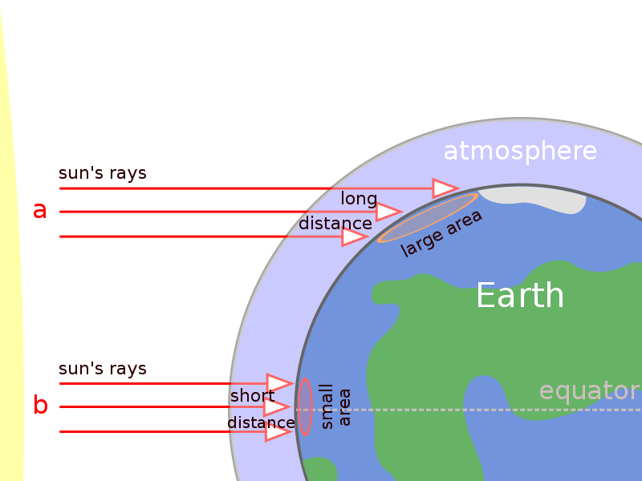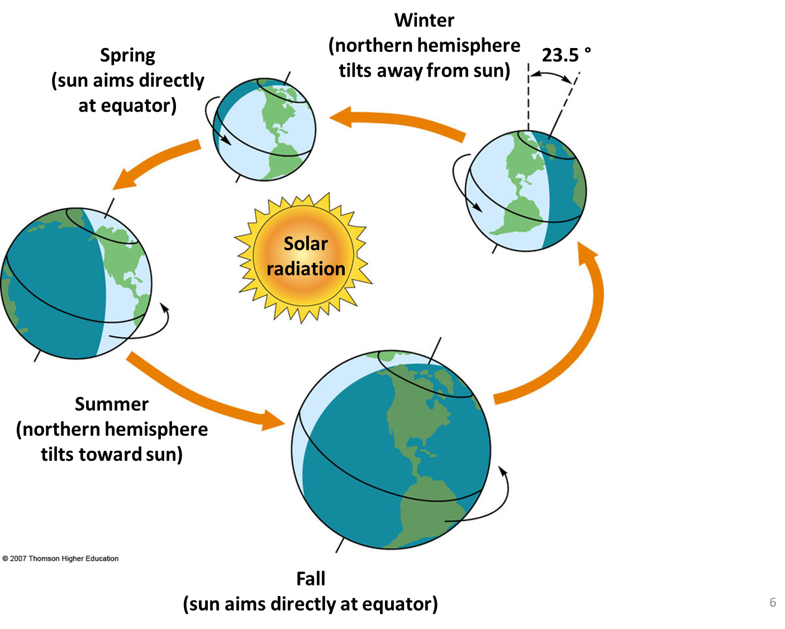
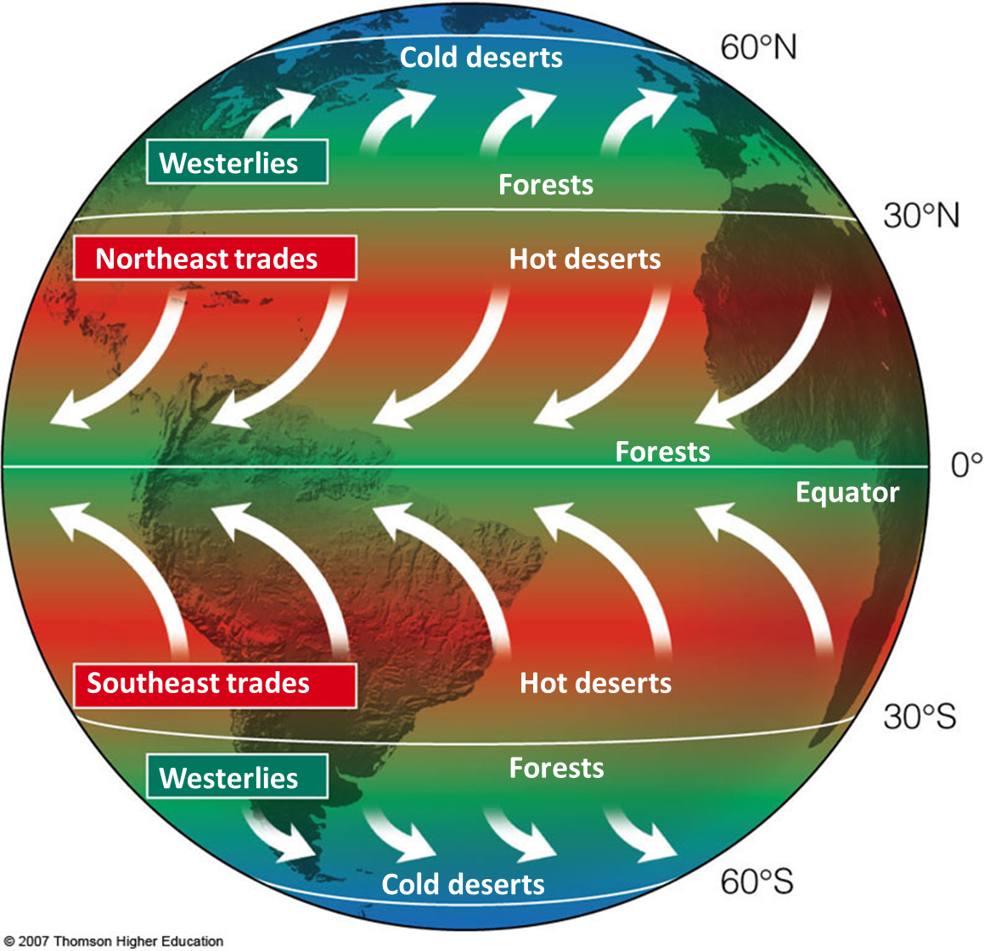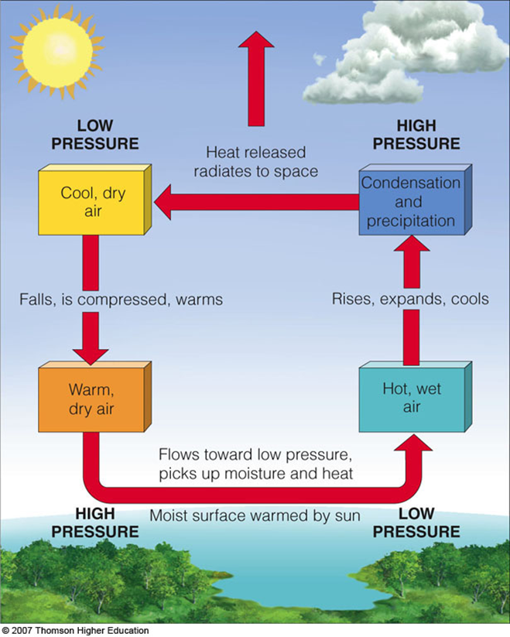

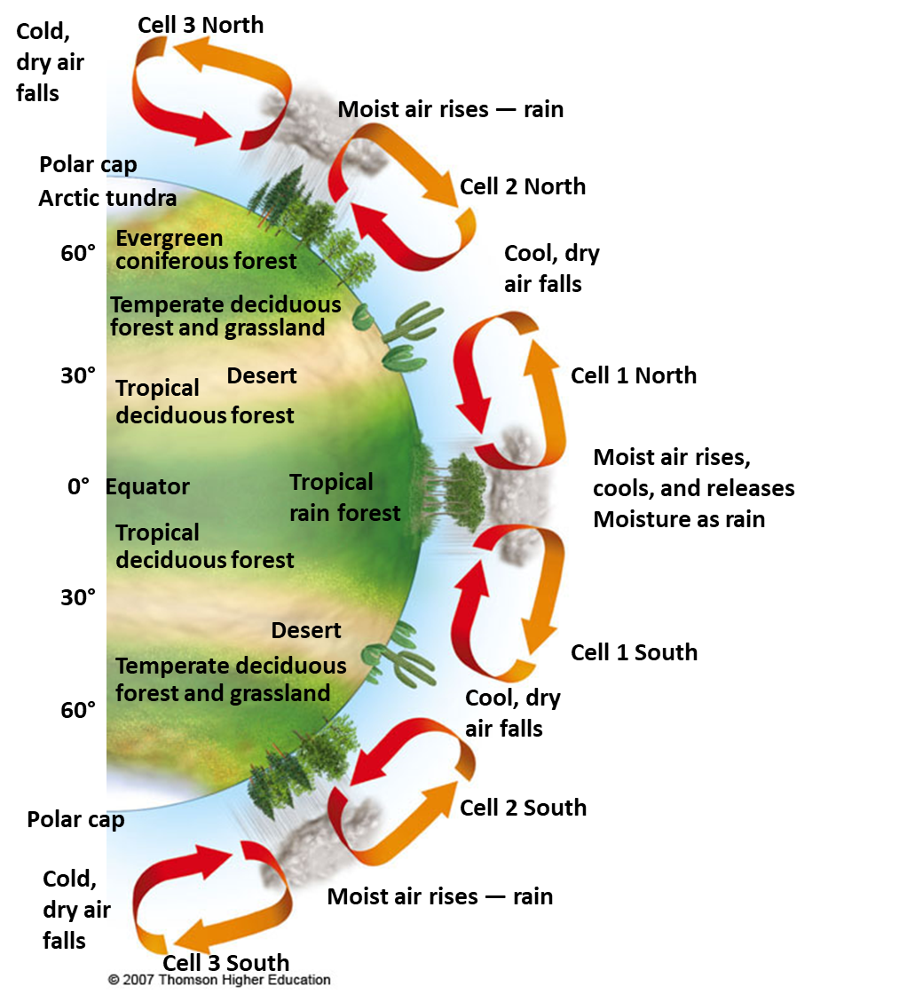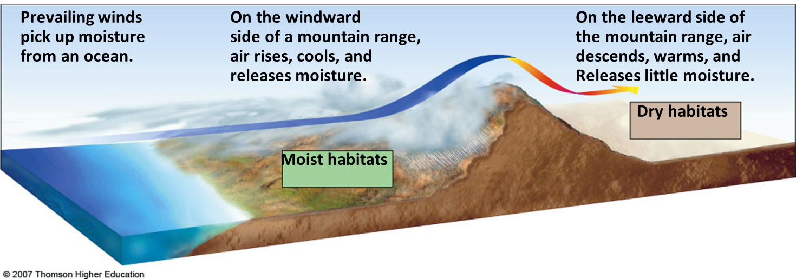
So the equator region are hot, and Polar Regions are cold, and temperate regions are in between generally have intermediate average temperatures. Temperature also becomes progressively colder as elevation above sea level increases.
A second factor is seasonal changes in temperatures and precipitation. The earth’s axis is tilted with respect to the sun’s rays. As a result, regions away from the equator are tipped toward or away from the sun most of the year, as the earth makes its annual revolution around the sun. This creates opposite seasons in the northern and southern hemispheres.
A third factor is rotation of the earth on its axis. As the earth rotates around its north south axis, its equator spins faster than its polar regions. As a result, heated air masses rising above the equator and moving north and south to cooler areas are deflected to the west or east over different parts of the planet’s surface- a phenomenon known as the Coriolis Effect. The direction of air movement in the resulting huge atmospheric regions called cells sets up belts of prevailing winds – major surface winds that blow almost continuously and distribute air moisture, and dust over the earth’s surface.
The fourth factor affecting global air circulation is properties of air, water and land. Heat from the sun evaporates ocean water and transfer heat from the oceans to the atmosphere, especially near the hot equator. This evaporation of water creates cyclical convection cells that circulate air , heat and moisture both vertically and from place to place in the troposphere.
The earth’s air circulation patterns, prevailing winds, and mixture of continents and oceans result in six giant convection cells- three north of the equator and three south of the equator – in which warm, moist air rises and cools, and the cool, dry air sinks. This leads an irregular distribution of climates and patterns of vegetation.
Ocean currents
The major ocean currents also affect the climates of regions. The oceans absorb heat from the air circulation pattern, with the bulk of this heat being absorbed near the warm tropical areas. This heat and differences in water density create warm and cold ocean currents. Irregularly shaped contents interrupt these currents and cause them to flow clockwise in roughly circular pattern between the continents in the northern hemisphere and counterclockwise in the southern hemisphere. Driven by winds and the earth’s rotation these currents help redistribute heat received from the sun from one -place to another, thereby influencing climate and vegetation especially near coastal areas. The warm Gulf Stream for example, transports 25 times more water than all of the world’s rivers combined. Ocean currents also help mix ocean waters and distribute the nutrients and dissolved oxygen needed by aquatic organisms.
Atmospheric gases
Small amount of certain gases, including water vapour, carbon dioxide, methane and nitrous oxide absorb and returns some heat to earth surface again to keep earth surface warm during night. It plays major role in earth’s average temperature.
Topography and local climate
Heat is absorbed and released more slowly by water than by land. This difference creates land and sea breezes. As a result, the world’s oceans and large lakes moderate the climate of nearby lands.
Various topographic features of the earth’s surface create local and regional climatic conditions that differ from the general climate of t a region For example, mountains interrupt the flow of prevailing surface winds and the movement of storms. When moist air blowing inland from an ocean reaches a mountain range, it cools and expands as it rises in altitude and then loses most of its moisture as rain and snow on the windward slopes. As the drier air mass flows down the leeward slopes, it draws moisture out of the plants and soil below. The lower precipitation and the resulting semiarid or arid conditions on the leeward side of high mountains create the rain shadow effect, sometimes leading to the formation of deserts. Thus, winds play a key role in forming some of the earth’s deserts.
Continents lying north or south of warm oceans experience heavy rains called monsoons parts of the year. Intense heating of land near such oceans during summer creates vast low pressure air masses that draw moisture form the ocean. This plus trade winds and equatorial heating lead to heavy rainfall and alternating wet seasons with flooding and dry seasons with drought conditions.
Cities also create distinct microclimates. Bricks, concrete, asphalt, and other building materials absorb and hold heat, and buildings block wind flow. Motor vehicles and the climate control systems of buildings release large quantities of heat and pollutants. As a result, cities tend to have more haze and smog, higher temperatures and lower wind speeds than the surrounding countryside.

4.2 Greenhouse gases and its global scenario
A greenhouse gas is a gas in an atmosphere that absorbs and emits radiant energy within the thermal infrared range. Greenhouse gases are those that absorb and emit infrared radiation in the wavelength range emitted by Earth. This process is the fundamental cause of the greenhouse effect. The primary greenhouse gases in Earth's atmosphere are water vapor, carbon dioxide, methane, nitrous oxide, and ozone. Without greenhouse gases, the average temperature of Earth's surface would be about −18 °C rather than the present average of 15 °C.
Human activities since the beginning of the Industrial Revolution (around 1750) have produced a 40% increase in the atmospheric concentration of carbon dioxide (CO2), from 280 ppm in 1750 to 406 ppm in early 2017
This increase has occurred despite the uptake of more than half of the emissions by various natural "sinks" involved in the carbon cycle. The vast majority of anthropogenic carbon dioxide emissions (i.e., emissions produced by human activities) come from combustion of fossil fuels, principally coal, oil, and natural gas, with comparatively modest additional contributions coming from deforestation, changes in land use, soil erosion, and agriculture.
In order, the most abundant greenhouse gases in Earth's atmosphere are:
- Water vapor (H2O)
- Carbon dioxide (CO2)
- Methane (CH4)
- Nitrous oxide (N2O)
- Ozone (O3)
- Chlorofluorocarbons (CFCs)
- Hydrochlofluorocarbons (HCFCs) and
- Hydrofluorocarbons (HFCs)

Atmospheric concentrations of greenhouse gases are determined by the balance between sources (emissions of the gas from human activities and natural systems) and sinks (the removal of the gas from the atmosphere by conversion to a different chemical compound).The proportion of an emission remaining in the atmosphere after a specified time is the "airborne fraction" (AF). The annual airborne fraction is the ratio of the atmospheric increase in a given year to that year's total emissions. As of 2006 the annual airborne fraction for CO2 was about 0.45. The annual airborne fraction increased at a rate of 0.25 ± 0.21% per year over the period 1959–2006.
Water vapour, carbon dioxide, methane and nitrous oxide are the four major greenhouse gases in the troposphere. These gases have been present in varying concentrations in the troposphere during most of the earth’s long history. Fluctuations in the troposphere concentrations of these gases, especially carbon dioxide and methane, plus changes in solar output are the major factors causing the changes in the average temperature of the troposphere over the past 400000 years.
For more than 275 years, since the beginning of the Industrial Revolution, human actions have led to significant increases in the troposphere concentration of three greenhouse gases carbon dioxide, methane and nitrous oxide. These increases result mostly from burning fossil fuels (which adds co2 and CH4), clearing and burning forests (which add CO2 and N2O), and planting rice and using inorganic fertilizers (which releases CH4 and N2O).
In 2004, the US was the world’s largest emitter of greenhouse gases, with 22% of global emissions, followed by China (14%), The European Union (13%), Russia (6%), Japan (5%), and India (4%). But between 1990 and 2004, China’s emissions increased by 88% while those of the US rose by 19%. China’s emissions are expected to surpass U.S. emissions by 2025. The United States and Canada have some of the world’s highest greenhouse gas emissions per person. Each American, on average, releases about 10 times more CO2 than the average Chinese. In 2005, each person in the United States emitted, on average, 9 kilograms of CO2 to produce half of the country’s electricity and nearly 40% of its CO2
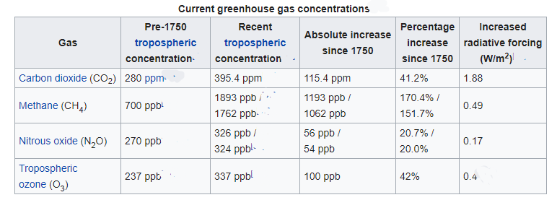

4.3 Greenhouse effect and global warming
Three major factors shape the earth’s climate.
- The sun: without solar energy the earth would be a dark and frigid planet with no life
- Natural greenhouse effect: the natural process warming the earth’s lower troposphere and surface because of several gases known as greenhouse gases.
- The ocean: that cover most of the planet surface and influence climate by storing carbon dioxide and heat, evaporating and receiving water as part of the hydrologic cycle, and moving stored heat from one place to another in currents. Natural cooling process also takes place at earth’s surface. Large quantities of heat are absorbed by the evaporation of surface water, most of it from the ocean. As these water vapour molecules rise, they condense to form droplets in clouds and release their stored heat higher in the troposphere. Because of the impact of this natural heating and cooling, the earth’s average surface temperature is about 15ºC.

Global warming refers to temperature increases in the troposphere, which in turn can cause climate change. Natural changes, human activities or both can cause such warming. Global climate change is a broader term that refers to changes in any aspects of the earth’s climate, including temperature, precipitation, and storm intensity and patterns.

4.4 Climate change and its impact on environment (different sectors including human health)

A warmer global climate could have a number of harmful and beneficial effects for humand, other species and ecosystems, depending mostly on where they are located and on how raodly the temperature changes.
Some areas will benefit because of less severe winters, more precipitation in dry areas, less precipitation in wet areas, and increased food production. Other areas will suffer harm from excessive heat, lack of water and decreased food production. According to the IPCC, poor people and wildlife species in the tropics will suffer the most harm.
Melting ice and snow
As the atmosphere warms, it causes convection that transfers surplus heat from equatorial to polar areas and higher Himalayas. Temperature increases tend to be much greater in polar regions. Measurements from the Arctic ocean, Greenland, and the northwestern shores of Alaska show that floating seaice areound the North Pole and Greenland is melting and thinning faster than it is being formed.
Light colored surfaces of ice and snow help cool the earth by reflecting 80-90% of incoming sunlight back into space. Much less sunlight is reflected by darker surfaces such as forests, grass, cities, and oceans. Ocean water, for example, absorbs 80-90% of the energy it receives. These, the earth’s poles and mountain top glaciers are the planet’s air conditioning system.
Melting of some of the earth’s icecaps, floating ice, and mountain glaciers would expose darker and much less reflective surfaces of water and land, resulting in a warmer troposphere.

4.5 Climate change scenario in Nepal
Nepal is among the least developed countries (LDCs) in South Asia covering area of 147181 square kilometers and with great topographical variation extending from 60 meters from mean sea level to 8848 meter from mean sea level. At the time of population census in 2011 there were 26,494,504 people residing in the country. Studies on climate change in Nepal reveals that 10 million people are exposed to increasing risks of climate change.
Ministry of Environment Nepal (MOE) states that the temperature rise rate for Nepal is 0.06 % (MOE Climate Change Policy 2011). Others claim that average temperatures across the country is different (i.e. higher in the mountains and the Himalayas: 0.08°C as compared to Terai: 0.04°C.) (Gautam and Pokhrel 2010). Extreme climatic conditions increase vulnerability to erosion, landslides, avalanches, flooding, loss of flora and fauna and decreased agricultural production (Nepal and Chipeniuk 2005).
Rice, Wheat and Maize are grown as major crops in Nepal. Nepal Agricultural Research Council (NARC) showed that the change in temperature has had a positive effect on the yield of rice and wheat in all regions but also showed a negative impact on the yield of maize, particularly in the plains land of Nepal, otherwise known as Nepal’s bread basket.
There are 2323 glacial lakes in Nepal covering 75 sq. kms. Geoscientists have recorded that the number and volume of Glacier Lake Outburst Flooding (GLOF) hazards are increasing in Nepal. Rate of retreat of some glaciers is estimated to be as high as 20 m/year. Evidence in the Main Rongbuk glacier (in Mount Everest): lost 330 feet of vertical ice, at a rate of more than 4ft/yr, between 1921 and 2007. Snow and glacier melt might increase water in Nepal's river system 5.7% till 2030, decrease by 28% by the end of this century. Crop failure and loss of livestock: threaten livelihoods of mountain farmers who are already vulnerable and food-insecure. Changes in snow patterns: affect tourism industry, cause enormous economic losses. Tourism is one of the major contributor in Nepalese economy. (Source: Devkota Dinesh, former VC, NPC) Impacts
Of 2,323 glacial lakes in Nepal, 20 have been found to be potentially dangerous with respect to glacial lake outburst floods (GLOFs). An example of such event occurred in 1985, when a GLOFs caused a 10-15 meters high surge of water and debris to flood down the BhoteKoshi and DudhKoshi rivers for 90 km, destroying the Namche Small Hydro Project. As a response to Nepal’s vulnerability to climate change, numerous adaptation options for various sectors have been proposed and many already implemented. One major project that focuses on GLOFs mitigation has been undertaken in the Tsho Rolpa glacial lake area. With Dutch support, the Nepalese government undertook a project to drain and reduce the depth of the Tsho Rolpa glacial lake by 3 meters. This reduced the risk of a GLOFs by 20 percent. A major aspect of the design was that a channel was cut into the moraine, and a gate was constructed to allow water to be released as necessary. In addition, an early warning system was simultaneously established in 19 villages downstream of the Rolwaling river. Local villagers were actively involved in the design of this system to ensure that they feel safe from potential flood events and are also made aware about the potential damages. Source: Raut 2005 Draining potentially dangerous glacial lakes in Nepal
Mosquitoes and other vector insects are spreading to the newer places of higher altitude. The subtropical and warm temperature regions are predicted to be particularly vulnerable to malaria and kalaazar. There will be higher risk of water-borne diseases due to poor sanitation and higher rainfall intensities. Increased flooding could damage municipal treatment facilities or land-fills, increasing the risk of contamination.
By directly eroding the resources that Poor People depend on for their livelihoods, climate change makes it easier for people to fall into poverty and harder for the poorest to escape from it:
- Physical resources. Shelter and infrastructure will be damaged or destroyed by an increased frequency of flooding, storms and climate-related disasters.
- Human resources. Malnutrition and the incidents of infectious diseases are predicted to rise with changing weather patterns.
- Social resources. Reduced livelihood security and prolonged or more frequent droughts and floods will lead to the displacement of communities
- Natural resources. Ecosystems are directly threatened by climate change. Change to the natural environment undermines the poor who depend on local ecosystems for a variety of goods and services, and rely on the productivity of their environment to support agriculture. Changes in local ecosystems may require changes to agricultural systems and practices.
- Financial resources. The repeated failure of crops or loss of infrastructure and homes leads to increased household costs, decline in income, slower economic development and lower livelihood security.
In Nepal, Flood is mainly restricted to Terai region. It has 6000 rives with 4 mega basin (perennial, fed by snow melt) and 6 smaller basins.
Rivers exhibit great variation in their dry and wet season flows. Not only small rivers but also the larger ones exhibit seasonal variations of more than 100 %. Intense cloudbursts in the catchments result in devastating flood.
Floods in Terai occur regularly and causes considerable damage. In case of sudden release by GLOFs, damage caused by cascading water and associated debris can be catastrophic.
- Climate change is likely to bring particularly rapid temperature increases in Nepal – faster than the average global rate of warming.
- Winter temperatures will increase more than summer temperatures. The level of winter rainfall is expected to decrease, whilst summer rainfall will increase.
- Extreme weather events such as heatwaves and very high rainfall are likely to become more frequent.
- Overall, Nepal is likely to become wetter, with the east of Nepal experiencing more rain than the west.
The aforementioned points will have ripple effect on various sectors and impose a huge threat to human health, lives, economy and the existence.

4.6 Solution/mitigation of climate change
Countries like Bangladesh, Bhutan and Nepal are very low on emission as per capita basis and on an overall basis. . Other countries, such as India, have higher and fast-rising greenhouse gas emissions. As such, efforts at mitigation are different in different countries.
Mitigation Efforts Required in Nepal.
In Nepal, the emission level by itself is low. However, the country is sandwiched between India and China, and winds get drifted from the neighboring countries which might have cascading effect in the country. Therefore Adaptation measures should be focused on.
- The country is yet to see industrial development. The use of clean energy and carbon free technology should be used.
- Vehicular emission poses dangerous threat, therefore electric vehicle should be promoted.
- Serious efforts should be made to lower the individual carbon foot print.
- The government should also invest in improvising the transport sector so that people use public transport more than the private vehicles.
- To really tackle climate change, action is needed on a global level and the global community should continue to work towards agreeing and implementing measures to keep emissions such that the temperature rise does not exceed 2 degrees. Moreover, South Asia is yet to see a huge infrastructural and other developments. So, all countries should focus on clean energy, energy efficiency, protection of carbon sinks, clean transport and other measures that keep emissions low, especially when these can be achieved with little or no additional costs.
Nepal Suffers high economic costs due to current climate variability and extreme climate events:
- Economy of Nepal and livelihoods are dependent on the climate, because a large proportion of GDP is associate with Climate sensitive activities. Events include floods, rainfall variability and low season river flows reducing hydro-electricity generation.
- Annual direct cost (approx. US $ 270 to 360 million/ year in 2013 prices) is high compared to international level.
- A key conclusion is that Nepal is not adequately adapted to the current climate. The country has a large existing adaptation deficit, which is a priority for early action.
- Agriculture is the most important contributor in the economy, therefore, adaptation for this sector should be rightly promulgated.
- Smart Agriculture system by Rain Water harvesting and use of right nutrients. Drought and flood proofing measures, promoting crop diversification, Integrated watershed management program, etc. should be used.
- Proper management of water resources system, promotion of indigenous and sustainable technologies, etc. Adaptation Required in Nepal
Act Now
- Building Adaptive capacity
- Reducing Vulnerability
- Stringent national adaptation plans such as NAPAs
Act Together
- Reduce emission level and individual carbon footprint (at the local level)
- Promote sustainable transport system and lower the use of fossil fuels (at national level)
- Abide by the Global rules and regulations as initiated in Climate Change forums (at international level)
Act Differently
- Use of Smart Technology in Agriculture, Innovative approach to adapt to consequences of climate change
- Use of Carbon free technology for further industrial development and restructuring of industries with larger emission by providing subsidies to promote low carbon technology
- Promotion of Renewable Energies.

4.7 Climate change vulnerability
By Raksha Adhikari
Climate change is a change in the statistical distribution of weather patterns when that change lasts for an extended period of time.
Vulnerability is the state of being exposed to the possibility of being attacked or harmed.
So, the alter caused by climate change into geophysical, biological and socio-economic systems is known as climate change vulnerability.
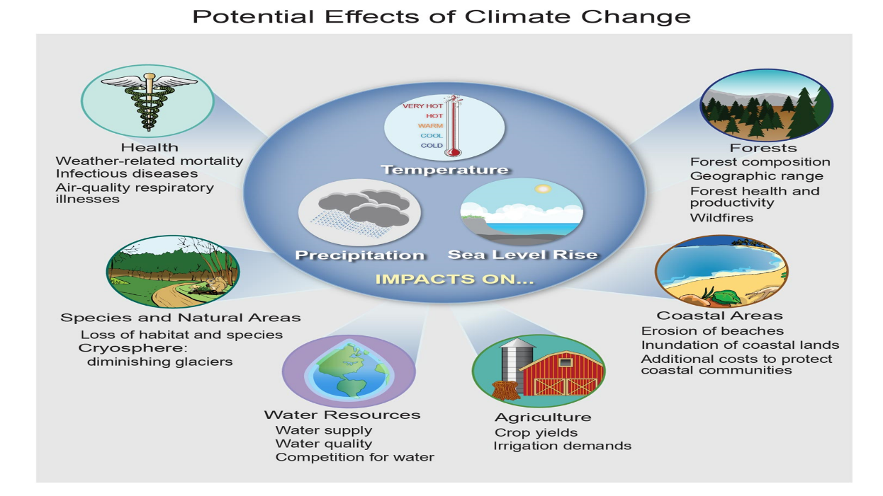
Who is more vulnerable to climate change?
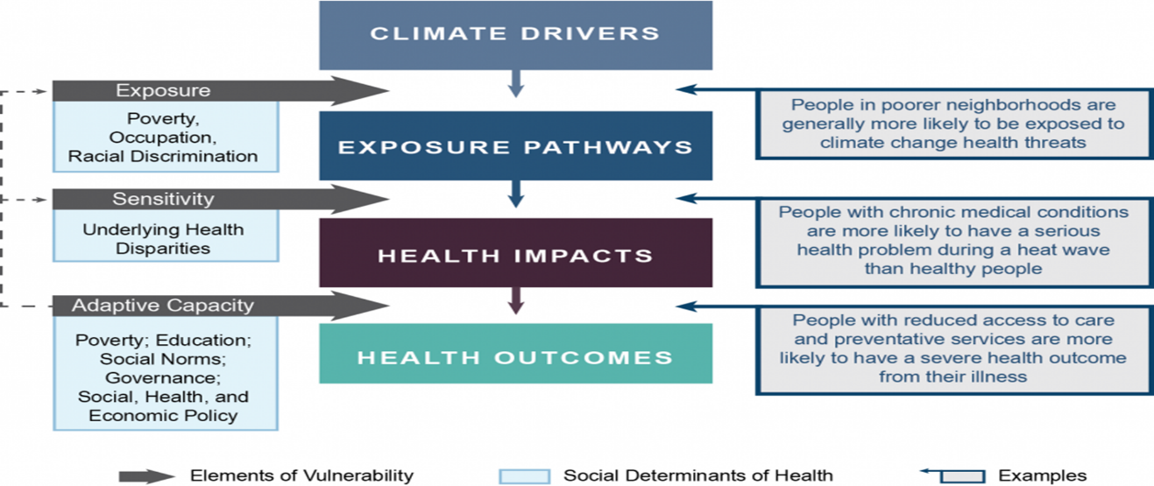
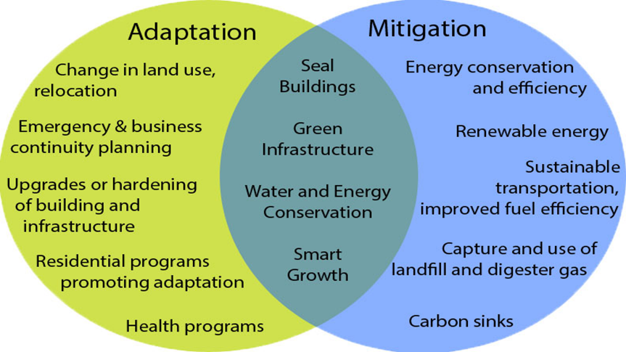
Climate change vulnerability assessment: A vulnerability assessment is the process of identifying, quantifying, and prioritizing (or ranking) the vulnerabilities in a system. The same process for climate change vulnerability system is the climate change vulnerability assessment.

4.8 Climate change adaptation: general concept of NAPA to LAPA, adaptive capacity and its determinants
Climate change adaptation is a response to global warming and climate change, that seeks to reduce the vulnerability of social and biological systems to relatively sudden change and thus offset the effects of global warming. Even if emissions are stabilized relatively soon, global warming and its effects should last many years, and adaptation would be necessary to the resulting changes in climate. Adaptation is especially important in developing countries since those countries are predicted to bear the brunt of the effects of global warming. That is, the capacity and potential for humans to adapt (called adaptive capacity) is unevenly distributed across different regions and populations, and developing countries generally have less capacity to adapt. Furthermore, the degree of adaptation correlates to the situational focus on environmental issues. Therefore, adaptation requires the situational assessment of sensitivity and vulnerability to environmental impacts
A National Adaptation Programme of Action (NAPA) is a type of plan submitted to the United Nations Framework Convention on Climate Change (UNFCCC) by Least Developed Countries, to describe the country's perception of its most "urgent and immediate needs to adapt to climate change". NAPAs are not supposed to include original research, but use existing information and include profiles of priority projects that are intended to address those needs that have been identified. The UNFCCC maintains a database of NAPAs, and of country priorities that have been identified within NAPAs. Nepal prepared NAPA in 2010.
The Least Developed Country Fund (LDCF) was established to finance the preparation of NAPAs and to implement the projects that they propose.
Local Adaptation Plans of Action (LAPAs) are community-based approaches that take a "vulnerability first" approach to climate change adaptation. LAPAs contrast with National Adaptation Programme of Action (NAPAs) in their bottom-up, local approach, but in some cases are funded under the similar development assistance schemes. LAPAs are often prepared at local government level, although community-based LAPAs are also in place. The practice was initiated in Nepal under the guidance of the Ministry of Population and Environment, the national focal point to United Nations Framework Convention on Climate Change.

4.9 International environmental convention and treaty: Kyoto protocol and recent convention
By Ramesh Rijal
What is Kyoto protocol?
The Kyoto Protocol is an international agreement linked to the United Nations Framework Convention on Climate Change, which commits its Parties by setting internationally binding emission reduction targets.
Recognizing that developed countries are principally responsible for the current high levels of GHG emissions in the atmosphere as a result of more than 150 years of industrial activity, the Protocol places a heavier burden on developed nations under the principle of "common but differentiated responsibilities."
The Kyoto Protocol was adopted in Kyoto, Japan, on 11 December 1997 and entered into force on 16 February 2005. The detailed rules for the implementation of the Protocol were adopted at COP 7 (Conference of Parties 7) in Marrakesh, Morocco, in 2001, and are referred to as the "Marrakesh Accords." Its first commitment period started in 2008 and ended in 2012.
The Kyoto mechanism
Under the Protocol, countries must meet their targets primarily through national measures. However, the Protocol also offers them an additional means to meet their targets by way of three market-based mechanisms.
The mechanisms help to stimulate green investment and help Parties meet their emission targets in a cost-effective way.
The Kyoto mechanisms are:
- International Emissions Trading
- Clean Development Mechanism (CDM)
- Joint implementation (JI)
Countries as part of Kyoto protocol
The Only Nations That Haven't Signed 1997's Global Climate Treaty are Afghanistan, Sudan & the U.S.A. A total of 192 countries have signed and ratified the Kyoto Protocol, the 1997 treaty that's the closest thing we have to a working global agreement to fight climate change
Goal of Kyoto protocol
The main goal of the Kyoto Protocol is to control emissions of the main anthropogenic (human-emitted) greenhouse gases (GHGs) in ways that reflect underlying national differences in GHG emissions, wealth, and capacity to make the reductions.
Achievement of Kyoto protocol
The headline result tell us that between 1990 and 2012 the original Kyoto protocol parties reduce their co2 emission by 12.5% which is well beyond the 2012 target of 4.7%.
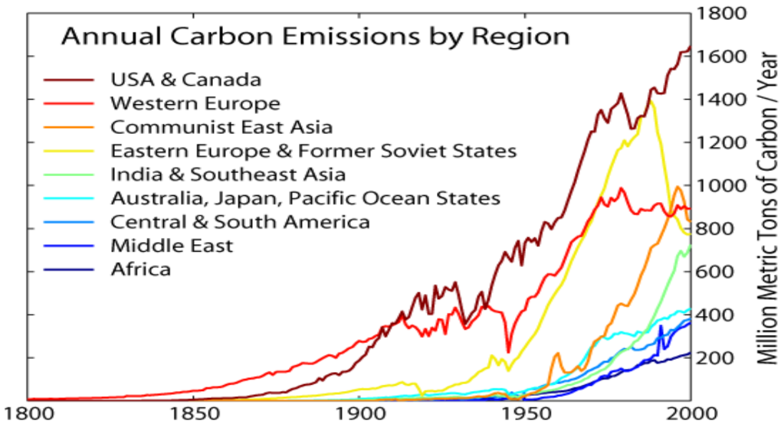

Recent Conventions:
2017: COP 23/CMP 13/CMA 1-2, Bonn, Germany
The 2017 United Nations Climate Change Conference ("COP23") was an international meeting of political leaders, non-state actors and activists to discuss environmental issues. It was held at UN Campus in Bonn (Germany) from 6–17 November 2017.

Sustainable Development Agenda (SDAN), 2003 • Climate Change Council 2009 • Climate Change Management Division, 2010, MoEnv • NAPA, 2010 • Climate change policy 2011 • Climate Resilient Planning Tool, 2011 : NPC • Local Adaptation Plan of Action (LAPA), November 2011 • Three year Plan 2010 emphasized on climate resilient planning of infrastructure sector and integrated poverty environment initiatives Adaptation Initiatives in Nepal

